

Akhil Vinayak Hariharasudhan

S394648

Artificial Intelligence and Machine Learning for Robotics

MSc in Robotics

Academic Year: 2022 - 2023

Supervisor: Dr. Seemal Asif

Jan 2023

This thesis is submitted in partial fulfilment of the requirements for the degree of Robotics

© Cranfield University 2023. All rights reserved. No part of this publication may be reproduced without the written permission of the copyright owner.

ABSTRACT

This report will explore various Machine Learning algorithm that will be used to solve a classification problem in which multiple datasets of the force and torque of a robot after failure is detected. All the five different datasets will be solved using five different machine learning methods. The accuracy of these approaches will be compared and used to determine the most effective algorithms for each dataset.

TABLE OF CONTENTS

Contents

ABSTRACT i

LIST OF FIGURES iv

LIST OF TABLES v

LIST OF EQUATIONS vi

LIST OF ABBREVIATIONS vii

1 Introduction 1

1.1 Literature Review 1

1.2 Fundamentals of AI and ML 2

1.2.1 Data collection 3

1.2.2 Data Preparation: 3

1.2.3 Training model on data 4

1.2.4 Analysis/Evaluation: 8

1.2.5 Deploy the model: 8

1.2.6 Retrain model 8

1.3 Scope and objectives 8

2 Methodology 9

2.1.1 Pre-processing 10

2.2 Algorithm 14

2.3 Mathematical representation 15

3 Results and discussions 17

3.1 LP1 18

3.2 LP2 37

3.3 LP3 51

3.4 LP4 66

3.5 LP5 76

4 Conclusion 89

REFERENCES 93

APPENDICES 94

# LIST OF FIGURES

Figure 1: Machine learning steps 3

Figure 2: Data collection 3

Figure 3: Supervised learning 5

Figure 4: Reinforcement learning 6

Figure 5: Reinforcement learning steps 6

Figure 6: Algorithms for different problems 7

[Figure 7:Dataset before averaging 9](https://cranfield-my.sharepoint.com/personal/a_hariharasudhan_648_cranfield_ac_uk/Documents/AI%20and%20ML/AIML.docx#_Toc123605691)

[Figure 8: Dataset after averaging 9](https://cranfield-my.sharepoint.com/personal/a_hariharasudhan_648_cranfield_ac_uk/Documents/AI%20and%20ML/AIML.docx#_Toc123605692)

[Figure 9: class after encoding 10](https://cranfield-my.sharepoint.com/personal/a_hariharasudhan_648_cranfield_ac_uk/Documents/AI%20and%20ML/AIML.docx#_Toc123605693)

Figure 10: Class before encoding 10

[Figure 11: Train-test splitting 11](https://cranfield-my.sharepoint.com/personal/a_hariharasudhan_648_cranfield_ac_uk/Documents/AI%20and%20ML/AIML.docx#_Toc123605695)

Figure 12: PCA 11

Figure 13: PCA scree plot 12

Figure 14: PCA dataset 12

Figure 15: LP1 dataset 18

Figure 16: LP1 class count 18

Figure 17: LP1 Decision tree computation time 19

Figure 18: LP1 Decision Tree Accuracy 20

Figure 19: LP1 Decision Tree Confusion Matrix 20

Figure 20: LP1 Decision Tree Classification Report 21

Figure 21: LP1 Decision Tree Diagram 21

Figure 22: LP1 DT with PCA computation time 22

Figure 23: LP1 DT with PCA Accuracy 22

Figure 24: LP1 DT with PCA Confusion Matrix 22

Figure 25: LP1 DT with PCA Classification Report 23

Figure 26: LP1 DT with PCA diagram 23

Figure 27: LP1 SVM Computation Time 24

Figure 28: LP1 SVM accuracy 24

Figure 29: LP1 SVM Classification report 24

Figure 30: LP1 SVM confusion matrix 25

Figure 31: LP1 SVM ROC Curve 26

Figure 32: LP1 SVM with PCA Computation time 26

Figure 33: LP1 SVM with PCA accuracy 27

Figure 34: LP1 SVM with PCA classification report 27

Figure 35: LP1 SVM with PCA Confusion Matrix 27

Figure 36: LP1 NB computation time and accuracy 28

Figure 37: LP1 NB classification report 28

Figure 38: LP1 NB ROC curve 29

Figure 39: LP1 NB Confusion matrix 29

Figure 40: LP1 NB with PCA 30

Figure 41:LP1 KNN computation time 30

Figure 42: LP1 KNN accuracy 31

Figure 43: LP1 KNN classification report 31

Figure 44: LP1 KNN confusion matrix 32

Figure 45: LP1 KNN with PCA 33

Figure 46:LP1 MLP computation time 33

Figure 47: LP1 MLP classification report 34

Figure 48: LP1 MLP accuracy 34

Figure 49: LP1 RF computation time 35

Figure 50: LP1 RF classification report 35

Figure 51: LP1 RF accuracy 35

Figure 52: LP1 RF confusion matrix 36

Figure 53: LP1 RF with PCA 37

Figure 54: LP1 ANN computation time 38

Figure 55: LP1 ANN model summary 38

Figure 56: LP1 ANN model compile 38

Figure 57: LP1 ANN steps 39

[Figure 58: LP1 ANN train and validation loss 40](https://cranfield-my.sharepoint.com/personal/a_hariharasudhan_648_cranfield_ac_uk/Documents/AI%20and%20ML/AIML.docx#_Toc123605742)

[Figure 59: LP1 ANN train and validation accuracy 40](https://cranfield-my.sharepoint.com/personal/a_hariharasudhan_648_cranfield_ac_uk/Documents/AI%20and%20ML/AIML.docx#_Toc123605743)

Figure 62: LP1 ANN with PCA 41

[Figure 60: LP1 with PCA train & valid accuracy 41](https://cranfield-my.sharepoint.com/personal/a_hariharasudhan_648_cranfield_ac_uk/Documents/AI%20and%20ML/AIML.docx#_Toc123605745)

[Figure 61:LP1 ANN with PCA train & valid loss 41](https://cranfield-my.sharepoint.com/personal/a_hariharasudhan_648_cranfield_ac_uk/Documents/AI%20and%20ML/AIML.docx#_Toc123605746)

[Figure 63: LP2 Dataset 42](https://cranfield-my.sharepoint.com/personal/a_hariharasudhan_648_cranfield_ac_uk/Documents/AI%20and%20ML/AIML.docx#_Toc123605747)

[Figure 64: LP2 Class count 43](https://cranfield-my.sharepoint.com/personal/a_hariharasudhan_648_cranfield_ac_uk/Documents/AI%20and%20ML/AIML.docx#_Toc123605748)

Figure 65: LP2 DT time computation 44

Figure 66: LP2 DT accuracy 44

Figure 67: LP2 DT classification report 45

Figure 68: LP2 DT confusion matrix 45

Figure 69: LP2 DT diagram 46

[Figure 70: LP2 DT with PCA 46](https://cranfield-my.sharepoint.com/personal/a_hariharasudhan_648_cranfield_ac_uk/Documents/AI%20and%20ML/AIML.docx#_Toc123605754)

Figure 71: LP2 DT with PCA classification report 47

[Figure 72: LP2 DT with PCA confusion matrix 47](https://cranfield-my.sharepoint.com/personal/a_hariharasudhan_648_cranfield_ac_uk/Documents/AI%20and%20ML/AIML.docx#_Toc123605756)

[Figure 73:LP2 SVM confusion matrix 48](https://cranfield-my.sharepoint.com/personal/a_hariharasudhan_648_cranfield_ac_uk/Documents/AI%20and%20ML/AIML.docx#_Toc123605757)

Figure 75:LP2 SVM classification report & time 48

[Figure 74: LP2 SVM ROC curve 48](https://cranfield-my.sharepoint.com/personal/a_hariharasudhan_648_cranfield_ac_uk/Documents/AI%20and%20ML/AIML.docx#_Toc123605759)

Figure 76: LP2 SVM with PCA 49

Figure 77: LP2 SVM with PCA confusion matrix 50

Figure 78: LP2 NB time and accuracy 50

Figure 79: LP2 NB classification report 51

[Figure 80: LP2 NB ROC curve 51](https://cranfield-my.sharepoint.com/personal/a_hariharasudhan_648_cranfield_ac_uk/Documents/AI%20and%20ML/AIML.docx#_Toc123605764)

[Figure 81: LP2 NB confusion matrix 51](https://cranfield-my.sharepoint.com/personal/a_hariharasudhan_648_cranfield_ac_uk/Documents/AI%20and%20ML/AIML.docx#_Toc123605765)

Figure 82: LP2 NB with PCA time and accuracy 52

Figure 83: LP2 KNN time 52

Figure 84: LP2 KNN classification report 52

Figure 85: LP2 KNN accuracy 53

Figure 86: LP2 KNN with PCA 53

Figure 87: LP2 KNN with PCA accuracy 53

[Figure 88: LP2 MLP 54](https://cranfield-my.sharepoint.com/personal/a_hariharasudhan_648_cranfield_ac_uk/Documents/AI%20and%20ML/AIML.docx#_Toc123605772)

[Figure 89: LP2 MLP time 54](https://cranfield-my.sharepoint.com/personal/a_hariharasudhan_648_cranfield_ac_uk/Documents/AI%20and%20ML/AIML.docx#_Toc123605773)

Figure 90: LP2 RF 55

Figure 91: LP2 RF accuracy 55

Figure 92: LP2 RF confusion matrix 56

Figure 93: LP2 RF with PCA 56

[Figure 94: LP2 ANN model 57](https://cranfield-my.sharepoint.com/personal/a_hariharasudhan_648_cranfield_ac_uk/Documents/AI%20and%20ML/AIML.docx#_Toc123605778)

[Figure 95: LP2 ANN steps 57](https://cranfield-my.sharepoint.com/personal/a_hariharasudhan_648_cranfield_ac_uk/Documents/AI%20and%20ML/AIML.docx#_Toc123605779)

[Figure 96: LP2 ANN train & valid loss 58](https://cranfield-my.sharepoint.com/personal/a_hariharasudhan_648_cranfield_ac_uk/Documents/AI%20and%20ML/AIML.docx#_Toc123605780)

[Figure 97: LP2 ANN train & valid accuracy 58](https://cranfield-my.sharepoint.com/personal/a_hariharasudhan_648_cranfield_ac_uk/Documents/AI%20and%20ML/AIML.docx#_Toc123605781)

[Figure 98: LP2 ANN with PCA 59](https://cranfield-my.sharepoint.com/personal/a_hariharasudhan_648_cranfield_ac_uk/Documents/AI%20and%20ML/AIML.docx#_Toc123605782)

[Figure 99: LP2 ANN with PCA train & valid accuracy 59](https://cranfield-my.sharepoint.com/personal/a_hariharasudhan_648_cranfield_ac_uk/Documents/AI%20and%20ML/AIML.docx#_Toc123605783)

Figure 100: LP3 Dataset 60

Figure 101: LP3 class count 60

Figure 102: LP3 DT time 61

Figure 103: LP3 DT accuracy 62

Figure 104: LP3 DT classification report 62

Figure 105: LP3 DT confusion matrix 62

Figure 106: LP3 DT with PCA time 63

[Figure 107: LP3 DT with PCA confusion matrix 63](https://cranfield-my.sharepoint.com/personal/a_hariharasudhan_648_cranfield_ac_uk/Documents/AI%20and%20ML/AIML.docx#_Toc123605791)

Figure 108: LP3 DT with PCA accuracy 63

Figure 109: LP3 SVM classification report 64

Figure 110: LP3 SVM accuracy 64

Figure 111:LP3 SVM confusion matrix 65

[Figure 112: LP3 SVM with PCA 65](https://cranfield-my.sharepoint.com/personal/a_hariharasudhan_648_cranfield_ac_uk/Documents/AI%20and%20ML/AIML.docx#_Toc123605796)

Figure 113: LP3 SVM with PCA confusion matrix 66

Figure 114: LP3 NB time classification report 67

[Figure 115: LP3 NB confusion matrix 67](https://cranfield-my.sharepoint.com/personal/a_hariharasudhan_648_cranfield_ac_uk/Documents/AI%20and%20ML/AIML.docx#_Toc123605799)

Figure 116: LP3 NB with PCA 68

Figure 117: LP3 KNN 68

Figure 118: LP3 KNN confusion matrix 69

Figure 119: LP3 KNN with PCA 69

Figure 120: LP3 MLP 70

Figure 121: LP3 RF 71

Figure 122: LP3 RF with PCA 72

[Figure 123: LP3 ANN 73](https://cranfield-my.sharepoint.com/personal/a_hariharasudhan_648_cranfield_ac_uk/Documents/AI%20and%20ML/AIML.docx#_Toc123605807)

[Figure 124: LP3 ANN train & validation accuracy 74](https://cranfield-my.sharepoint.com/personal/a_hariharasudhan_648_cranfield_ac_uk/Documents/AI%20and%20ML/AIML.docx#_Toc123605808)

Figure 125: LP3 ANN with PCA 75

[Figure 126: LP4 class count 76](https://cranfield-my.sharepoint.com/personal/a_hariharasudhan_648_cranfield_ac_uk/Documents/AI%20and%20ML/AIML.docx#_Toc123605810)

Figure 127: LP4 DT time 76

Figure 128: LP4 DT classification report 77

[Figure 129: LP4 DT confusion matrix 77](https://cranfield-my.sharepoint.com/personal/a_hariharasudhan_648_cranfield_ac_uk/Documents/AI%20and%20ML/AIML.docx#_Toc123605813)

Figure 130: LP4 DT with PCA 78

Figure 131: LP4 NB 79

Figure 132: LP4 NB with PCA 80

Figure 133: LP4 KNN 80

Figure 134: LP4 KNN with PCA 81

Figure 135: LP4 MLP 82

Figure 136: LP4 RF 83

Figure 137: LP4 RF with PCA 84

Figure 138: LP4 ANN 85

[Figure 139: LP4 ANN Train & validation accuracy 86](https://cranfield-my.sharepoint.com/personal/a_hariharasudhan_648_cranfield_ac_uk/Documents/AI%20and%20ML/AIML.docx#_Toc123605823)

[Figure 140: LP4 ANN with PCA 86](https://cranfield-my.sharepoint.com/personal/a_hariharasudhan_648_cranfield_ac_uk/Documents/AI%20and%20ML/AIML.docx#_Toc123605824)

[Figure 141: LP4 ANN with PCA train & valid acc 87](https://cranfield-my.sharepoint.com/personal/a_hariharasudhan_648_cranfield_ac_uk/Documents/AI%20and%20ML/AIML.docx#_Toc123605825)

[Figure 142: LP5 Class count 87](https://cranfield-my.sharepoint.com/personal/a_hariharasudhan_648_cranfield_ac_uk/Documents/AI%20and%20ML/AIML.docx#_Toc123605826)

Figure 143: LP5 DT 88

Figure 144: LP5 DT with PCA 89

Figure 145: LP5 NB 91

Figure 146: LP5 NB with PCA 92

Figure 147: LP5 KNN 93

Figure 148: LP5 KNN with PCA 94

Figure 149: LP5 MLP 94

Figure 150: LP5 RF 96

Figure 151: LP5 RF with PCA 97

[Figure 152: LP5 ANN 99](https://cranfield-my.sharepoint.com/personal/a_hariharasudhan_648_cranfield_ac_uk/Documents/AI%20and%20ML/AIML.docx#_Toc123605836)

Figure 153: LP5 ANN with PCA 100

LIST OF TABLES

Table 1: Conclusion 101

LIST OF EQUATIONS

Equation 1: Accuracy 13

Equation 2: Precision 13

Equation 3: Recall 13

Equation 4: F-measure 13

Equation 5: Entropy 15

Equation 6: Gini Index 15

Equation 7: class posterior 15

Equation 8: Naive Bayes 16

Equation 9: KNN 16

Equation 10: Decision function 16

[Equation 11: SVC 17](https://cranfield-my.sharepoint.com/personal/a_hariharasudhan_648_cranfield_ac_uk/Documents/AI%20and%20ML/AIML.docx#_Toc123605848)

Equation 12: Neural network 17

|  |  |
| --- | --- |
|  |  |
|  |  |
|  |  |

# Introduction

There are several applications for Machine Learning and one of the most significant uses is analysing data to find the solutions for specific problems. This will improve the efficiency of the systems. Firstly, data will be collected and then prepared. Afterwards, it will be split and then five different machine learning techniques will be used on the multi-Class classification dataset. Finally, the model will be evaluated and visualised.

## Literature Review

This section reviews various machine learning methods used by researchers on classification problems.

The goal of supervised learning is to build a concise model of the distribution of class labels in terms of predictor features. The resulting classifier is then used to assign class labels to the testing instances where the values of the predictor features are known, but the value of the class label is unknown. Several studies reported that these techniques are significant for future prediction such as in the field of robotics. In these studies, authors applied multiple approaches to specified problems and achieve high accuracies.

In the report “comparison of machine learning algorithms in data classification” the author applies these techniques on two datasets based on its accuracy and then the performance of ML classifiers is compared in terms of accuracy, precision, recall and F measure on both datasets to figure out which techniques effectively analyse the data.

The report uses six classification techniques: Logistic Regression (LR), Decision Tree (DT), Naive Bayes (NB), K-Nearest Neighbours (KNN), Support Vector Machines (SVM) and Random Forest (RF) to predict about the heart and hepatitis diseases datasets to predict that how many patients are affected with heart problem and faces hepatitis problem.

The author extracts valuable information from both the datasets and implements all the ML classifiers mentioned. The result shows that different classifiers behave differently on the same dataset. From the analysis, it is found that the random forest classifier performed best out of the six classifiers on both datasets for disease prediction.(Ul Hassan et al., 2018)

We will be using the same classification techniques that was used on this literature to evaluate our datasets since the report is based on a multiclass classification problem.

Neural networks are also applied for prediction of robot failures. The data collected and the classes in each class are normal, collision, obstruction, and front collision. It is then distributed as training and testing set and a multilayer feedforward neural network with different learning algorithms are used.

The best and worst neural network architecture is identified by finding out the prediction rate of each architecture. (Neural networks for prediction of robot failures)(Diryag et al., 2014)

Therefore, for the multiclass dataset that has been provided will use artificial neural network. The prediction rate of the network also will be identified and then compared with the rest of the classification methods.

## Fundamentals of AI and ML

Machine learning (ML) is a sub-category of artificial intelligence that enables tasks such as recognition, planning, robot control, prediction etc. to improve their prediction accuracy.(Mitchell, n.d.)

ML is used to explore knowledge, validate the data and their behaviour. The data is split into two datasets (training and testing) and then these are used to explore where it stands in the future. ML steps are shown in fig:

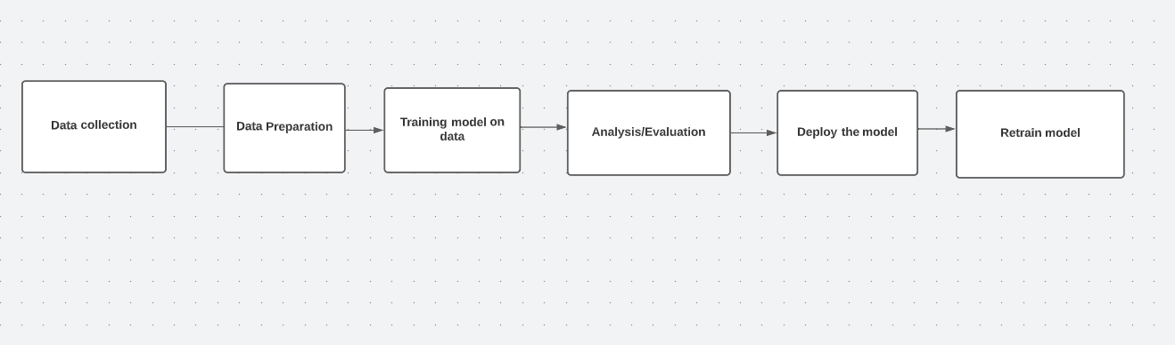

Figure 1: Machine learning steps

### Data collection

The first stage of machine learning process is to gather data from various sources.

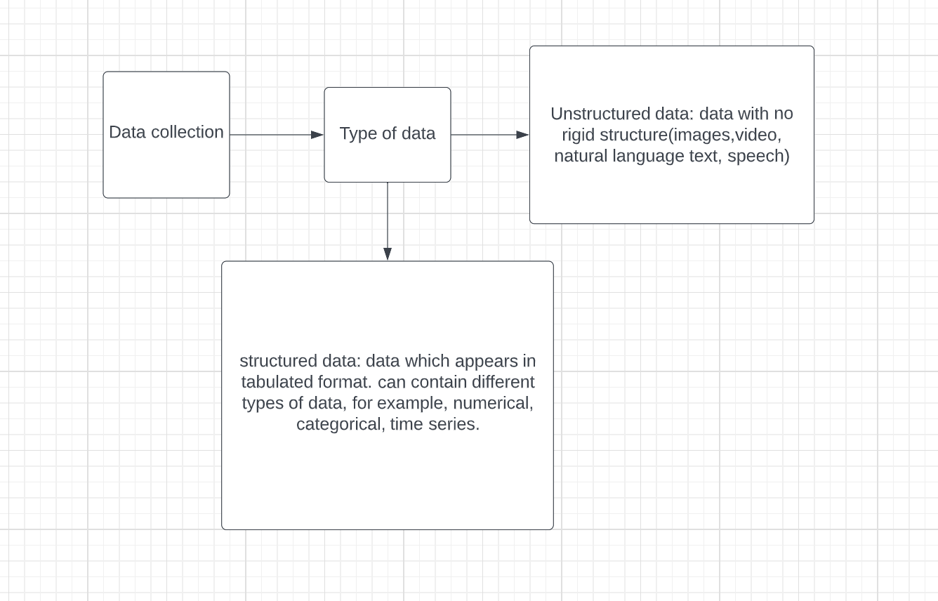

Figure 2: Data collection

### Data Preparation:

There are three parts in data preparation.

1. Exploratory data analysis (EDA): This is where we need to figure out the feature variables (input) and the target variables(output). Understanding the kind of data (structured, unstructured, categorical, numerical). Removal or adding missing values are the steps taken in the first step of data preparation.
2. Data processing: A very important stage of data preparation and consists of the following steps:
3. Feature imputation: the missing values are filled.
4. Feature encoding: turning values into numbers since a machine learning model requires all values to be numerical.
5. Feature standardization: When numerical variables are on different scales, some algorithms don’t perform well, therefore, scaling and standardization help to fix this.
6. Feature engineering: transform data into more meaningful representation by adding in domain knowledge.
7. Feature selection: this stage is where the most important feature from the dataset is chosen. This will help in reduce overfitting and training time and accuracy.
8. Finally, the need to find a way to deal with imbalances from the given dataset.
9. Data splitting: the model is split into three parts. The model learns on training set. The hyperparameters of the model are tuned on the validation set and the test set is where the final performance of the model is analysed.

### Training model on data

Firstly, the algorithm needs to be chosen. This is the hardest part of solving a machine learning problem. The right estimator depends on what type of dataset is available. There are three main type of machine learning categories:

1. Supervised learning:

Supervised learning algorithms try to model relationships and dependencies between the target prediction output and input features such that the output values can be predicted for the new data based on those relationships which it learned from the previous datasets. Generates a function that maps inputs to desired outputs.

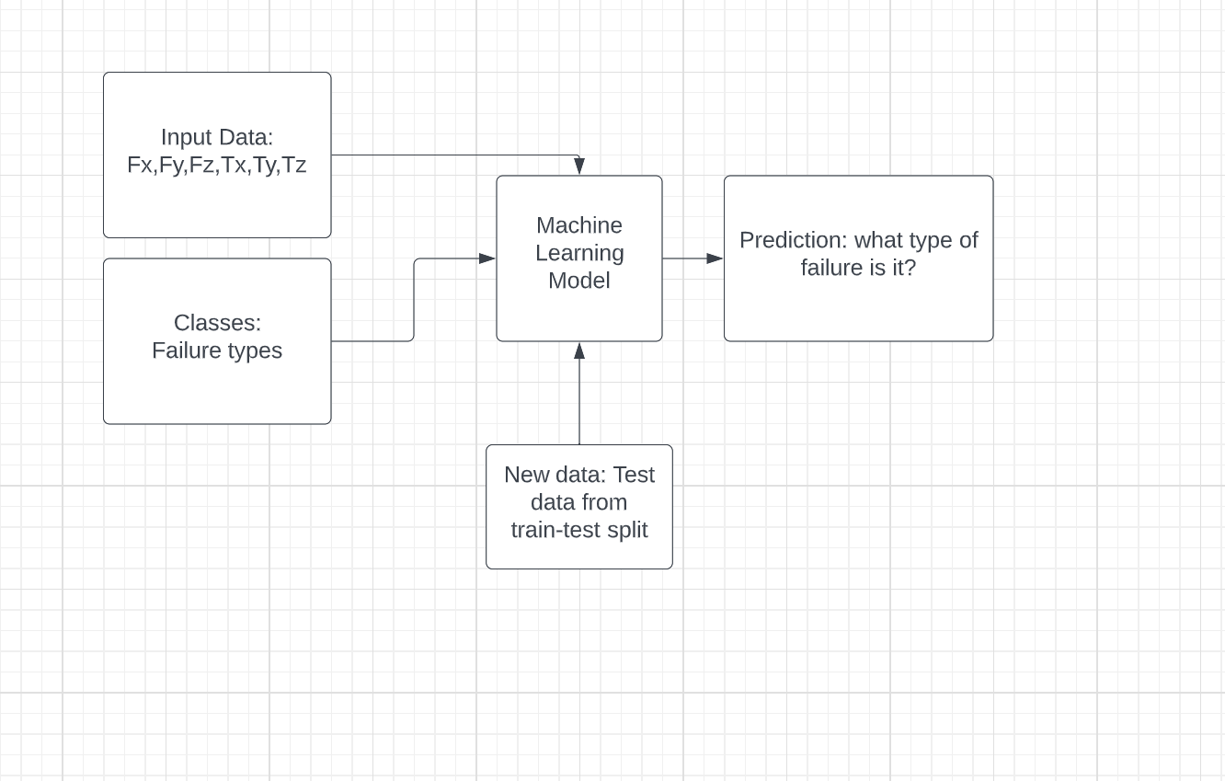

Figure 3: Supervised learning

1. Unsupervised learning

The unsupervised learning algorithm, the computer is trained with unlabelled data. The computer might be able to find new information after it learns patterns in data, these algorithms are useful in cases where we don’t know what to look for in the data. Unsupervised learning algorithms are mainly used in pattern detection and descriptive modelling. These algorithms try to use techniques on the input data to mine for rules, detect patterns and summarize and group the data points which help in extracting useful insights and describe the data better to the users. Models a set of inputs, like k-means clustering, association Rules etc.

1. Reinforcement Learning:

The reinforcement learning algorithms uses the information gathered from the interaction with the environment to take steps that would minimize the risk or maximize the reward. The algorithm will continuously learn from the environment in an iterative manner. In this process, the algorithm will learn from what it experienced from the environment until all the possible states are explored.

Simple reward-based feedback is required for the algorithm or known as an agent to learn which is known as reinforcement signal.

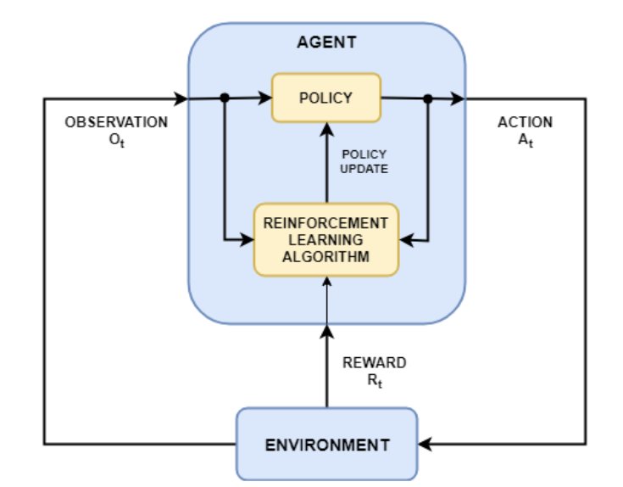

Figure 4: Reinforcement learning

The agent finds observations and a reward from the environment and sends actions to the environment. The reward will depend upon how successful an action is with respect to completing the task goal.

Reinforcement learning workflow:

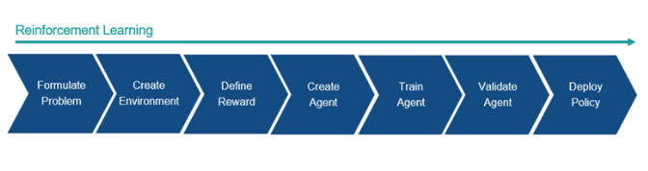

Figure 5: Reinforcement learning steps

1. Define the task for the agent to learn and how it should interact with the environment and any other goals the agent should try to achieve.
2. Define the environment in which the agent will be operating
3. Implement the reinforcement signal to measure its performance against the task goals.
4. Creating the agent and training it using the environment, reward and agent learning algorithm
5. Implement the trained agent.

The algorithm for different types of problems is shown in the figure below:

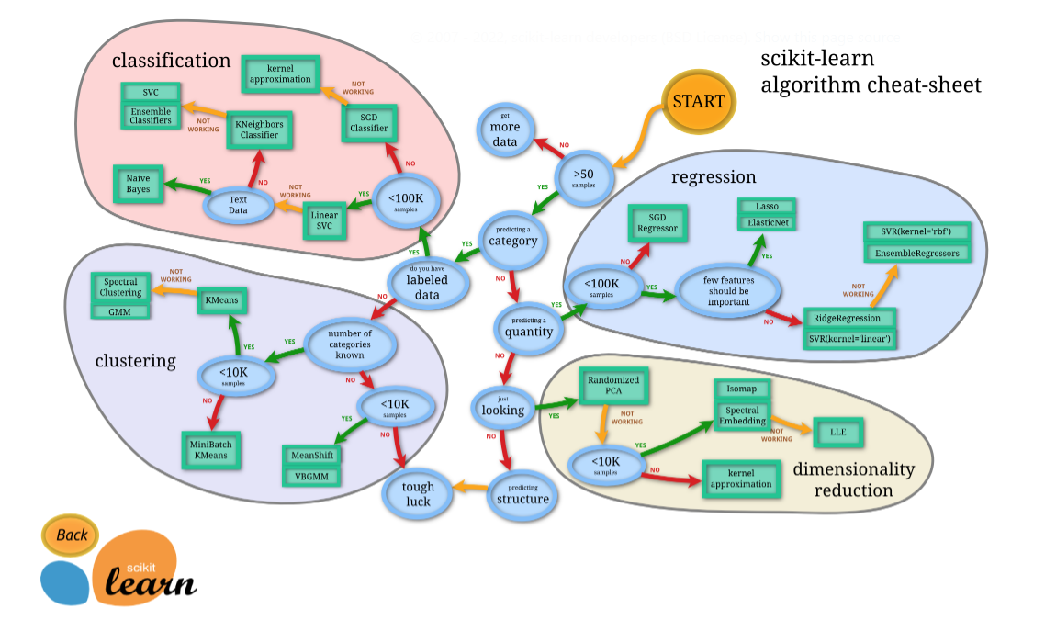

Figure 6: Algorithms for different problems

Secondly, if the data is underfitting and hence doesn’t perform (low accuracy), then the data must be trained for longer or an advanced model needs to be used. Finally, if the data is overfitting which happens when the model performs better on the training set than on the test set, various regularization techniques could be used. These are:

1. L(lasso) and L(ridge) regularization
2. Dropout
3. Early stopping
4. Data augmentation
5. Batch normalization

Hyperparameters tuning used to reduce training time and improves performance. The most important hyperparameter is setting of the learning rate. Generally, high learning rate leads to rapid adaptation of the algorithm to new data. Finding the optimal leaning rate by training the model from a low learning rate to a very large value. Using Adam optimizer (learning rate scheduling) will involve decreasing the learning rate slowly as model learns more. Other hyperparameters used to tune are:

1. Number of layers
2. Batch size
3. Number of trees (decision tree)
4. Number of iterations

### Analysis/Evaluation:

The evaluation metrics used in classification is accuracy, precision, recall, f1, confusion matrix, mean average precision. For regression mean squared error, mean absolute error or r-squared are used for analysis. The metrics used depends upon the time taken for the model to train and its feasibility.

### Deploy the model:

The model is put into the production since you want to know how it performs

### Retrain model

See how the model performs after serving based on the various evaluation metrics discussed and try to improve the model upon the findings.

## Scope and objectives

This report will evaluate five different models on each dataset and find the best 3 classification techniques on each dataset.

# 2 Methodology

The dataset we have been given is of classification type. The dataset includes five datasets. Failures in approach to grasp position (LP1), failures in transfer of a part (LP2), position of part after a transfer failure (LP3) and failures in approach to ungrasp position (LP4).

The average of the 15 force/torque collected from the datatypes. Then the data will be split so that 1/3 of the data will be for testing and the rest for training. Five different machine learning techniques will be used to investigate the datasets and the best three will be chosen depending on their accuracy score.

**Data preparation**

Firstly, the dataset from UCI was converted to excel:

<http://archive.ics.uci.edu/ml/datasets/Robot+Execution+Failures>

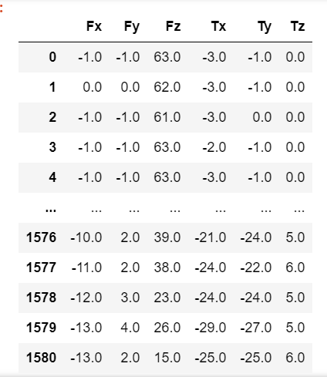Then each column was labelled (Fz, Fy, Fz, Tx, Ty and Tz). In the data preparation stage the averages of each 15 force/torque were calculated. This reduces the size of the data i.e., for LP1 the number of rows reduces from 1320 to 88 since the average of the forces and torques every 15 times will be used.

Figure 7:Dataset before averaging

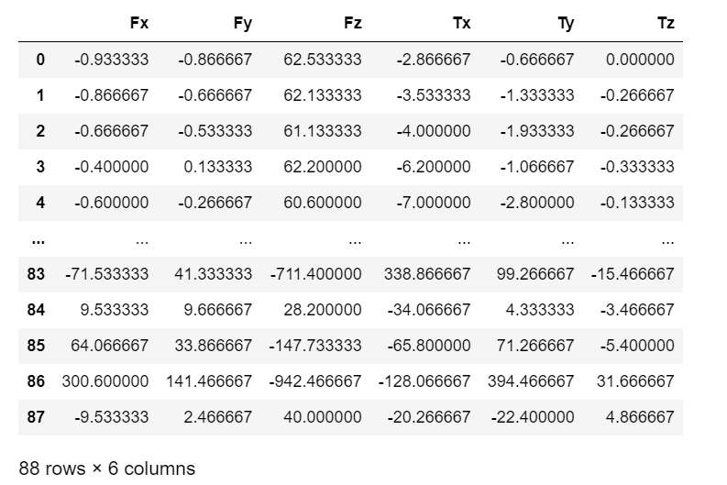

Figure 8: Dataset after averaging

## 2.1.1 Pre-processing

Many of the model’s prediction are made during the data pre-processing stage. Standardization of the datasets is a common requirement for many machine learning techniques. For this dataset we will be using label encoder which is a utility class to normalize the labels (Failure types) such that they only contain values between 0 and n classes - 1.

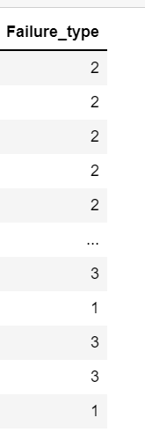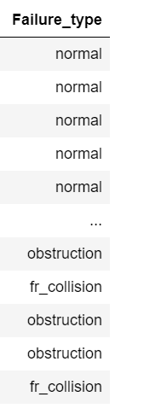

Figure 9: class after encoding

Figure 10: Class before encoding

Data splitting techniques

In supervised learning, a model is trained to predict the outcome of an unknown target. After the raining process, the final model should be able to predict the correct outputs (Failure types) from the input samples, but it should be generalised well to previously unseen data. Poor generalisation leads to overtraining and therefore model will not be able to give correct outputs. The technique to prevent this is cross validation where it will find a balance between minimal variance and minimal bias of the model performance. The problem of data splitting can be also handled as a statistical sampling problem, the most common method is known as simple random sampling (SRS). Other data splitting techniques are K-fold cross-validation which uses a combination of more tests to gain a stable estimate if the model error.

For our data sets we will be using Simple random sampling (SRS).

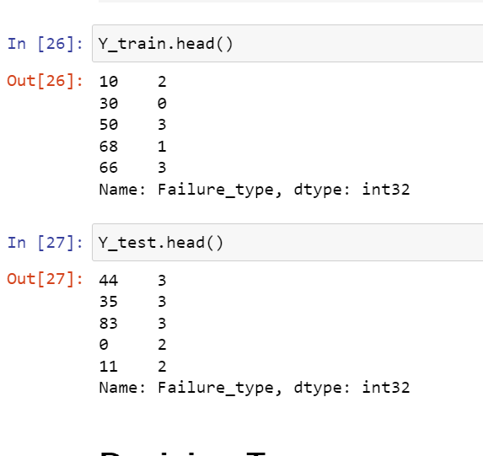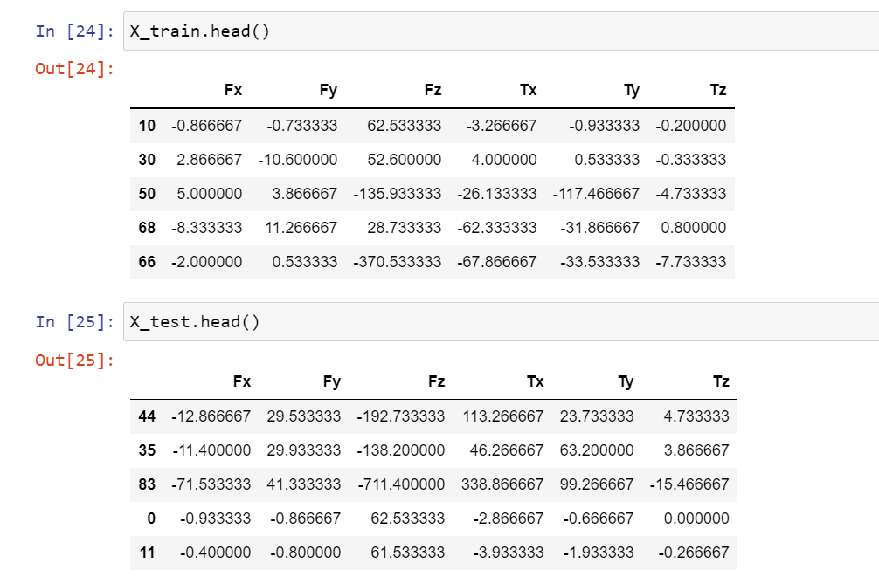

Figure 11: Train-test splitting

PCA

Principal Component Analysis is used to reduce the dimensionality of a data set while ensuring the variation present in the dataset. It projects the entire dataset onto principal components. For the five datasets, PCA will be used to extract the most contributing principal components i.e., PC1, PC2, PC3 which contributes to more than 95% of the data set.

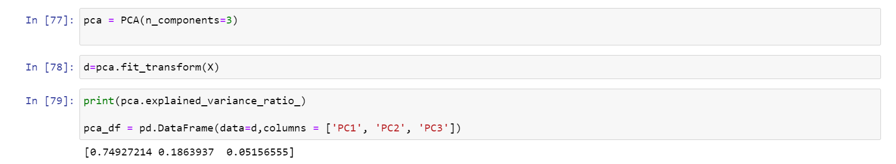

Figure 12: PCA

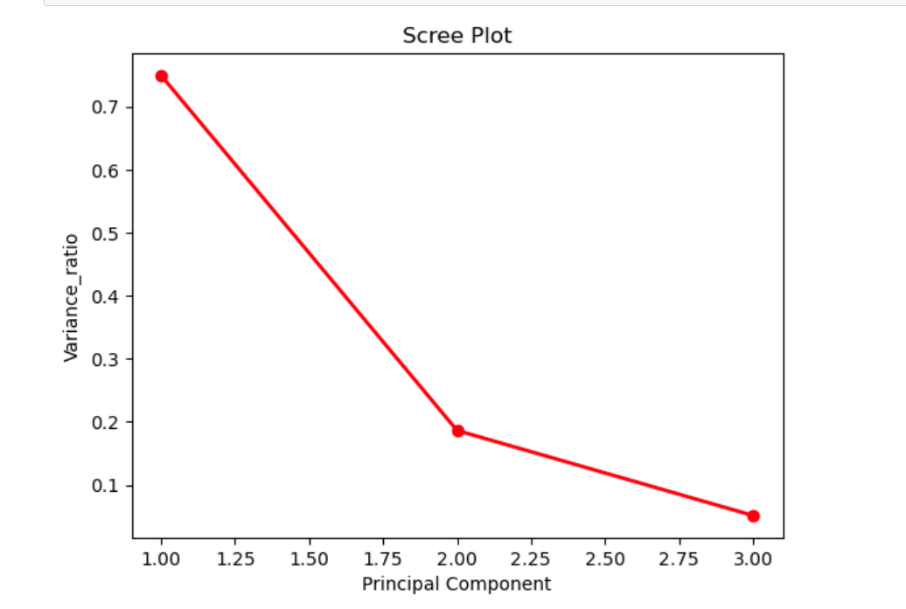

Figure 13: PCA scree plot

PCA finds the directions of maximum variance in hight-dimensional data and the scree plot helps us to visualise how much does each principal component contributes.

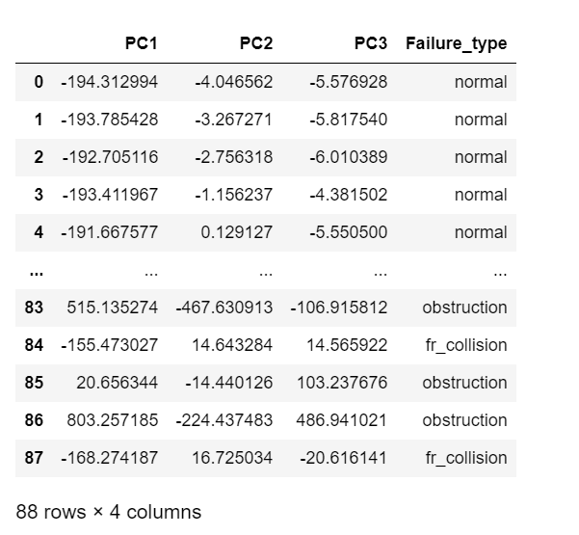

Figure 14: PCA dataset

**Evaluation Parameters**

The metrics used to evaluate the performance of each of the algorithm are accuracy, precision, recall and F measure from the classification report.

$$Accuracy= \frac{TP+TN}{TP+TN+FP+FN}$$

Equation 1: Accuracy

$$Precision= \frac{Tp}{TP+FP}$$

Equation 2: Precision

$$Recall= \frac{TP}{TP+FP}$$

Equation 3: Recall

$$F measure= \frac{2*(Precision*Recall)}{Precision*Recall}$$

Equation 4: F-measure

Where True Positive (TP), True Negative (TN), False Positive (FP), False Negative (FN)

# 2.2 Algorithm

The dataset is of a multiclass classification type since all of them have 2 or more classes. Therefore, the algorithms we will be using are: Decision tree, K-nearest neighbour, random forest, SVM (support vector machines) and ANN (Artificial neural network).(Ul Hassan et al., 2018)

1. **Decision tree**

Decision tree is a popular supervised learning method used for classification and regression. The goal of a decision tree is to be able to predict the value of target variables (in our case the failure types) by learning decision rules inferred from the data features (forces and torques in x, y and z directions).

1. **Naive Bayes**

Naive bayes classifier assumes that a specific feature is not related to the existence of any other features in the class (failure types). The gaussian naive bayes will be implemented for this problem. In this technique it is assumed that each class follow a Gaussian distribution.

1. **K-Nearest Neighbours (KNN)**

KNN classifier uses the existing cases and categorises new cases by the majority votes of its neighbours using the distance functions.

1. **Support Vectors Machines (SVM)**

All the data is plotted in dimensional space where the number if dimensions is equivalent to the number of classes (failure type). Then a line is drawn known as support vector classifier which will then be used to predict which class does the new dataset belongs to.

1. **Random Forests (RF)**

Makes use of multiple decision trees for training sets and uses them to predict a mode of classes of the distinct tree. Every tree is a contributor to classify new case based on its attributes.

1. **Artificial Neural Network (ANN)**

Neural networks consist of nodes that performs parallel computations for data processing and knowledge representation. The nodes can exchange information between each other and pass on information through weighted connections. By changing the weights between the neurons in other layers, the ANN can derive hidden rules between the data.(Diryag et al., 2014)

## 2.3 Mathematical representation

**1.Decision tree**: In classification trees the split is quantified by an impurity measure. The impurity can be measured as a function of entropy which is the amount of data to accurately describe the same dataset:

$$entropy= -\sum_{i=1}^{n}{P_{i}}*log⁡(p_{i})$$

Equation 5: Entropy

Another impurity measure is Gini index which is measure of inequality in sample.

$$Gini Index= 1-\sum_{i=1}^{n}{{P_{i}}^{2}}$$

Equation 6: Gini Index

Where Pi id the probability of an element being classified for a distinct class.

**2.Naive Bayes**: Gaussian Naive Bayes assumes that the class-conditional densities are normally distributed.

$$P\left(x \right|t=c, μ_{c},Σ_{c})=N\left(x \right| μ_{c},Σ_{c} )$$

Equation 7: class posterior

Where training data of input (N) classes (x) with target classes (t). $μ_{c}$ is the class-specific mean vector and $Σ_{c}$ is the class specific covariance matrix. Using Bayes theorem, we calculate the class posterior

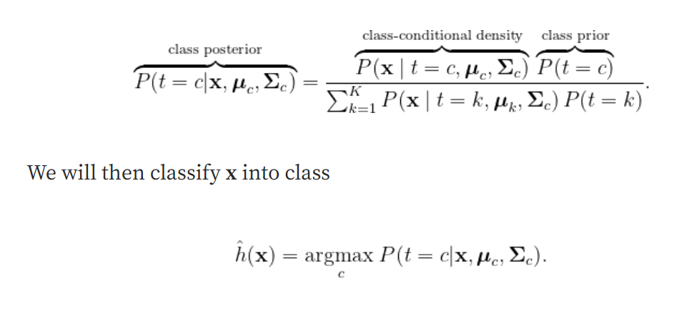

Equation 8: Naive Bayes

**3.KNN** uses the query instance $x_{q}$ to locate the nearest training example $x_{n}$, then estimate 🡨 f($x_{n}$). Take mean of values of KNN.

🡨

Equation 9: KNN

**4.SVC (support vector classification)** is used for multiclass classification problems. The output of a decision function which in classifier predicts the score for each sample in relation to each class becomes:

$$\sum_{i∈SV}{y_{i}}∝_{i}K\left(x_{i},x\right)+b$$

Equation 10: Decision function

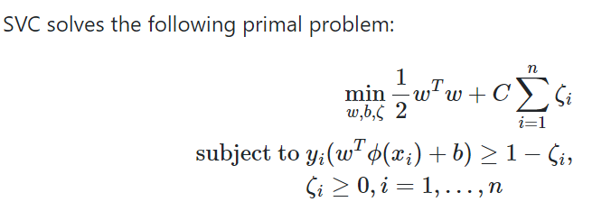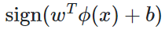Where xi is the training vectors and a vector yi. The goal is to find q and b such that the prediction given by

Equation 11: SVC

**5.Neural networks**

A weight is a connection between nodes that carries a value. Bias is the non-observable factors and activation where the neuron makes decision on output z (everything coming into neuron) and returns another output. If f(z)=z, we say the f(z) is a linear activation:

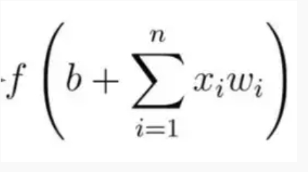

Equation 12: Neural network

Where b: bias

X: input of neurons

W: weights

N: the number of inputs from the incoming layer

I = a counter from 1 to n

# Results and discussions

All the classification technique discussed will be used on each of the dataset to find out which of the technique provides the most accuracy for the datasets.

## LP1

LP1: Failures in approach to grasp position. The first step was to understand the dataset. 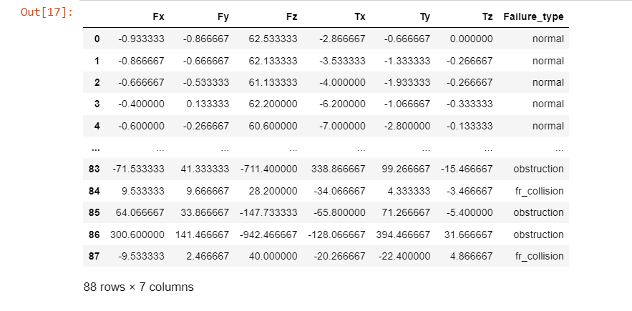

Figure 15: LP1 dataset

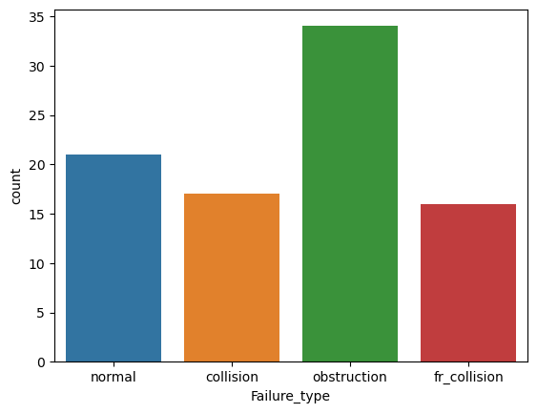

Figure 16: LP1 class count

The count plot shows that obstruction failure type has the most number of data. This can possibly lead to bias. After label encoding the classes will be represented as shown below:

1. Fr_collision
2. Normal
3. Obstruction
4. Collision
5. **Decision tree**:

The time taken, precision, recall, f1 -score and accuracy of the decision tree is shown below:

The time taken to compute the decision tree was 65.5 ms. Also the parameters used are also shown below:

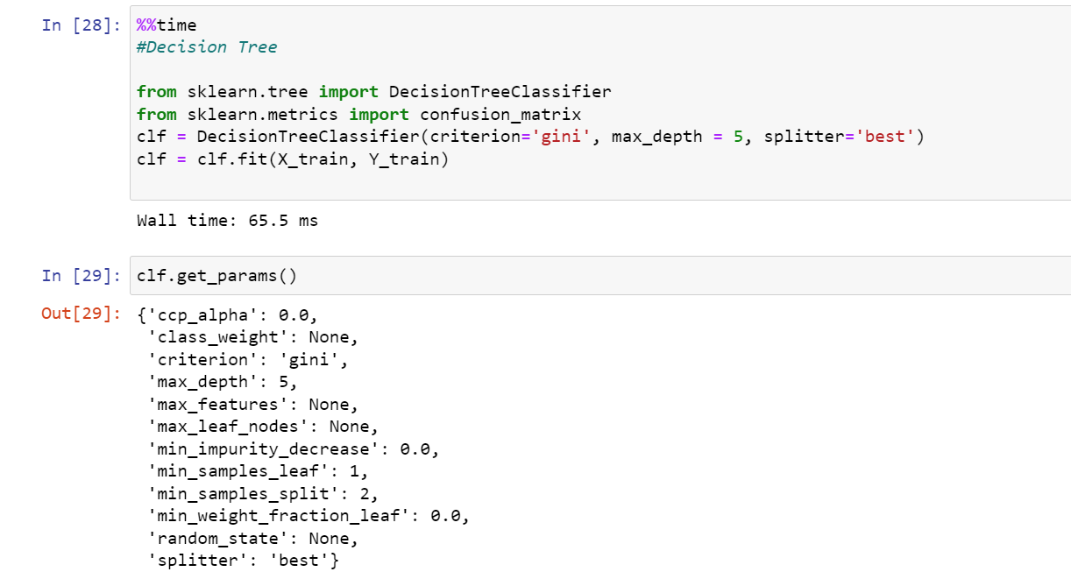

Figure 17: LP1 Decision tree computation time

The accuracy of decision tree is:

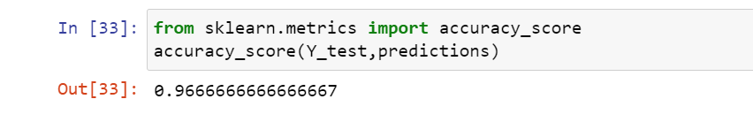

Figure 18: LP1 Decision Tree Accuracy

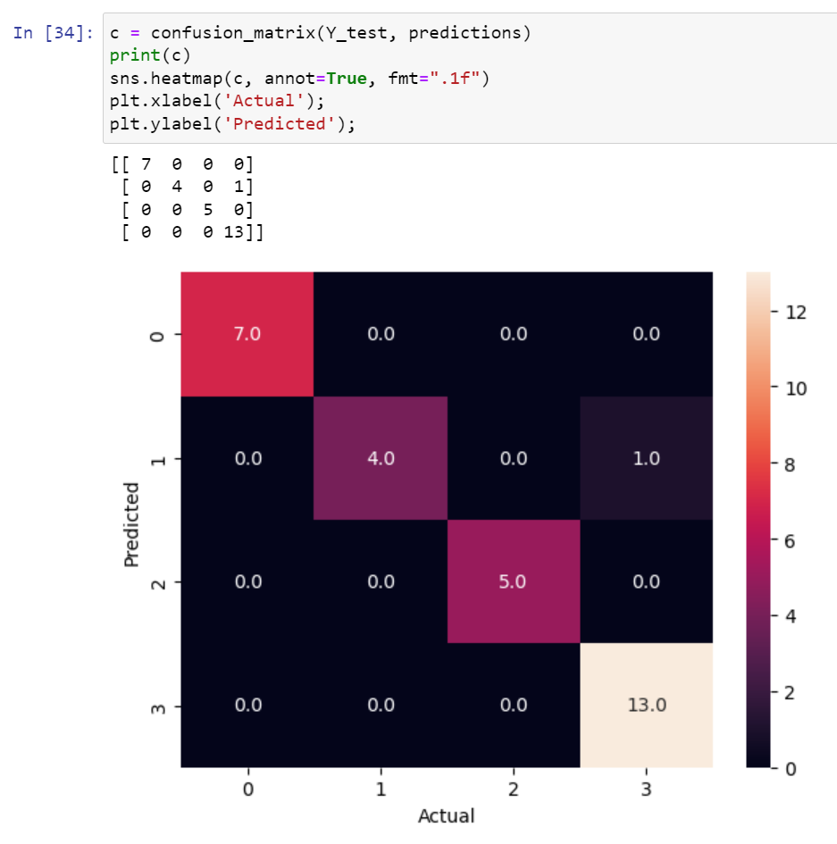

Figure 19: LP1 Decision Tree Confusion Matrix

From the confusion matrix Fr_collision is 100% accurate and same goes for normal and obstruction whereas the decision tree incorrectly predicted collision class as normal. The classification report for the decision tree is presented below with all the evaluation metrics.

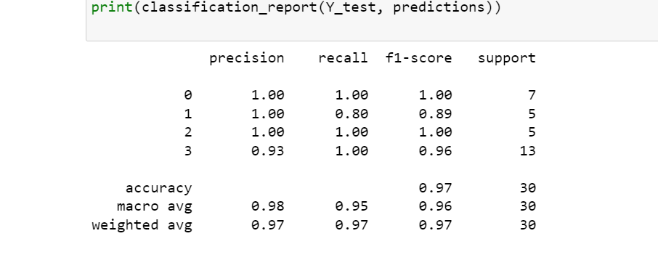

Figure 20: LP1 Decision Tree Classification Report

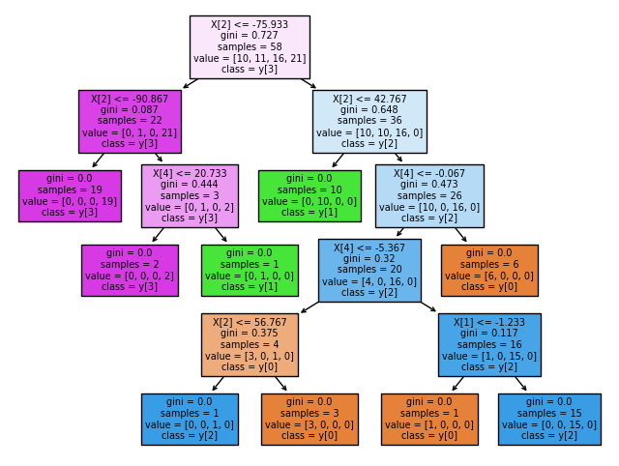

Figure 21: LP1 Decision Tree Diagram

**With PCA**

The accuracy of the decision tree increases when PCA is used as shown below:

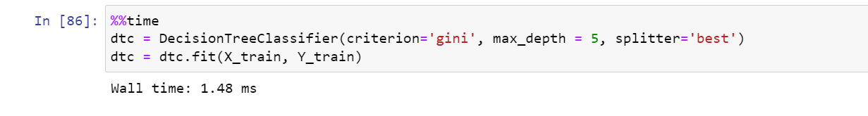

Figure 22: LP1 DT with PCA computation time

It can also be seen that the time taken also decreases from 65.5 ms to 1.45 ms. This does reduce the accuracy score of the decision tree.

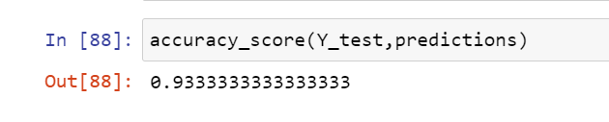

Figure 23: LP1 DT with PCA Accuracy

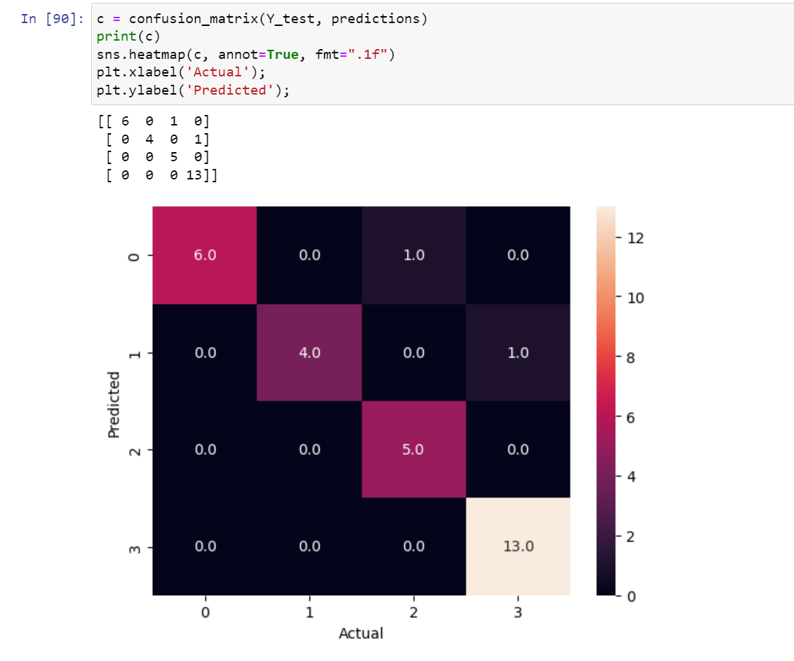

Figure 24: LP1 DT with PCA Confusion Matrix

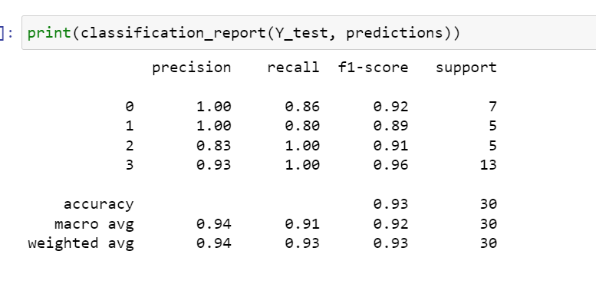

Figure 25: LP1 DT with PCA Classification Report

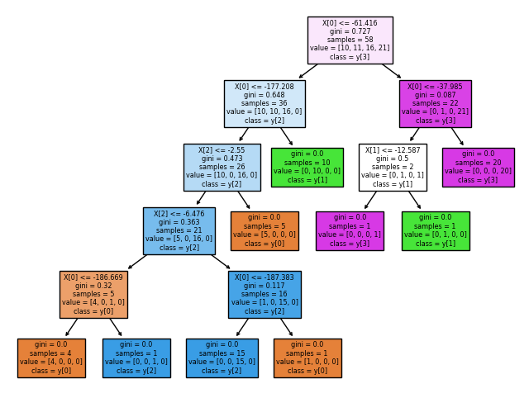

Figure 26: LP1 DT with PCA diagram

1. **SVM**

Support vector classification will be used to train the model where the polynomial kernel will be used to map the original dataset into a higher dimensional space to make it linear dataset. This kernel is being used to reduce the time even though it might be giving less accuracy score unlike rbf or gaussian kernels.

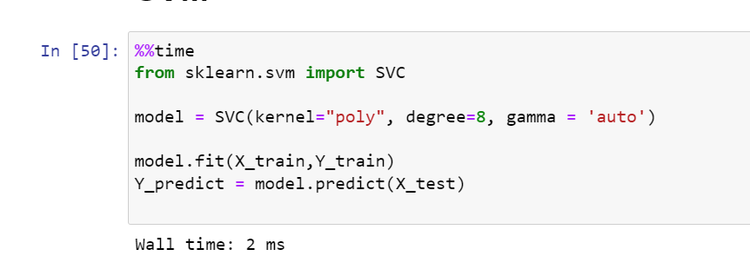

Figure 27: LP1 SVM Computation Time

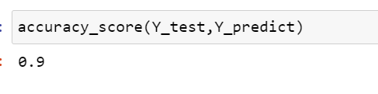

Figure 28: LP1 SVM accuracy

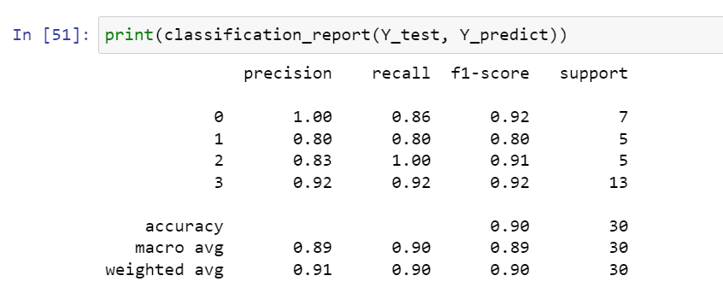

Figure 29: LP1 SVM Classification report

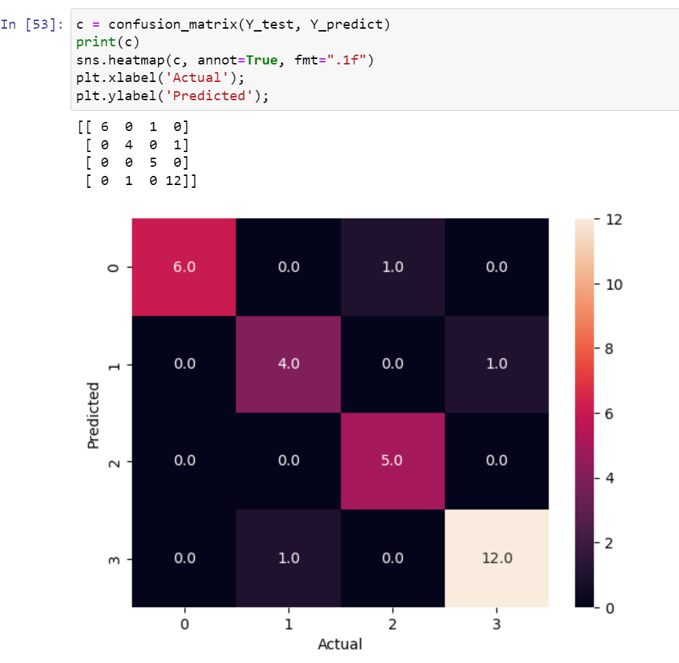

Figure 30: LP1 SVM confusion matrix

The confusion matrix shows that apart from class 0, the rest of classes (failure types) were predicted wrong at least once.

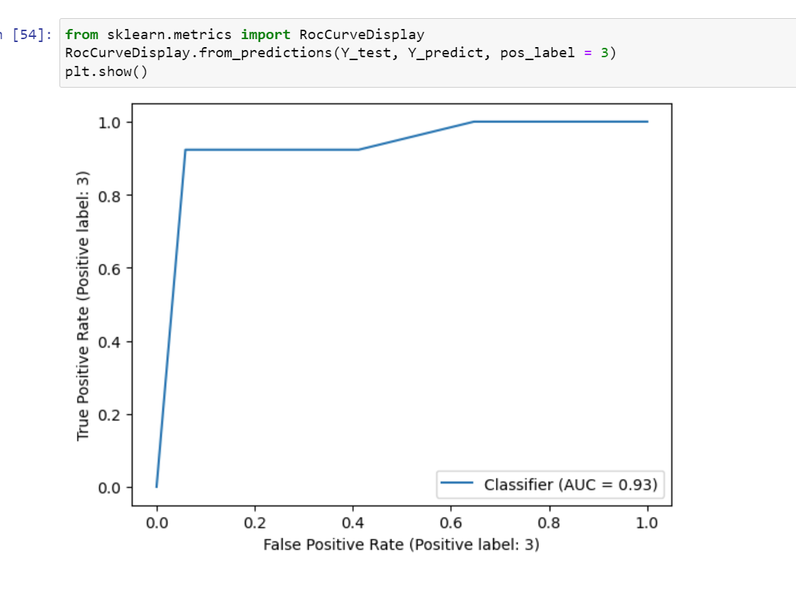

Figure 31: LP1 SVM ROC Curve

The above graph is a ROC curve.it shows the trade-off between true positive rate and false positive rate.

**With PCA:**

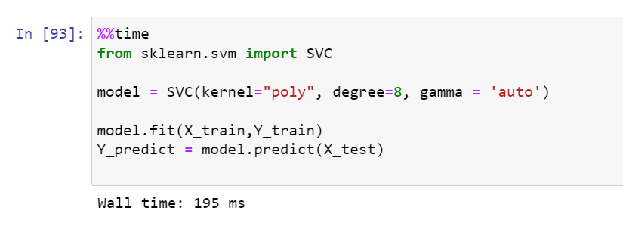

Figure 32: LP1 SVM with PCA Computation time

The time taken for the classification technique to compute is longer when using PCA. The accuracy score also declines from 90% to 63.3%.

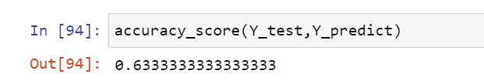

Figure 33: LP1 SVM with PCA accuracy

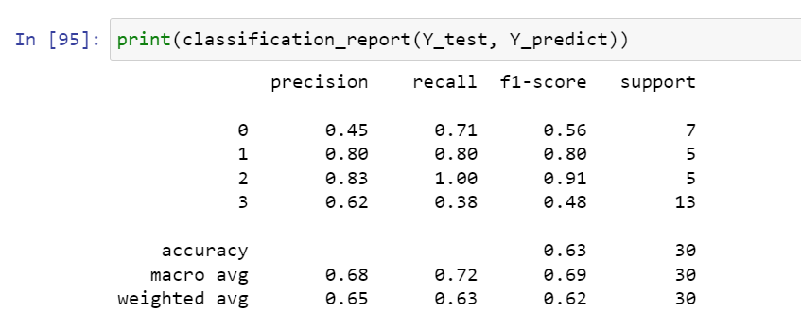

Figure 34: LP1 SVM with PCA classification report

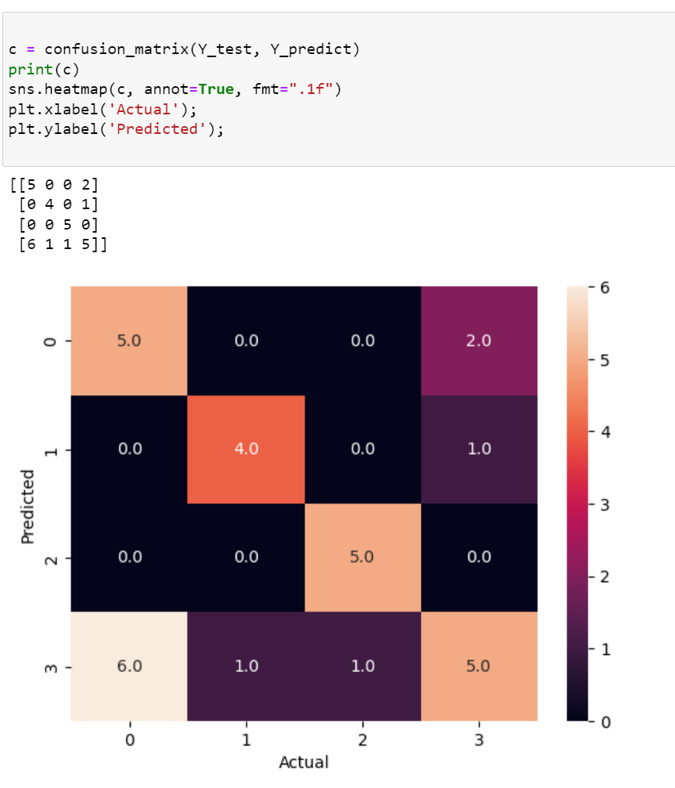

Figure 35: LP1 SVM with PCA Confusion Matrix

The confusion matrix shows that the model with PCA has more errors while predicting compares to SVM without PCA.

1. **Naïve Bayes:**

The Gaussian Naïve Bayes classifier used to fit the data tool 2.07 ms to complete and had an accuracy score of 90%.

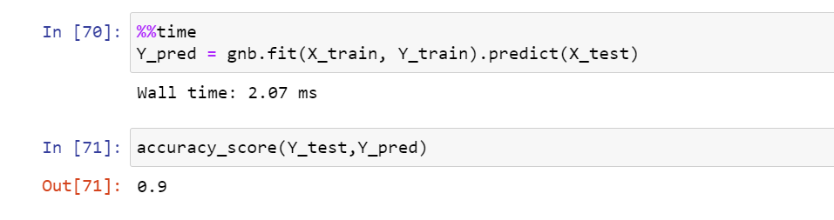

Figure 36: LP1 NB computation time and accuracy

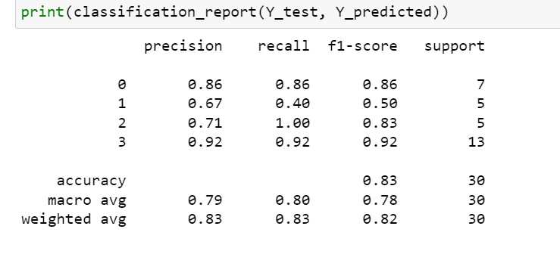

Figure 37: LP1 NB classification report

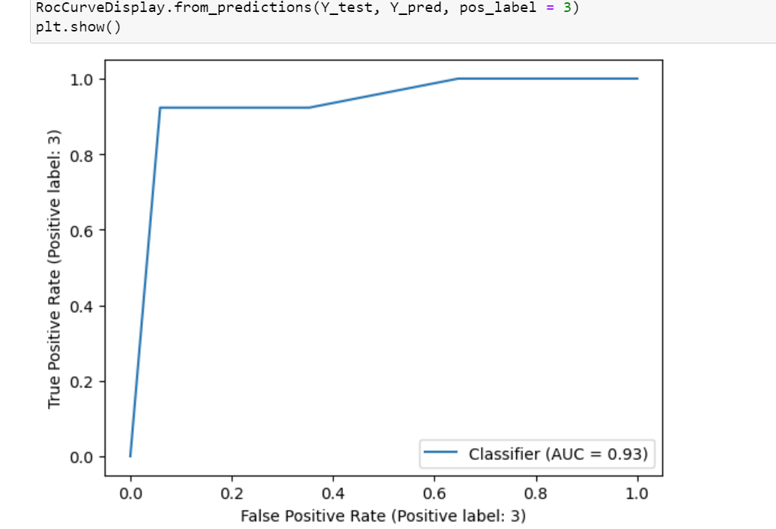

Figure 38: LP1 NB ROC curve

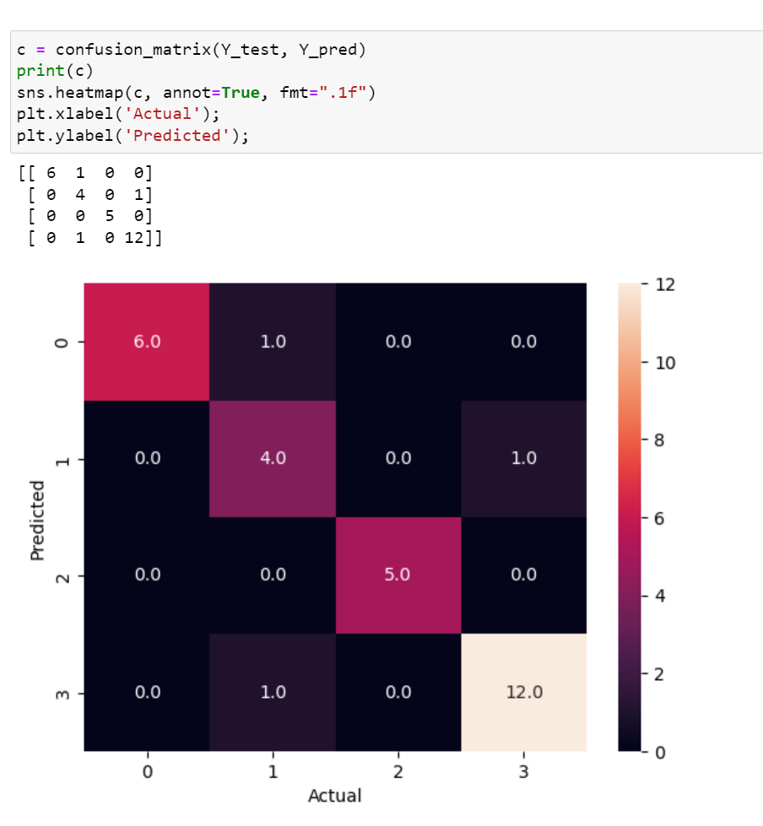

Figure 39: LP1 NB Confusion matrix

The Naïve Bayes predicts with 100% accuracy for classes 0 and 2 whereas the prediction for class 1 seems to be the worst. This is also the reason why the accuracy score is below 90%

**With PCA**

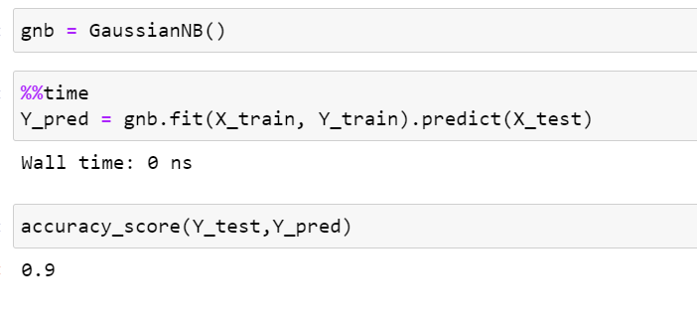

Figure 40: LP1 NB with PCA

With PCA the accuracy score of the classifier increases to 90% which is the desired score.

1. **KNN:**

The weights used for KNN is ‘distance’ which wright points by the inverse of their distance. Therefore the closer neighbours will have greater influence on the accuracy.

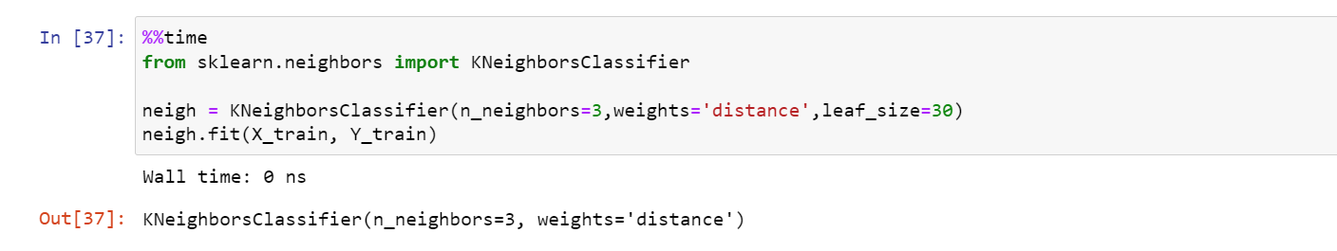

Figure 41:LP1 KNN computation time

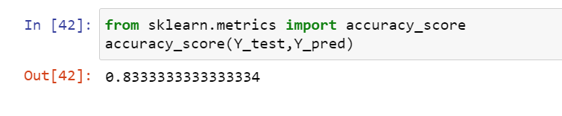

Figure 42: LP1 KNN accuracy

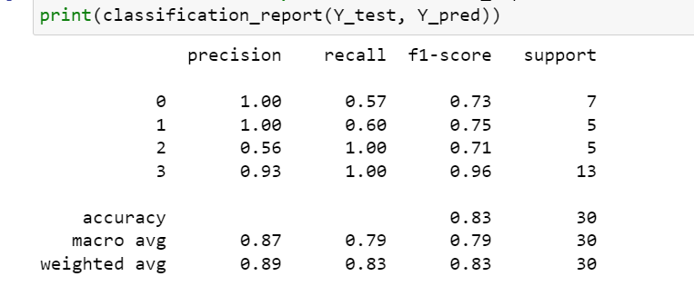

Figure 43: LP1 KNN classification report

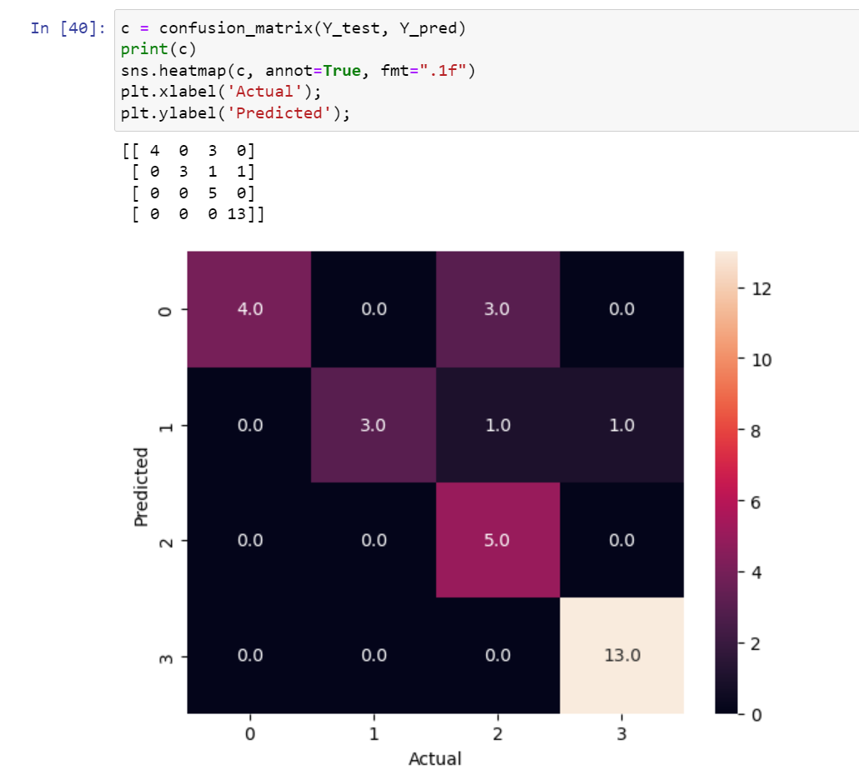

Figure 44: LP1 KNN confusion matrix

The confusion matrix tells us that KNN classifier performed poorly when predicting class 2 which is obstruction.

**With PCA:**

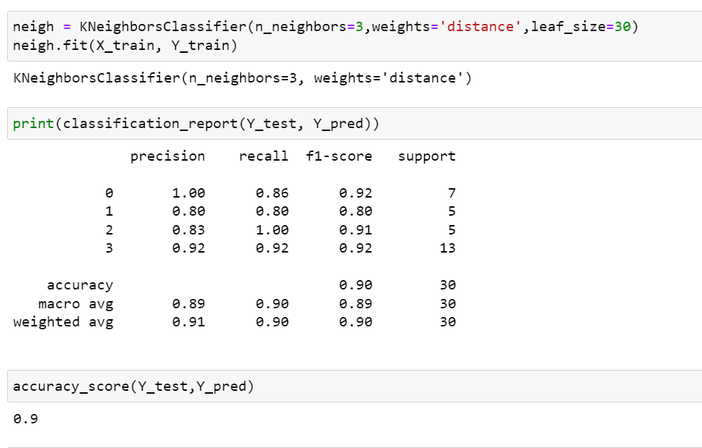

Figure 45: LP1 KNN with PCA

The accuracy improves with PCA.

1. **MLP classifier**

A Multi-layer perception classifier was also used on the dataset and it has an accuracy score of 83%. Only two layers which has 30 and 60 nodes. The time taken for the technique to complete was 73.2 ms.

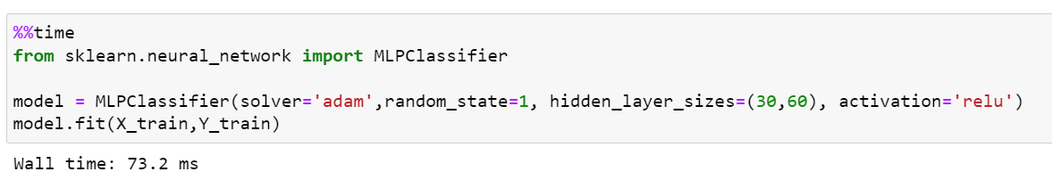

Figure 46:LP1 MLP computation time

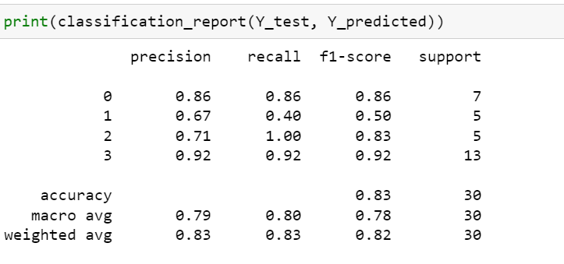

Figure 47: LP1 MLP classification report

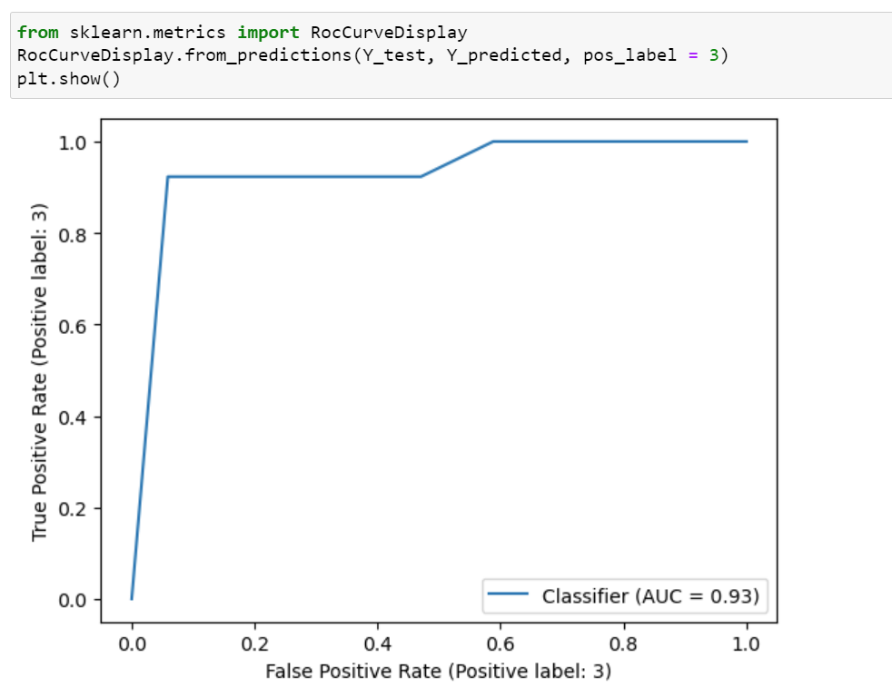

Figure 48: LP1 MLP accuracy

1. **Random Forest**

The number of trees in the forest used is 500 and the time taken for the model Is 289 ms.

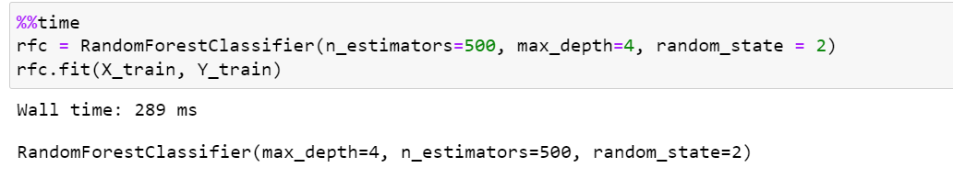

Figure 49: LP1 RF computation time

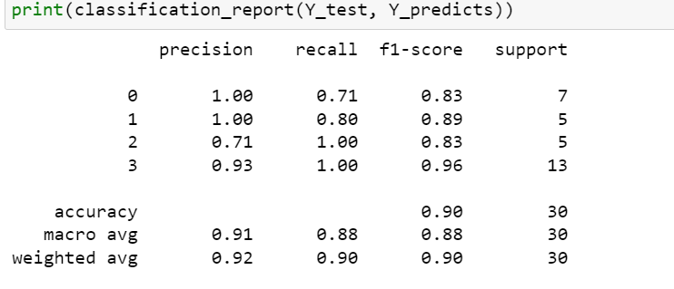

Figure 50: LP1 RF classification report

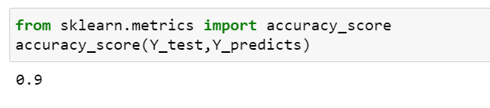

Figure 51: LP1 RF accuracy

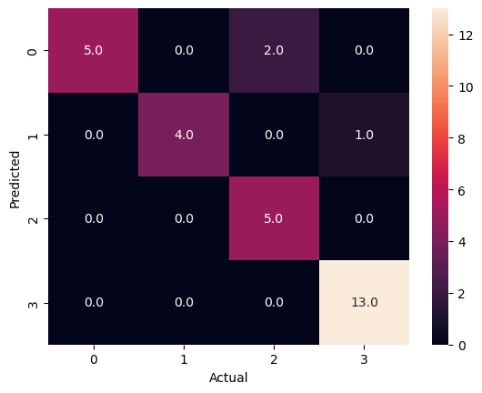

Figure 52: LP1 RF confusion matrix

The random forest is relatively good at predicting for all classes except 2.

**With PCA**

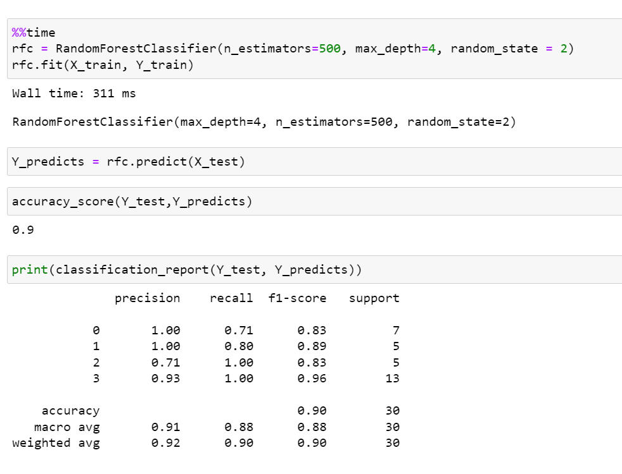

Figure 53: LP1 RF with PCA

The time taken to compute random forest when using PCA increases but the accuracy stays the same.

1. **ANN**

The model of the neural network has four layers. First layer has 60 neurons and uses ReLU as activation function which returns 0 if the input is negative, this is also the input layer. Second layer which has 30 nodes, and third layer uses sigmoid for its activation function. For the output layer SoftMax (normalized exponential function) use as the activation function.

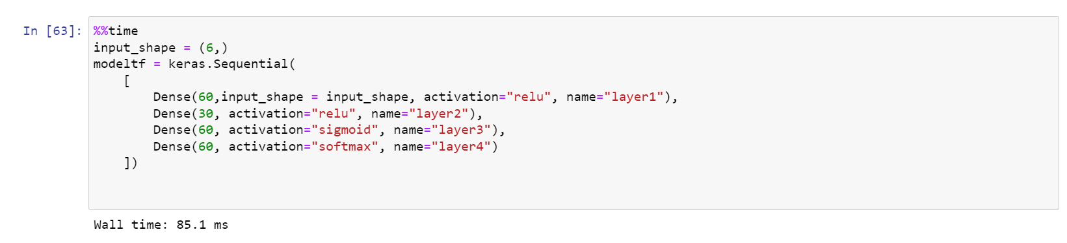

Figure 54: LP1 ANN computation time

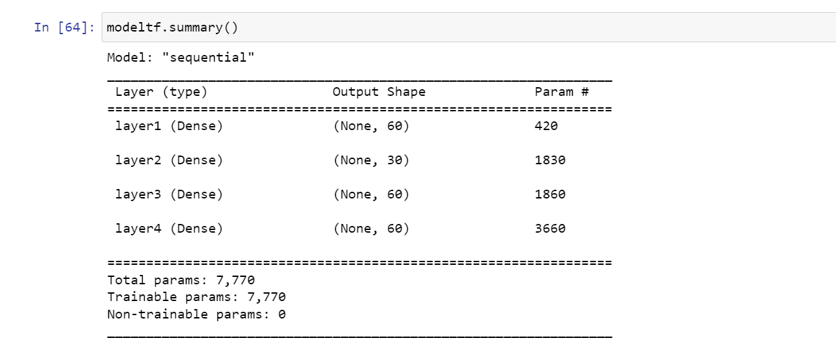

Figure 55: LP1 ANN model summary



Figure 56: LP1 ANN model compile

Sparse categorical crossentropy is used to compute the crossentropy loss between the failure types and predictions.

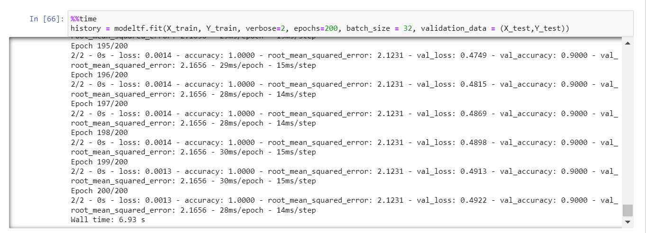

Figure 57: LP1 ANN steps

The neural network is trained with all the training data 200 times where the batch size will be 32. The validation accuracy of the neural network is 90% but the data is overfitted as shown in the graphs below.

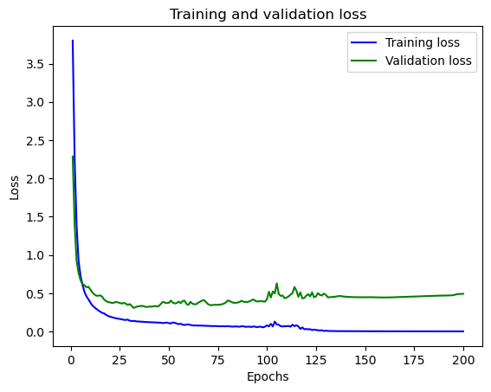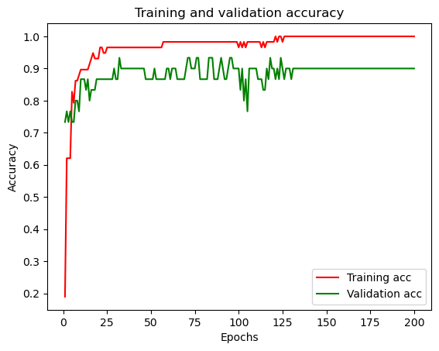

Figure 58: LP1 ANN train and validation loss

Figure 59: LP1 ANN train and validation accuracy

The training and validation accuracy graph shows that the data is overfitted since the dataset is small.

**With PCA**

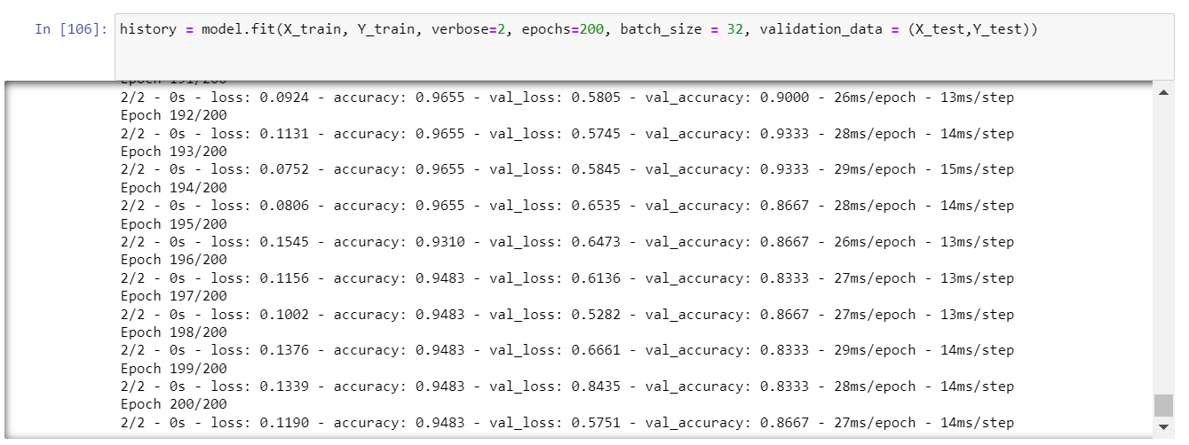

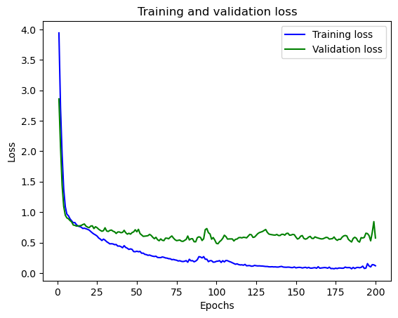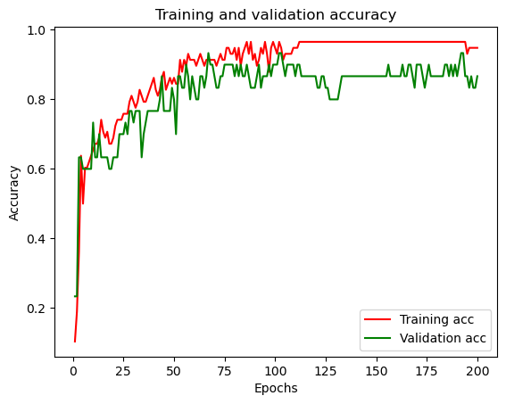Figure 62: LP1 ANN with PCA

Figure 60: LP1 with PCA train & valid accuracy

Figure 61:LP1 ANN with PCA train & valid loss

The accuracy of the NN reduces when PCA is used.

## LP2

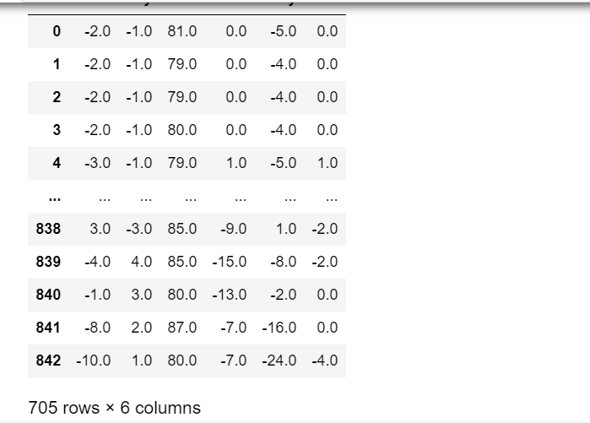The average of the datasets within LP2 will be used for all classifiers

Figure 63: LP2 Dataset

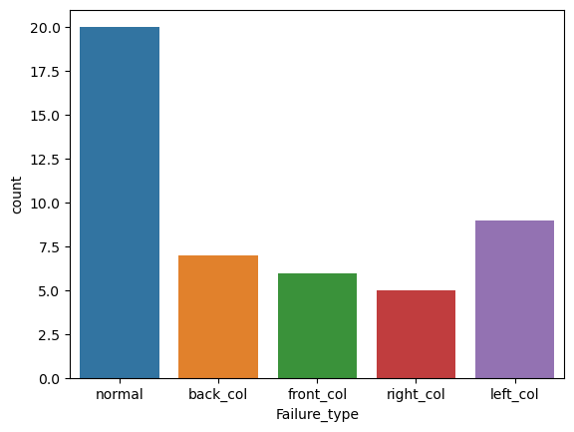The data is biased towards normal failure type. This will affect the classification techniques since the data split will be biased.

Figure 64: LP2 Class count

**Label Encoder**

1. Back_col
2. Front_col
3. Left_col
4. Normal
5. Right_col
6. **Decision tree**

The hyperparameters for the decision tree will be same as that of LP1.

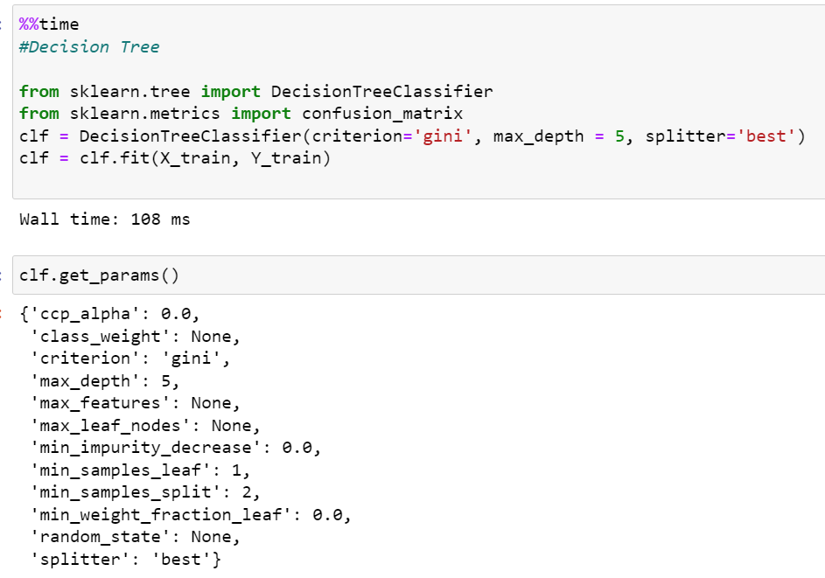

Figure 65: LP2 DT time computation

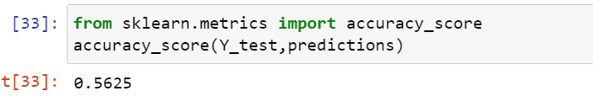

Figure 66: LP2 DT accuracy

The classification method could not find any precision, recall or f1-score for Back_col and Front_col. This is because the dataset is too small. Since there is only 46 values and 33% of them will be for testing, it will be very hard for the decision tree to get high accuracy. One way to fix is by increasing the number of data or duplicate it. There is also K-folding that could be used instead of train-test split.

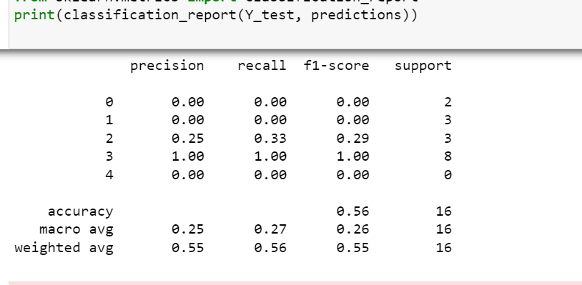

Figure 67: LP2 DT classification report

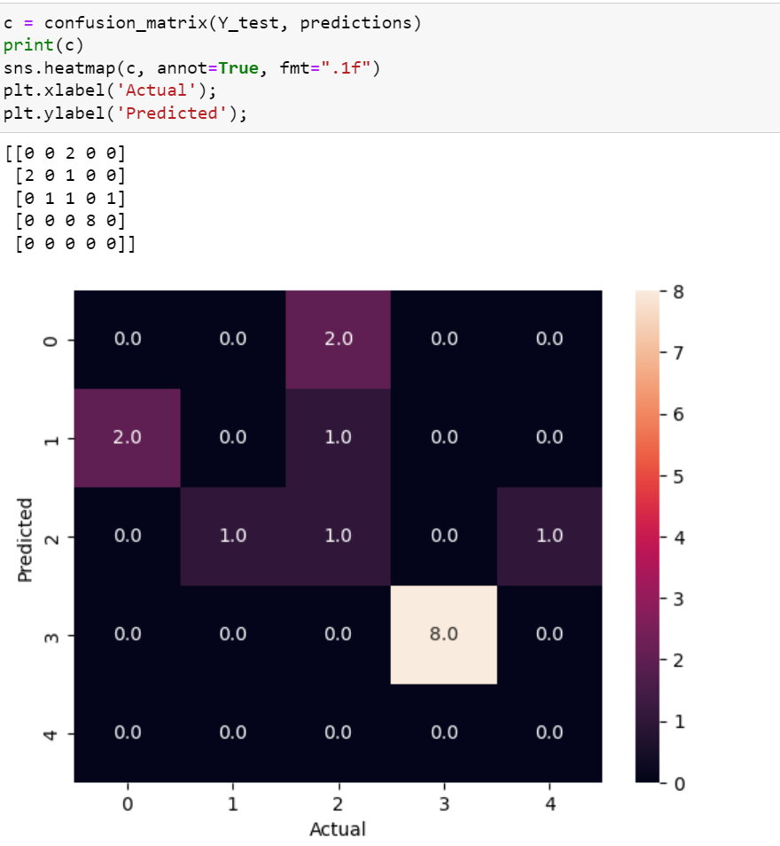

Figure 68: LP2 DT confusion matrix

The confusion matrix can be used to understand why the precision is low. The classifier is taking only 1 value of right_col and front_col whereas the dataset is having 8 normal failure types. Therefore, the accuracy is also 56% since 8 of the training data comes from normal class out of 16 according to the classification report.

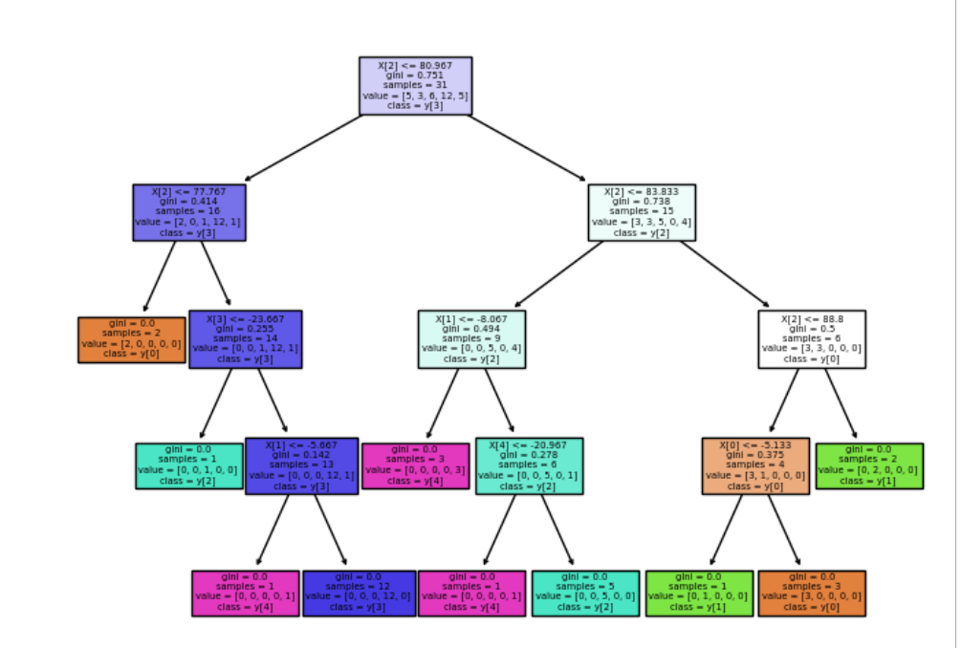

Figure 69: LP2 DT diagram

**With PCA**

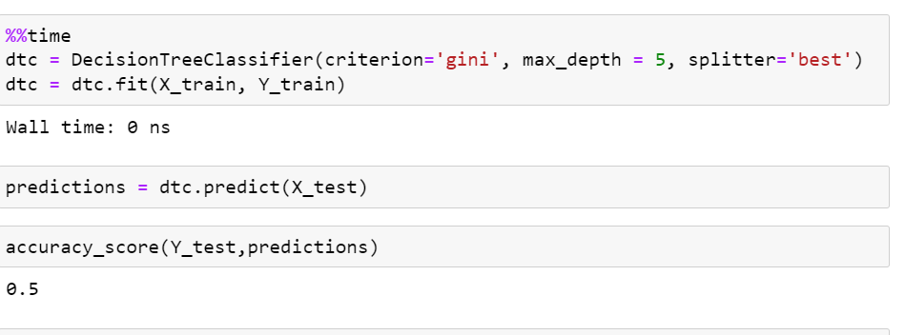With PCA the accuracy of the decision tree reduces.

Figure 70: LP2 DT with PCA

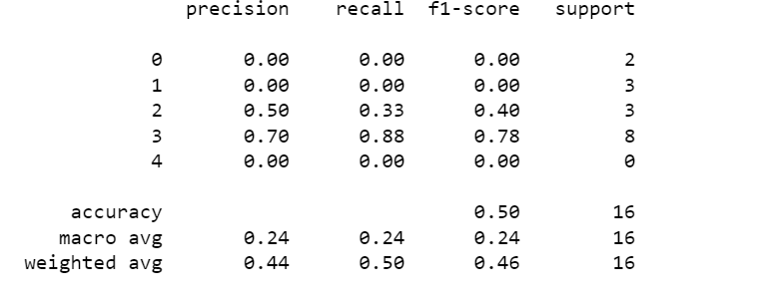

Figure 71: LP2 DT with PCA classification report

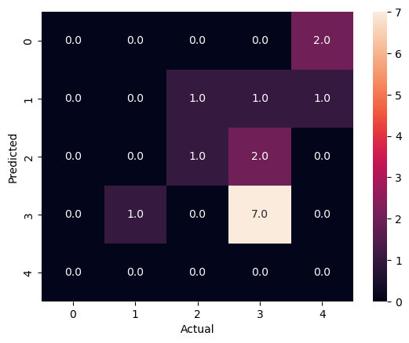

Figure 72: LP2 DT with PCA confusion matrix

The confusion matrix shows that this method makes more mistake when PCA is used to predict the normal class, hence the accuracy lowered to 50%.

1. **SVM**

SVM also faces the same problem as the decision tree, the dataset is too small to get accurate results. Therefore, its only 56.25% and the confusion matrix can be used to understand that 13 out of 16 values are from normal.

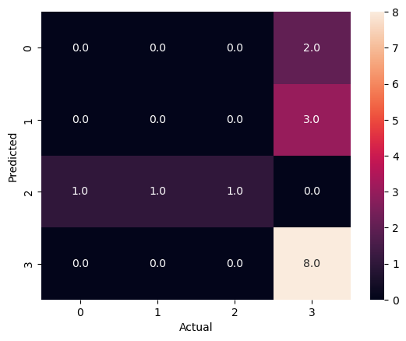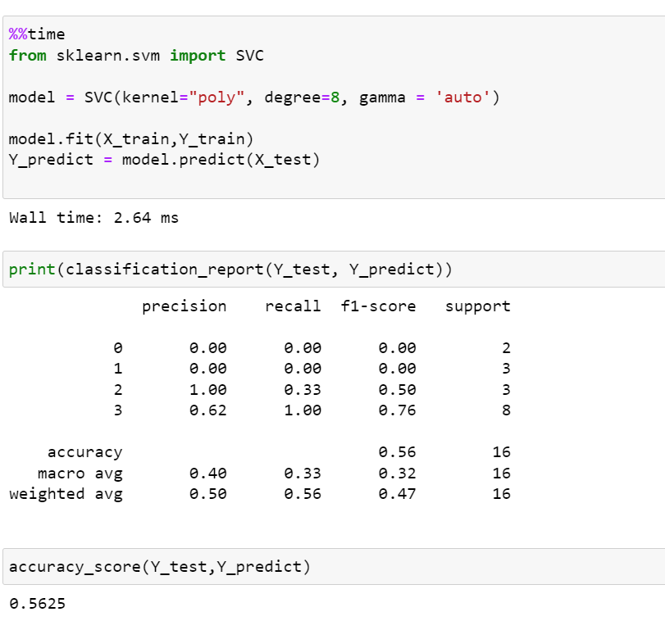

Figure 73:LP2 SVM confusion matrix

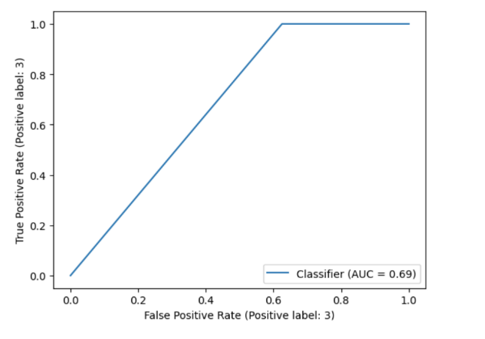Figure 75:LP2 SVM classification report & time

Figure 74: LP2 SVM ROC curve

**With PCA**

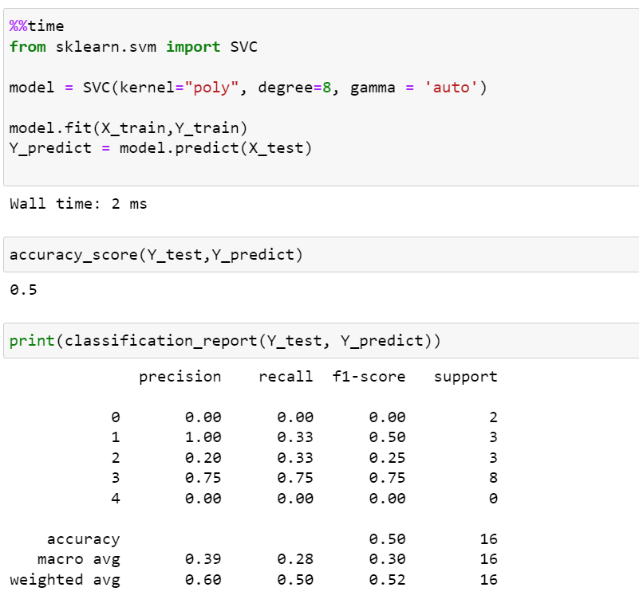

Figure 76: LP2 SVM with PCA

There was no change when PCA was used other than the accuracy decreasing while the time taken increases.

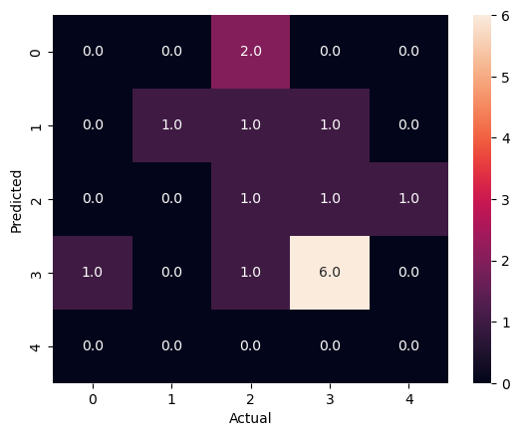

Figure 77: LP2 SVM with PCA confusion matrix

1. **Naïve Bayes**

Gaussian naïve bayes performed considerably well and gave an accuracy score of 62.5% which is better than rest of the methods since it doesn’t require much training data.

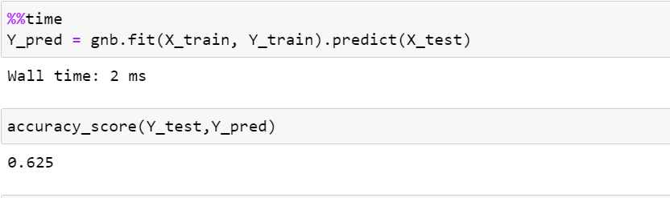

Figure 78: LP2 NB time and accuracy

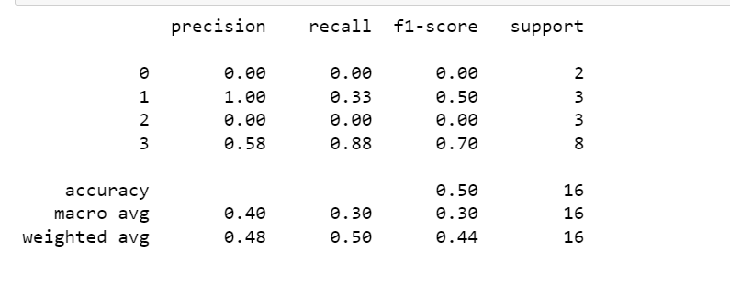

Figure 79: LP2 NB classification report

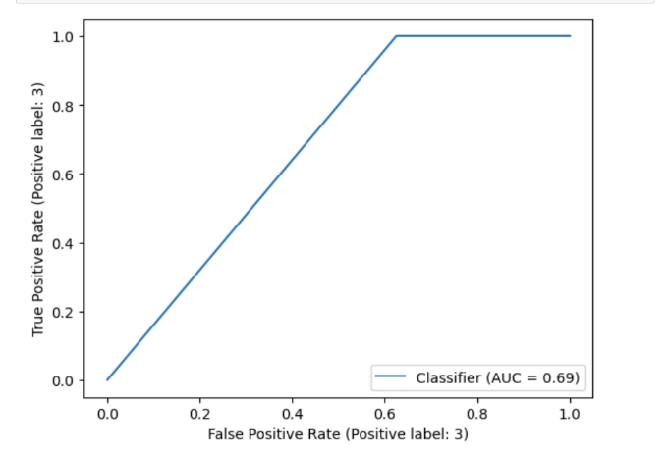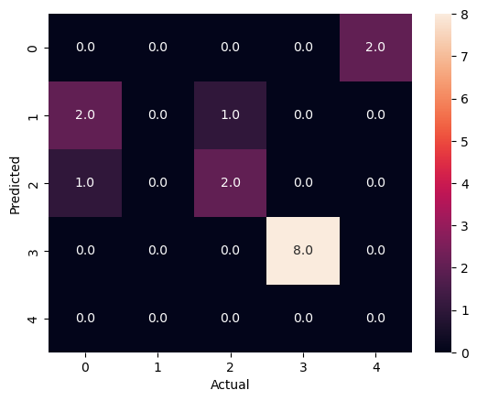

Figure 80: LP2 NB ROC curve

Figure 81: LP2 NB confusion matrix

**With PCA**

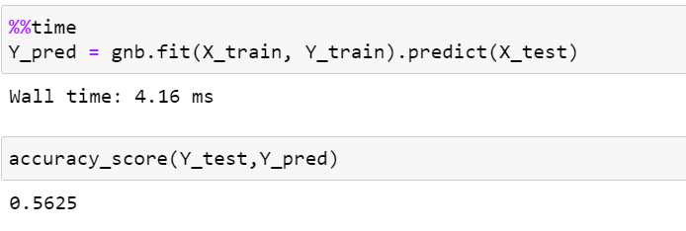

Figure 82: LP2 NB with PCA time and accuracy

With PCA the accuracy and time taken to compute increases.

1. **KNN**

The accuracy of KNN classifier depends on the quality of the data. Since the dataset is small and biased the accuracy becomes 56.25%.

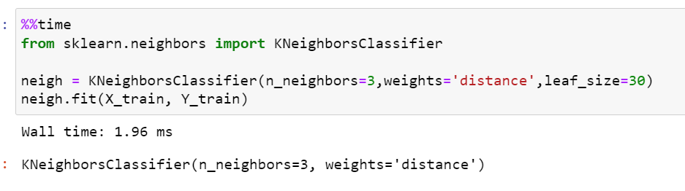

Figure 83: LP2 KNN time

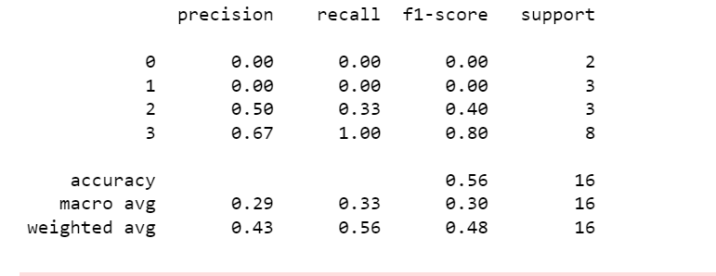

Figure 84: LP2 KNN classification report

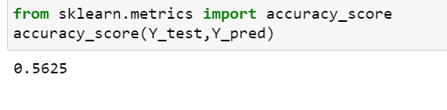

Figure 85: LP2 KNN accuracy

**With PCA**

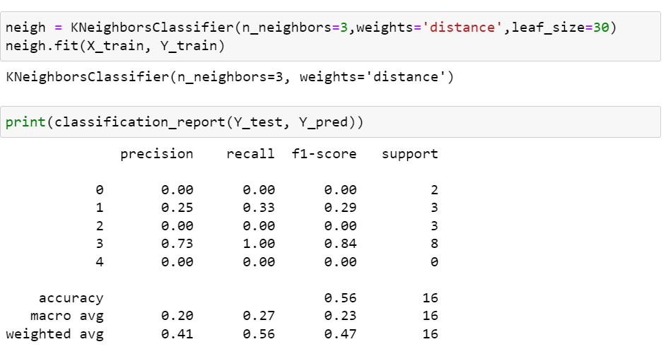

Figure 86: LP2 KNN with PCA

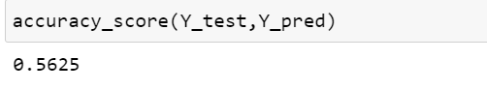

Figure 87: LP2 KNN with PCA accuracy

With PCA the accuracy remains the same.

1. **MLP classifier**

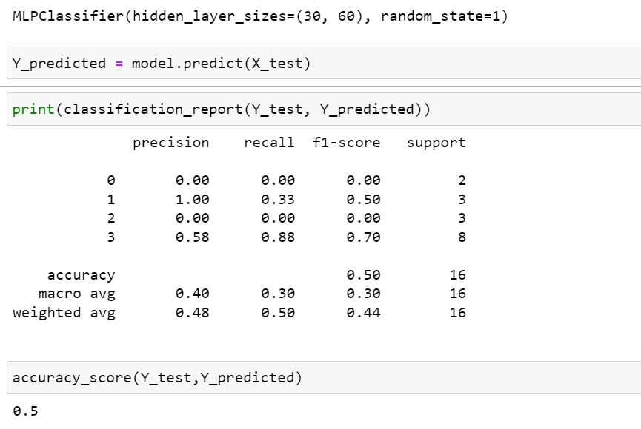MLP with hidden layers have non-convex function and to prevent this only 2 hidden layers were used. This still only gave an accuracy of 50% since the main issue with the dataset is that it is small.

Figure 88: LP2 MLP

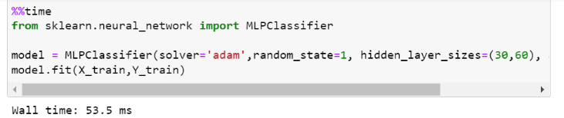

Figure 89: LP2 MLP time

1. **Random Forest**

All the parameters is kept same as that of LP1 nut due to lack of resources the accuracy was only 62.5%. This classifier performed better than the other classification techniques.

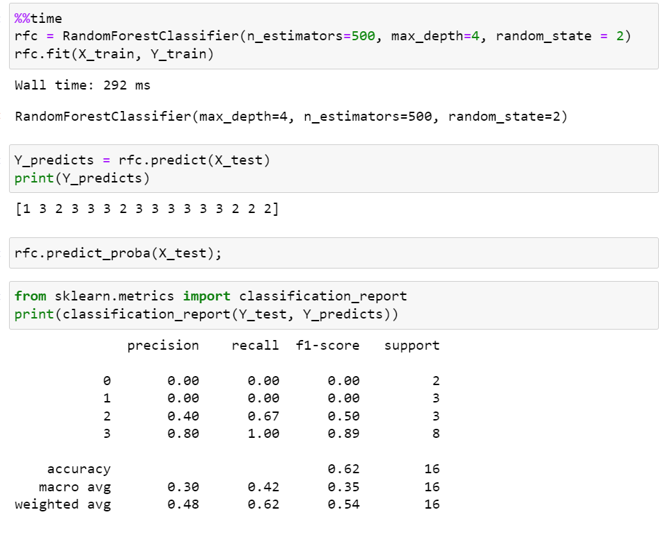

Figure 90: LP2 RF

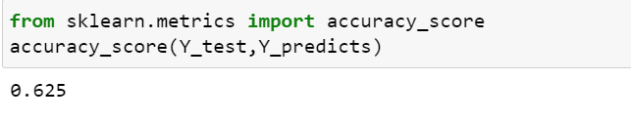

Figure 91: LP2 RF accuracy

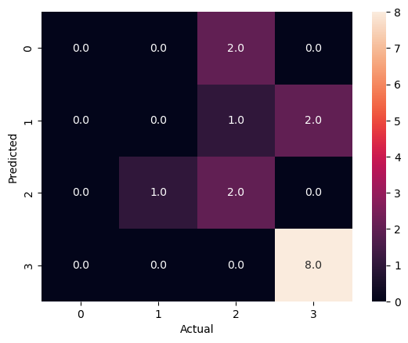

Figure 92: LP2 RF confusion matrix

The dataset has a bias towards normal collision

**With PCA**

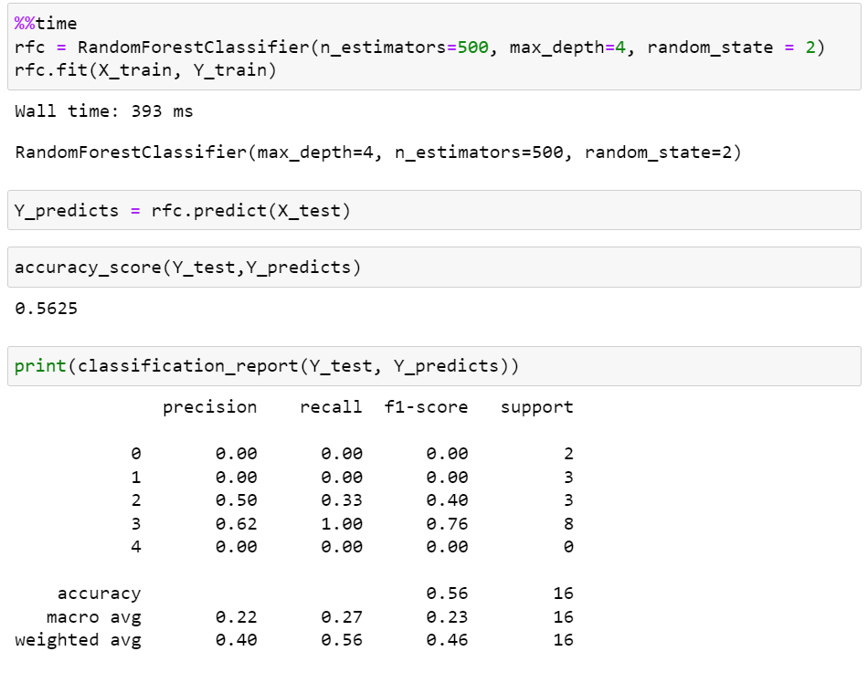

Figure 93: LP2 RF with PCA

Rain forest classifier took longer and gave a lower accuracy when PCA was used.

1. **ANN**

The neural network consists of four layers and gives an accuracy of 96% and validation accuracy of 43.7%. The large gap in the accuracies is due to the number of datasets for training and testing is small which can be seen in the training and validation accuracy graph.

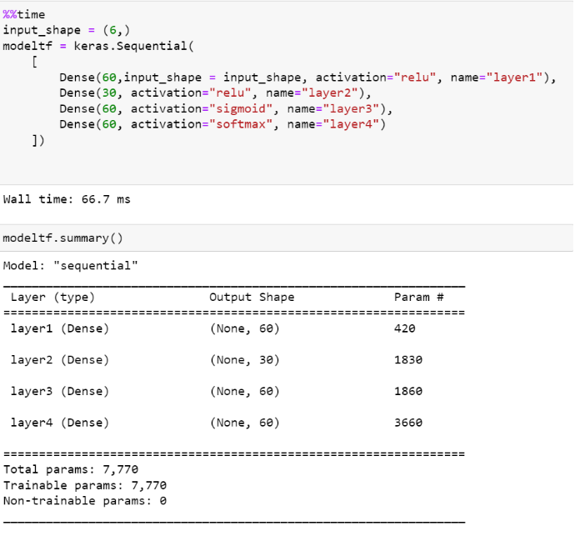

Figure 94: LP2 ANN model

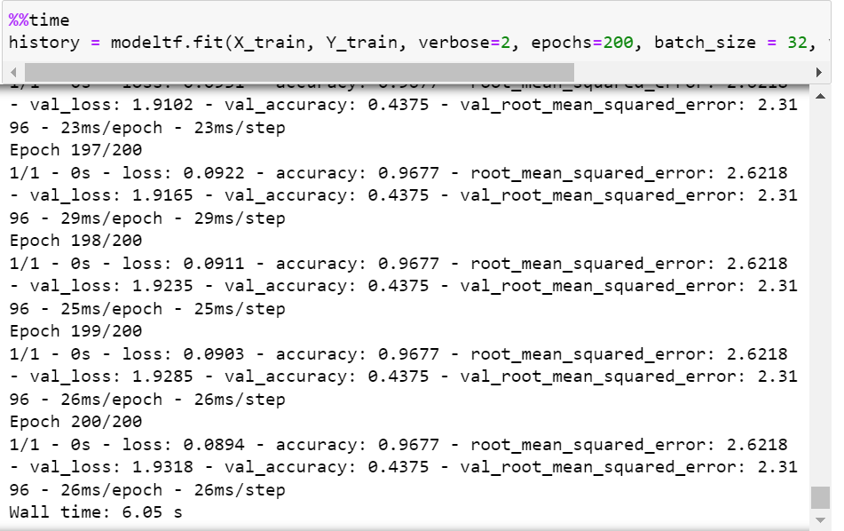

Figure 95: LP2 ANN steps

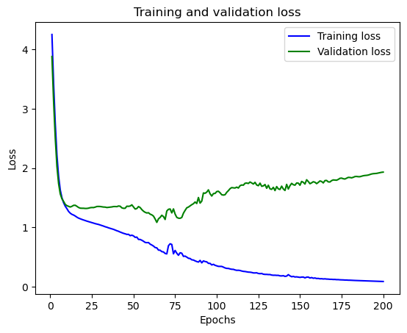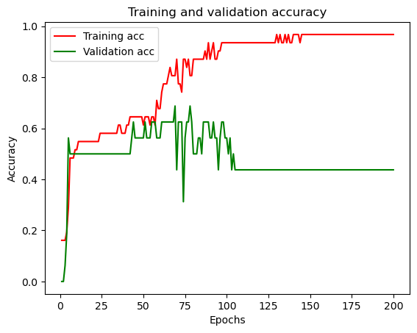

Figure 96: LP2 ANN train & valid loss

Figure 97: LP2 ANN train & valid accuracy

**With PCA**

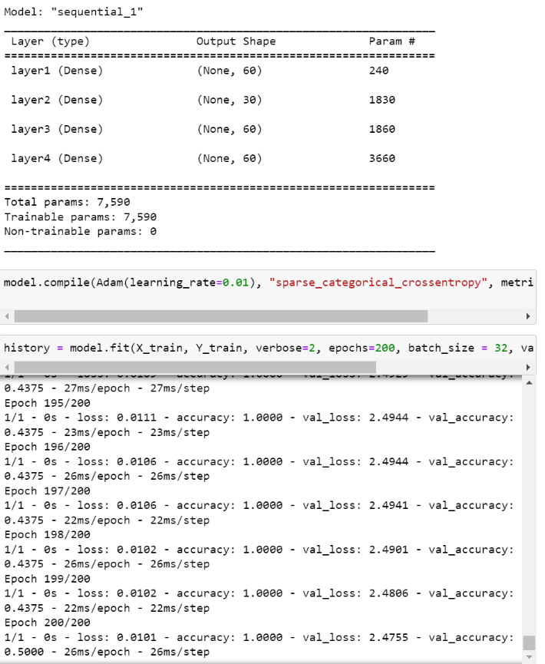

Figure 98: LP2 ANN with PCA

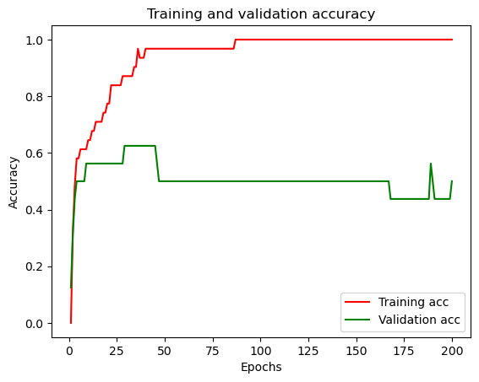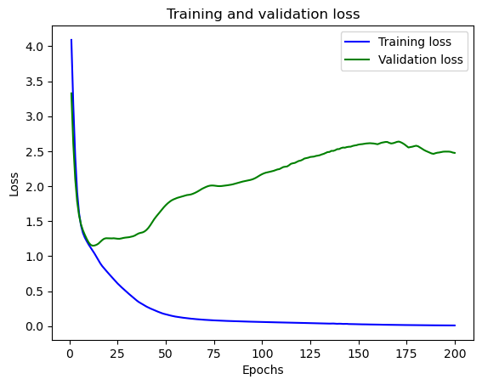

Figure 99: LP2 ANN with PCA train & valid accuracy

## LP3

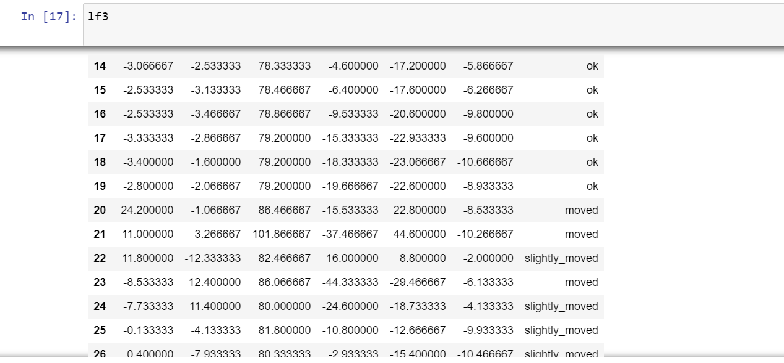

Figure 100: LP3 Dataset

The LP3 dataset consists of 46 datasets which are divided into the following:

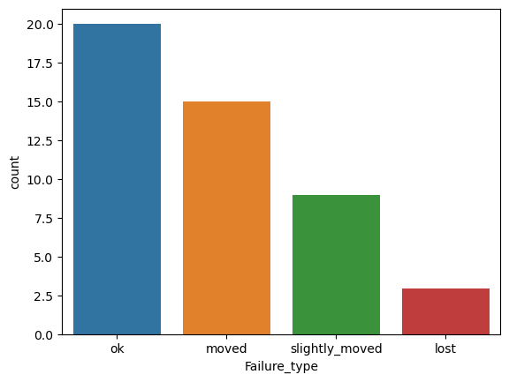

Figure 101: LP3 class count

The LP3 datasets have similar issues to that of LP2. We can refer to LP2 to understand why the accuracy is low for all the classification technique other than decision tree.

**Label encoder**:

1. lost
2. Moved
3. Ok
4. Slightly_moved
5. **Decision tree**

This is the best performing classification model.

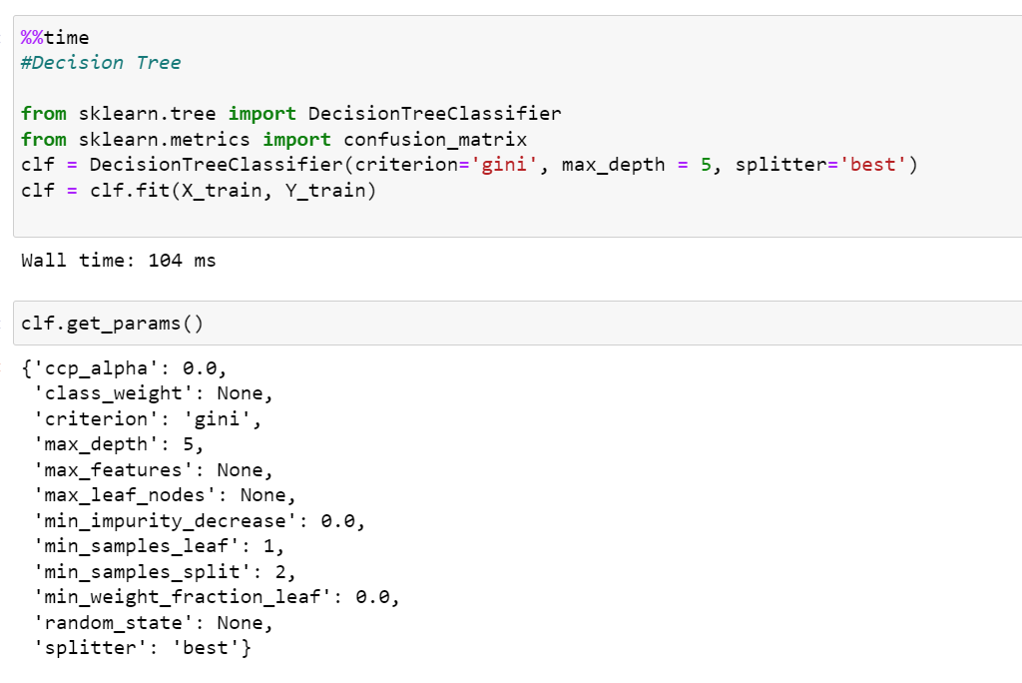

Figure 102: LP3 DT time

The time taken to compute the model is 104 ms and it gave an accuracy above 80%.

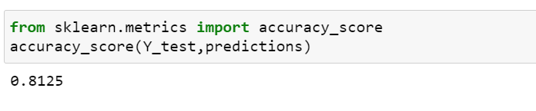

Figure 103: LP3 DT accuracy

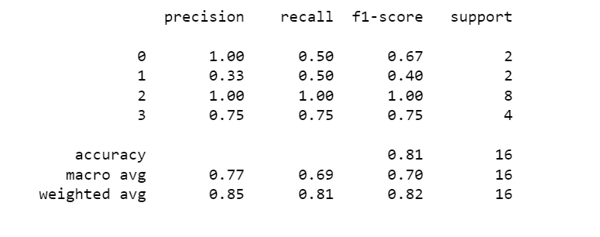

Figure 104: LP3 DT classification report

The 16 values were split unevenly since 50% of it belonged to class 2. This does affect the accuracy score as shown in the confusion matrix where the decision tree only used 1 value to train for class 0.

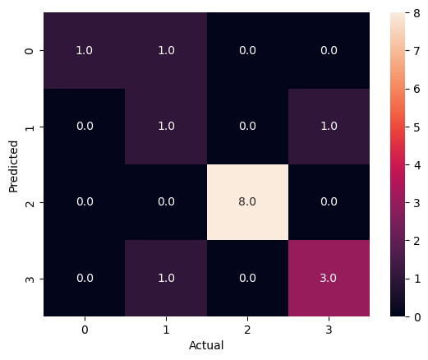

Figure 105: LP3 DT confusion matrix

**With PCA**

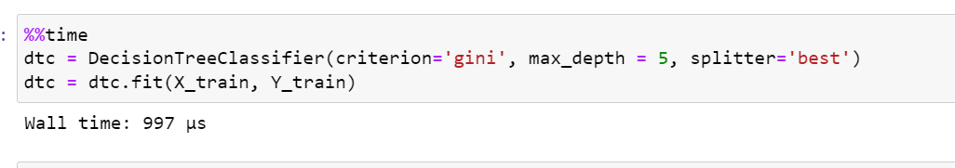

Figure 106: LP3 DT with PCA time

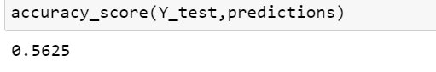

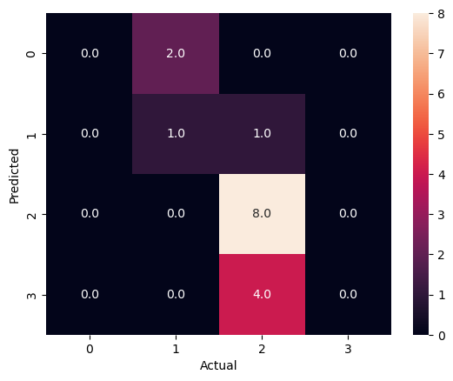Figure 108: LP3 DT with PCA accuracy

Figure 107: LP3 DT with PCA confusion matrix

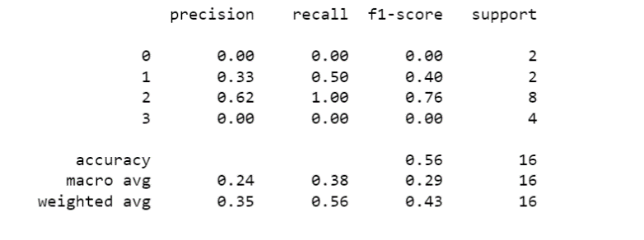

The accuracy of the decision tree reduced after using PCA.

1. **SVM**

The performance of SVM is like that of in LP2. The classifier seems to not be able to recall class 0.

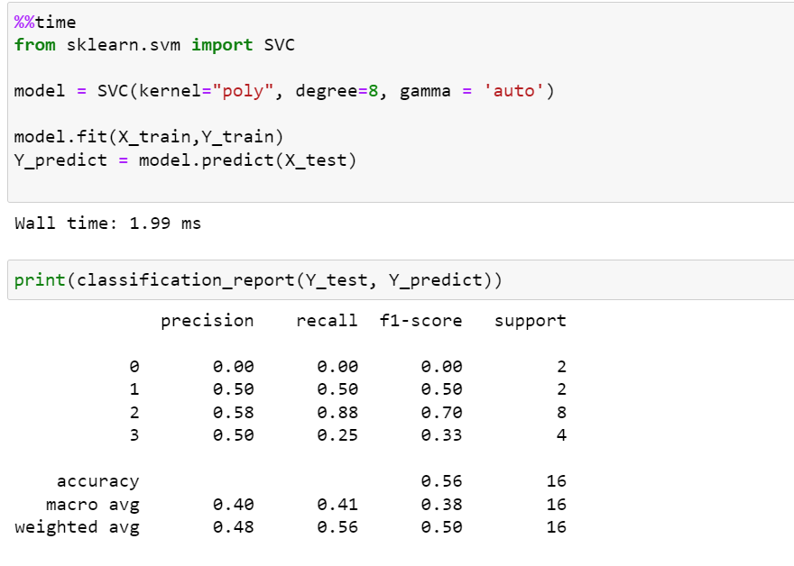

Figure 109: LP3 SVM classification report

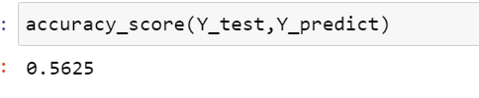

Figure 110: LP3 SVM accuracy

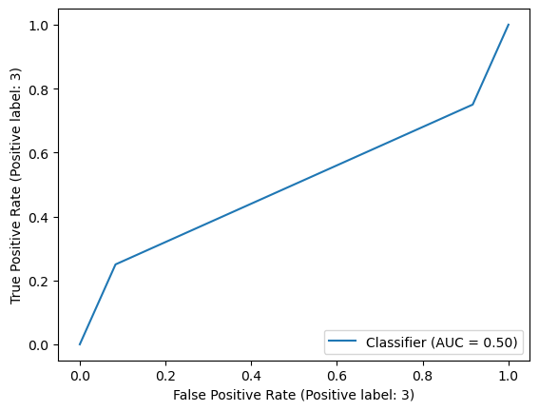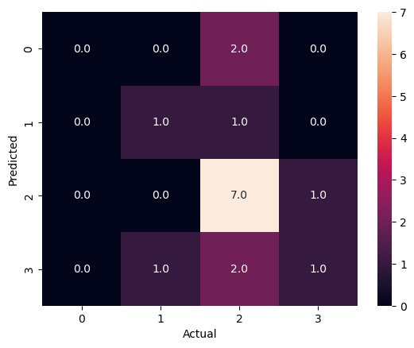

Figure 111:LP3 SVM confusion matrix

**With PCA**

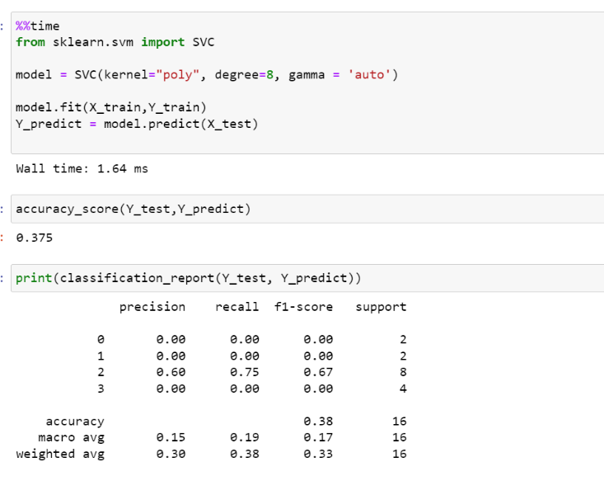The accuracy declines when PCA used.

Figure 112: LP3 SVM with PCA

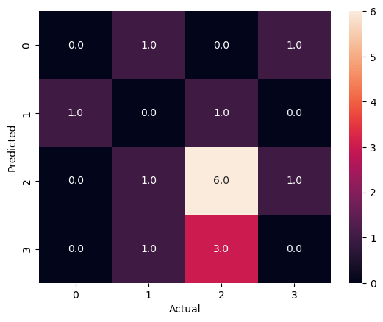

Figure 113: LP3 SVM with PCA confusion matrix

1. **Naïve Bayes**

Even though the Gaussian Naïve Bayes didn’t use any value for class 0 for training the prediction score was still high. This is probably due to the even distribution of the rest of the dataset. Class 2 has significant impact on the validation metrics since it contributes to 50% of the values used for training.

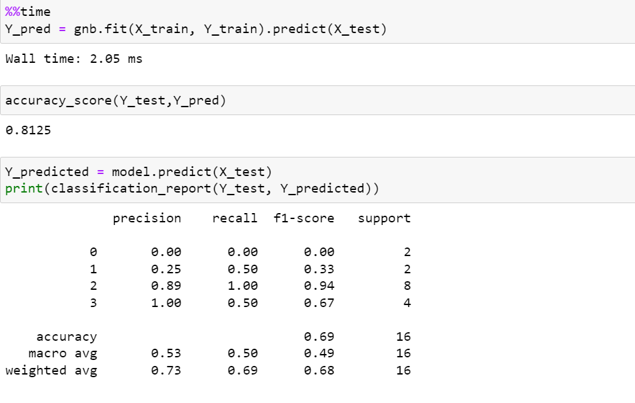

Figure 114: LP3 NB time classification report

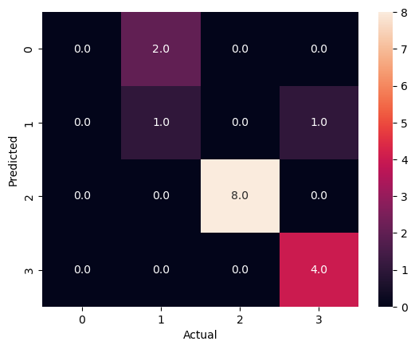

Figure 115: LP3 NB confusion matrix

**With PCA**

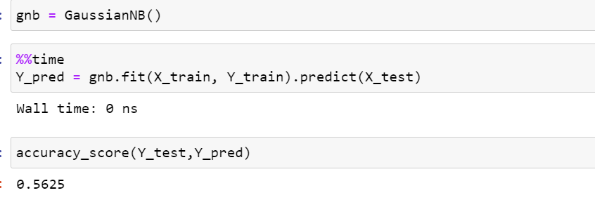

Figure 116: LP3 NB with PCA

1. **KNN**

KNN depends on the quality of data and since the dataset is small, it only uses the classes 1, 2 and 3 which provides unreliable accuracy score.

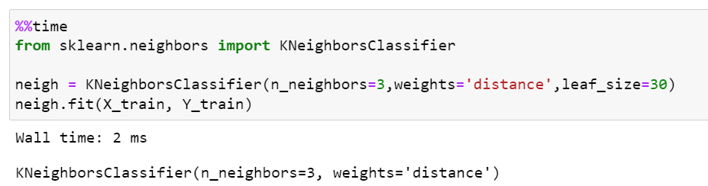

Figure 117: LP3 KNN

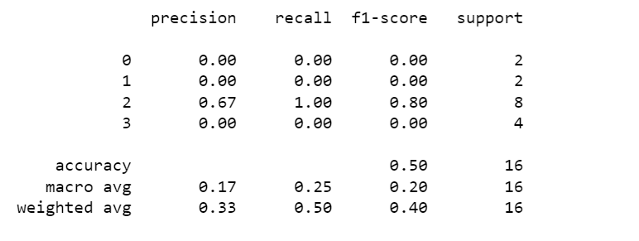

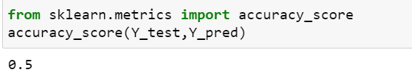

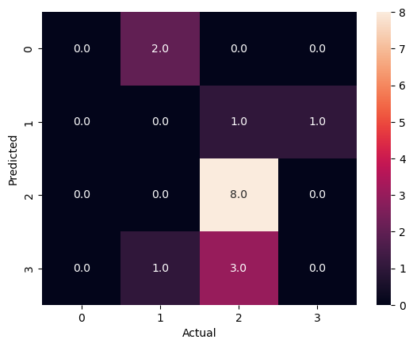

Figure 118: LP3 KNN confusion matrix

**With PCA**

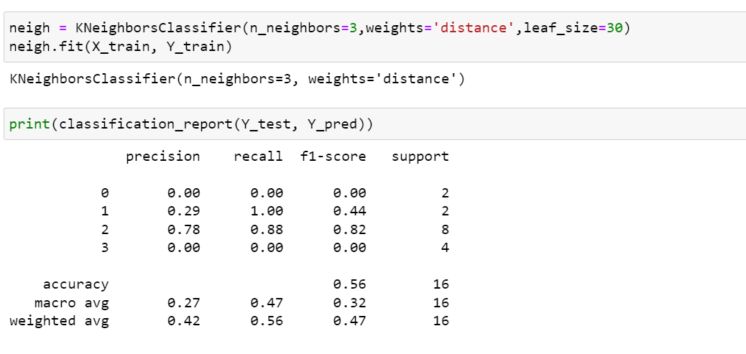

Figure 119: LP3 KNN with PCA

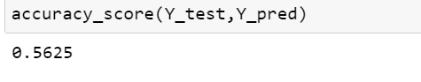

The accuracy score increases after using PCA.

1. **MLP classifier**

It trains iteratively at each step but since the dataset is too small the accuracy of MLP classifier reduces.

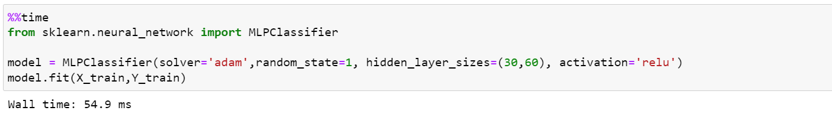

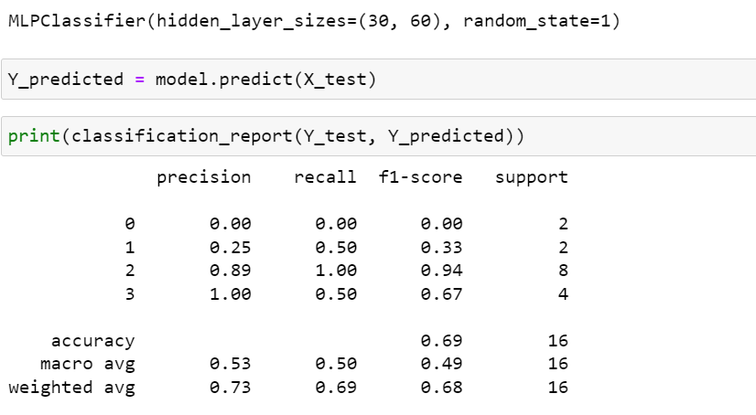

Figure 120: LP3 MLP

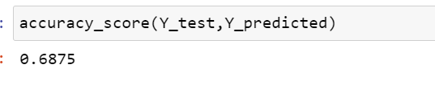

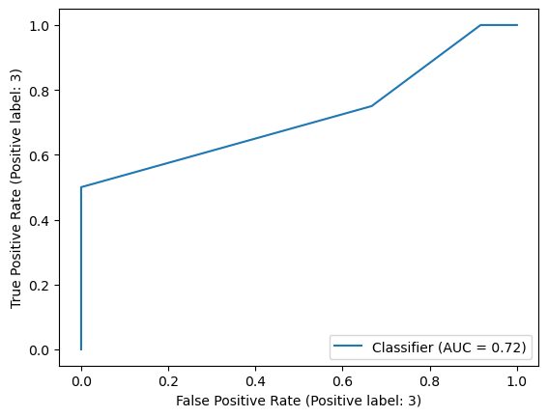

The ROC curve is not idle.

1. **Random Forest**

The random forest classifier uses 500 decision trees to train the dataset.

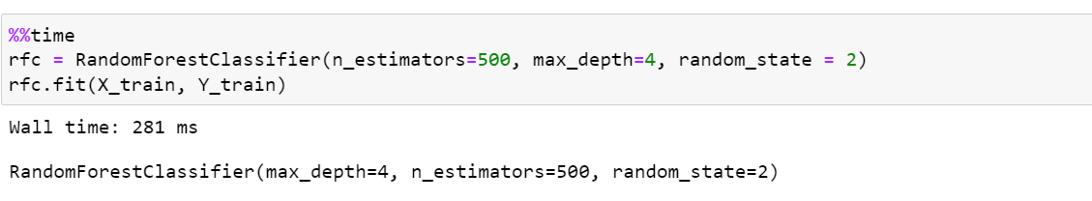

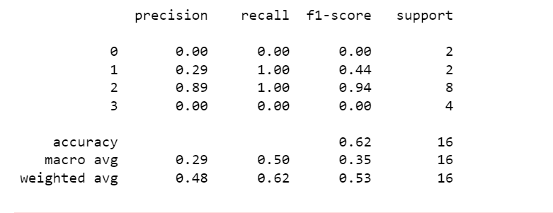

Figure 121: LP3 RF

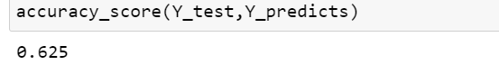

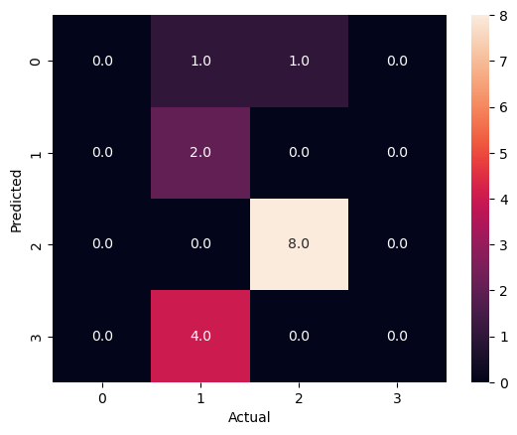

**With PCA**

The accuracy dampens when PCA is used.

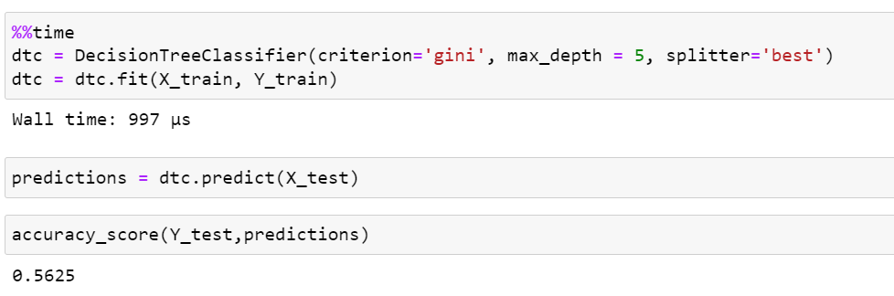

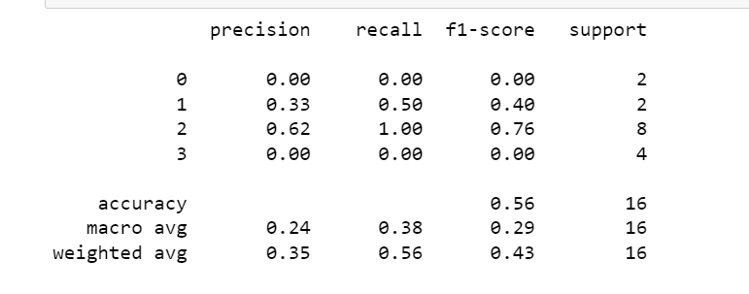

Figure 122: LP3 RF with PCA



1. **ANN**

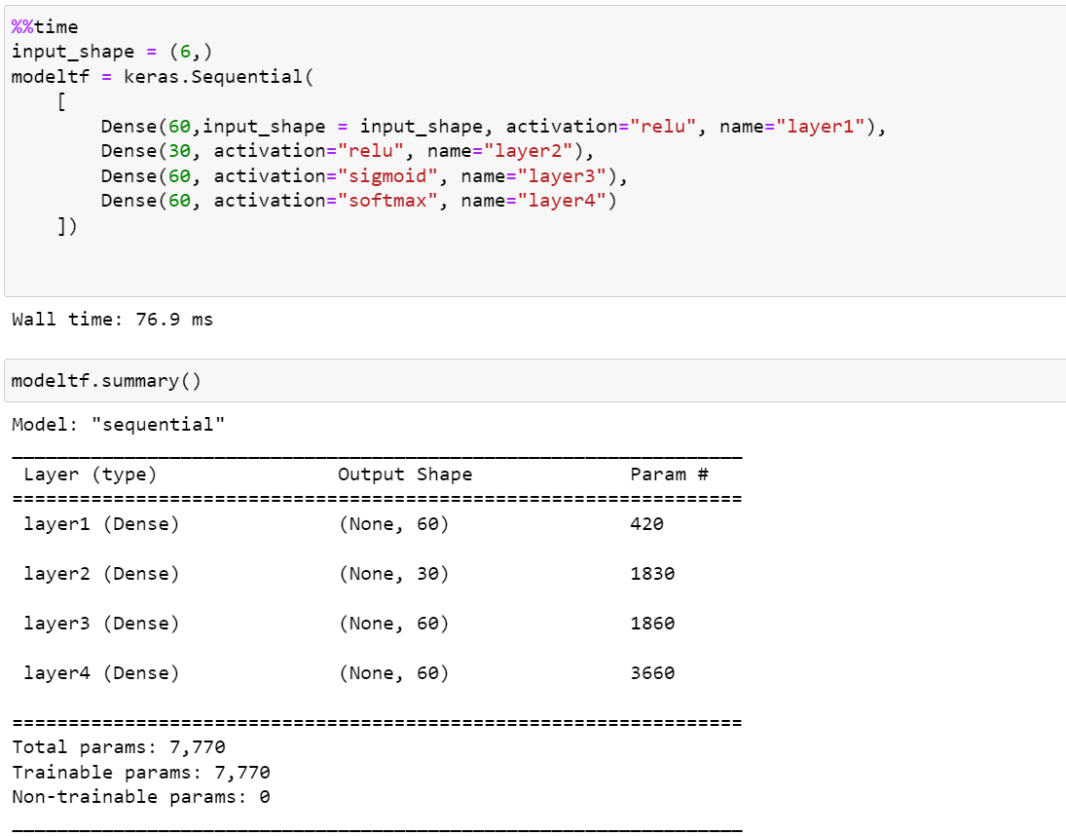Neural networks which have 4 layers, and 200 epochs gave validation accuracy of 62.5% since the data is overfitted due to the small number of datasets.

Figure 123: LP3 ANN

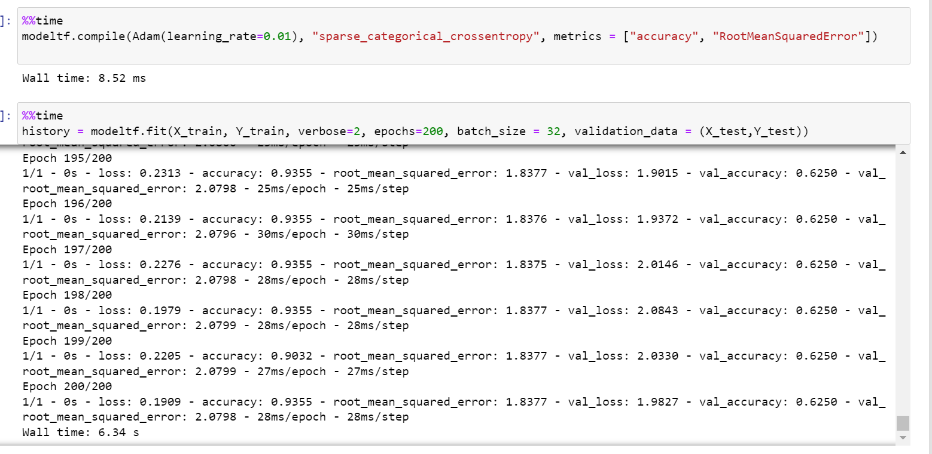

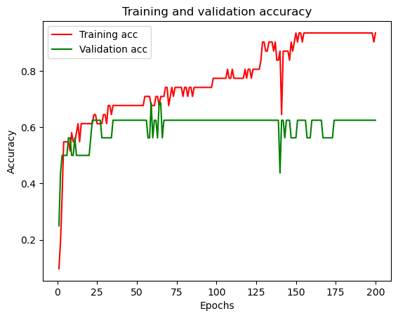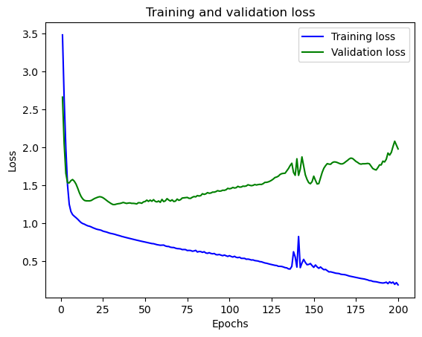

Figure 124: LP3 ANN train & validation accuracy

The graphs indicates that the data was overfitted and this affected the accuracy of the neural network.

**With PCA**

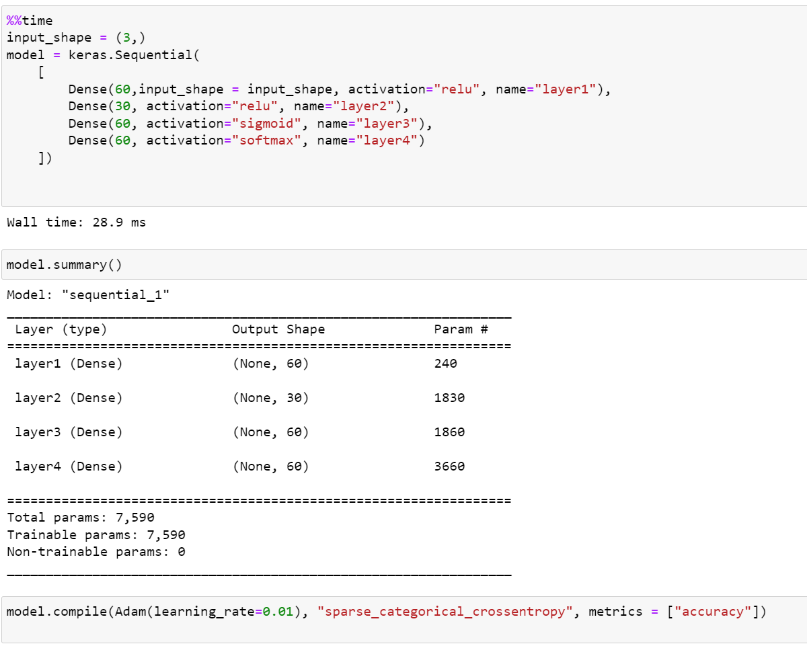

Figure 125: LP3 ANN with PCA

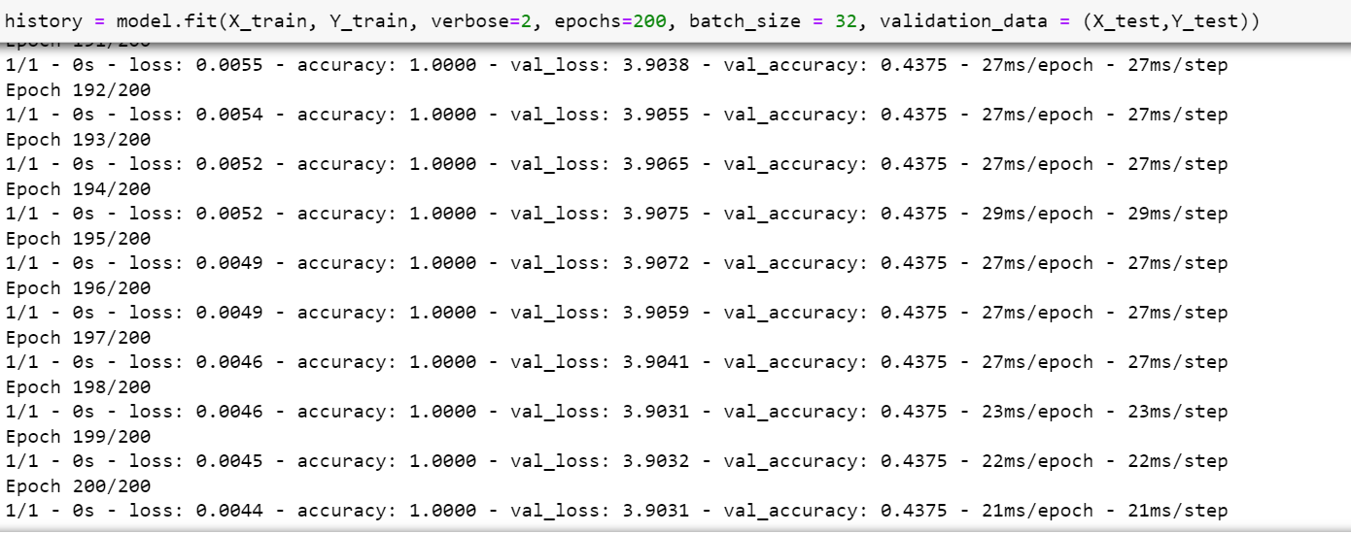

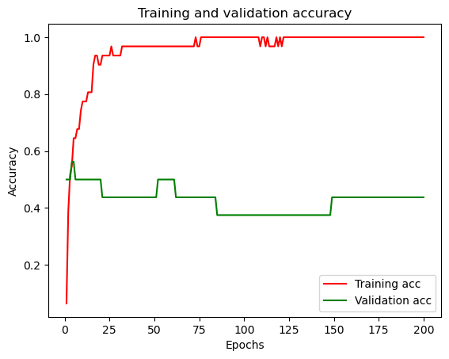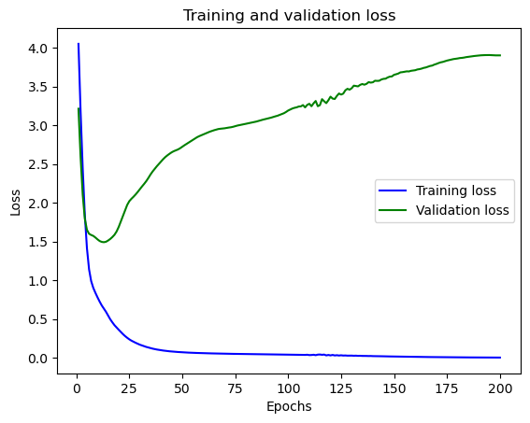

Implementing PCA didn’t improve the validation score of the model.

## LP4

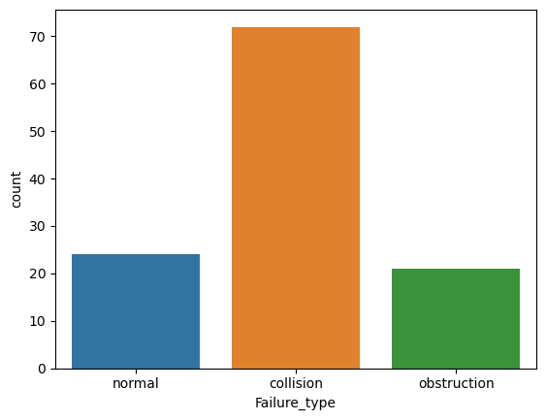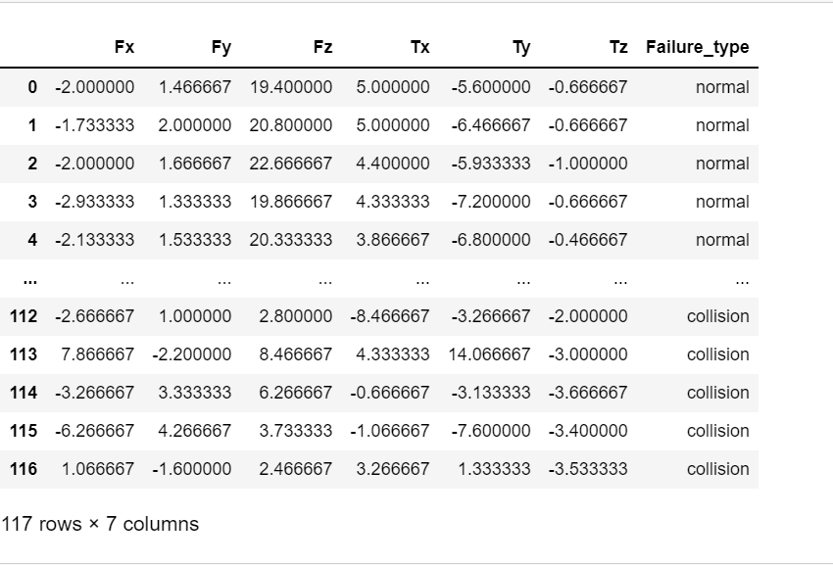LP4 have 116 datasets which is divided into the following:

Figure 126: LP4 class count

1. **Decision tree**

Since the dataset does have enough testing and training samples, decision tree was able to predict with a higher accuracy, but it still got affected by the larger contribution of collision failure type class.

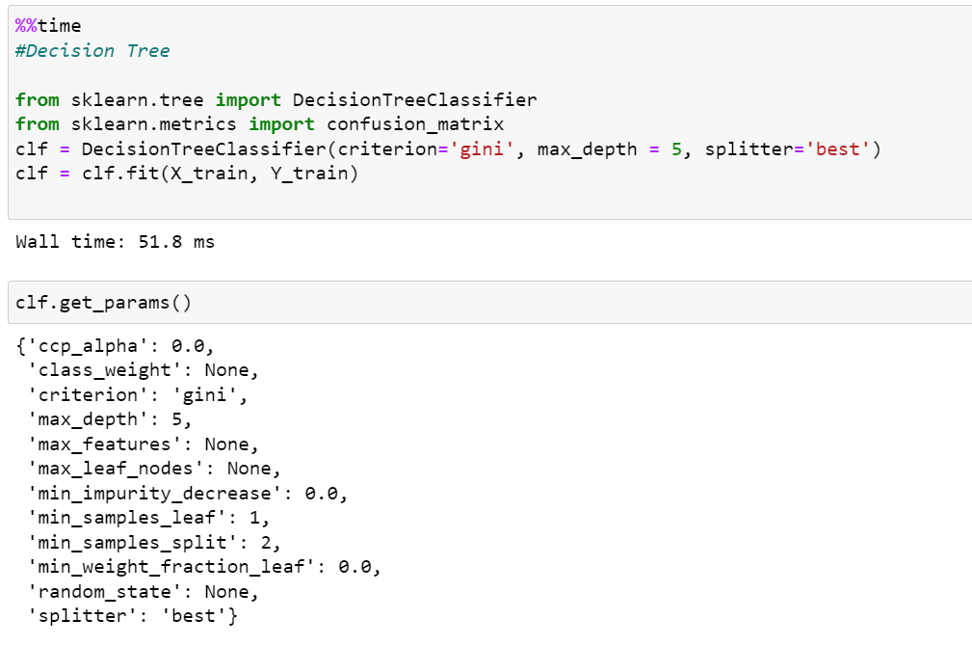

Figure 127: LP4 DT time

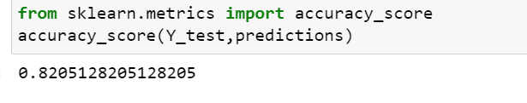

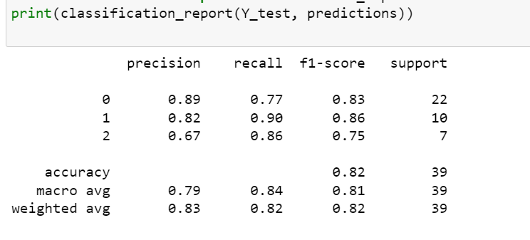

Figure 128: LP4 DT classification report

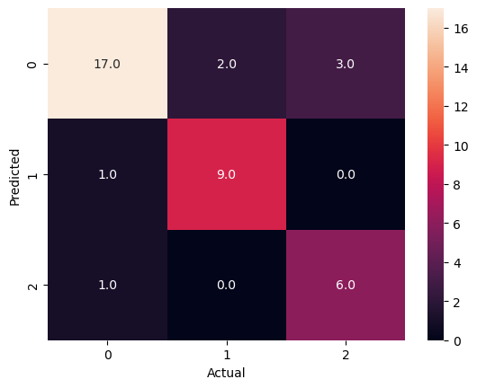

Figure 129: LP4 DT confusion matrix

**With PCA**

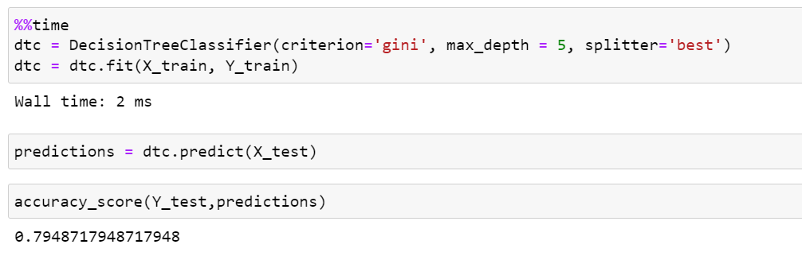

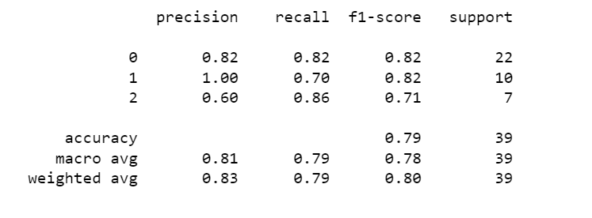

Figure 130: LP4 DT with PCA

1. **Naïve Bayes**

Naïve bayes assumes all the classes are independent and therefore will give a high accuracy for this dataset. The accuracy gets distorted due to collision failure type contributing most to the dataset.

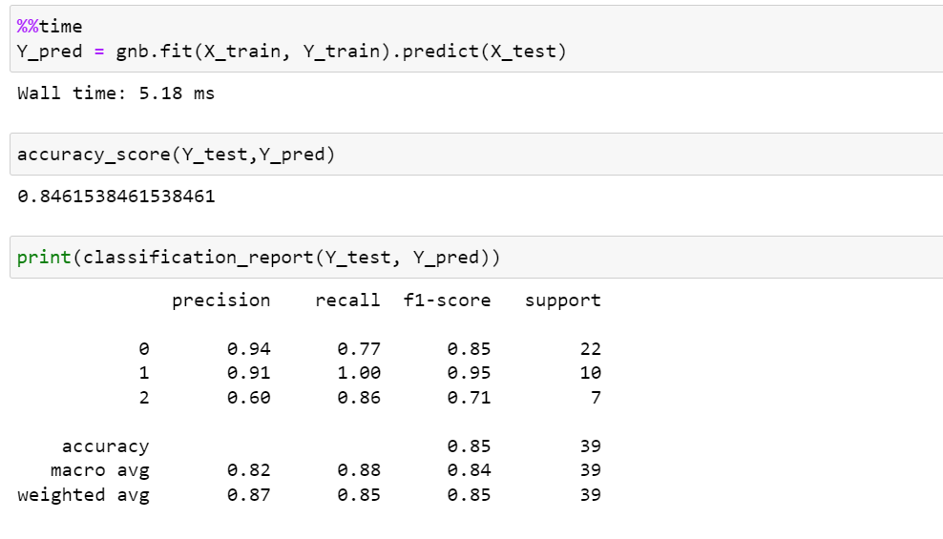

Figure 131: LP4 NB

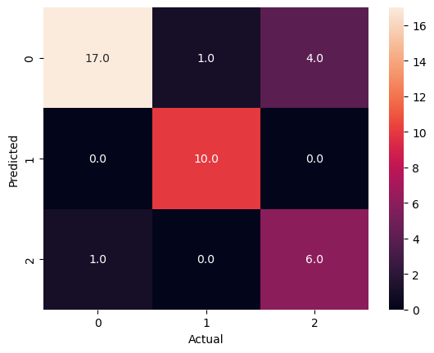

**With PCA**

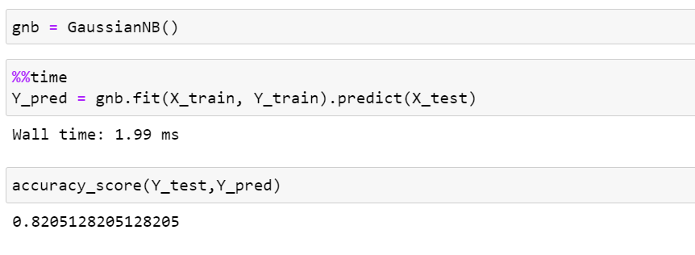

Figure 132: LP4 NB with PCA

1. **KNN**

KNN produced good accuracy score, but it is slower and costlier than other classifiers.

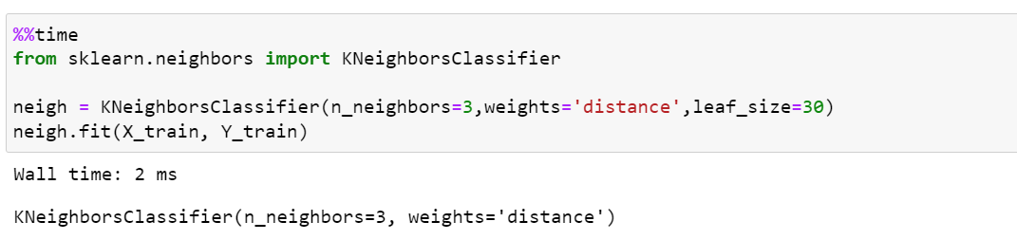

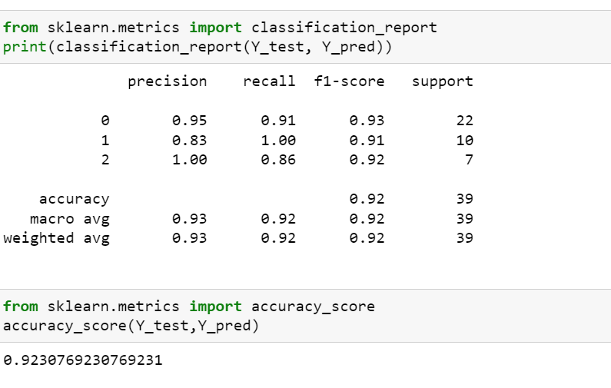

Figure 133: LP4 KNN

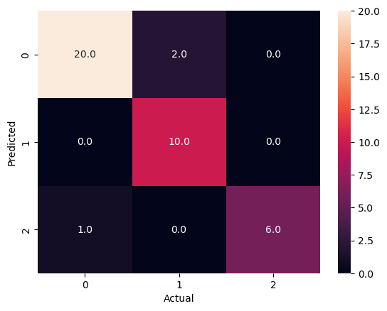

**With PCA**

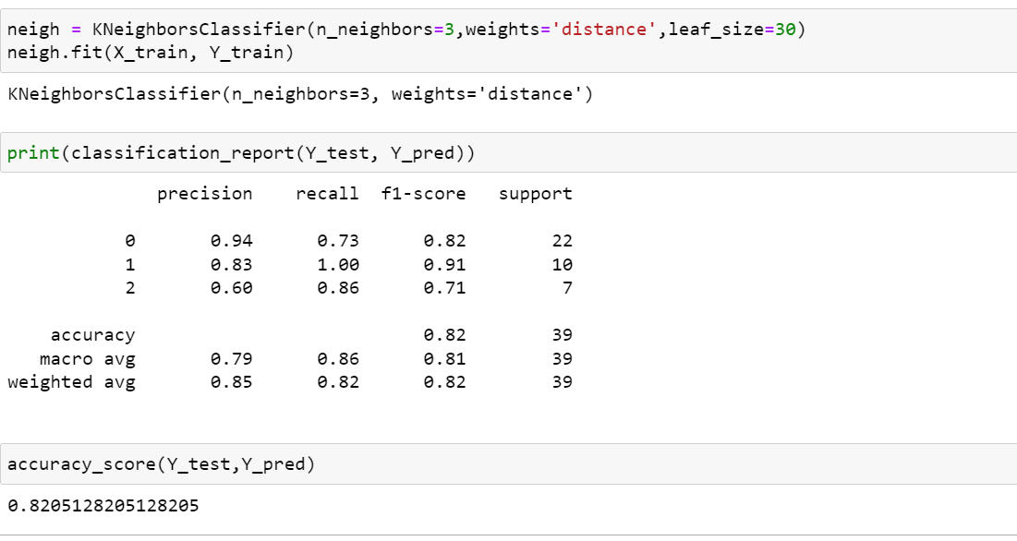

Figure 134: LP4 KNN with PCA

1. **MLP classifier**

MLP classifier produced great accuracy score since it is suitable for predicting classification problem.

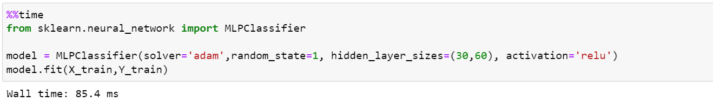

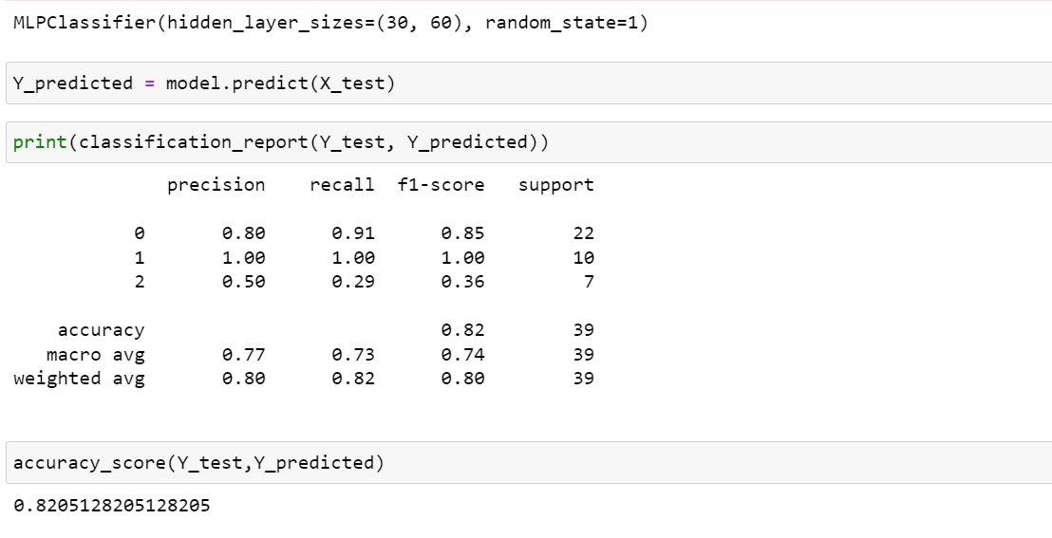

Figure 135: LP4 MLP

1. **Random Forest**

Random forest gave the best accuracy score for this dataset.

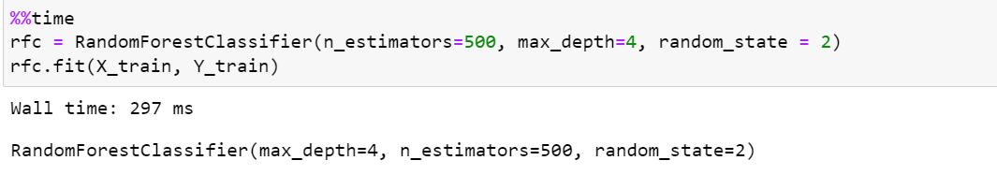

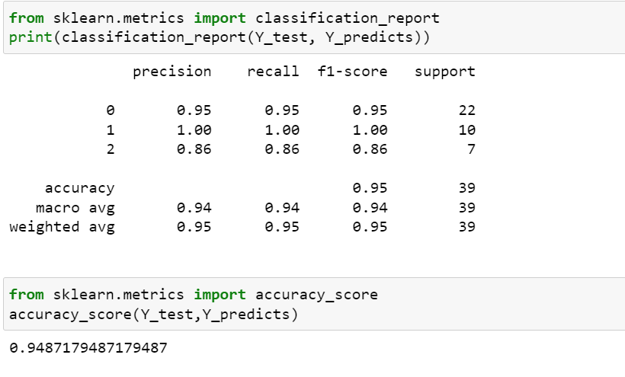

Figure 136: LP4 RF

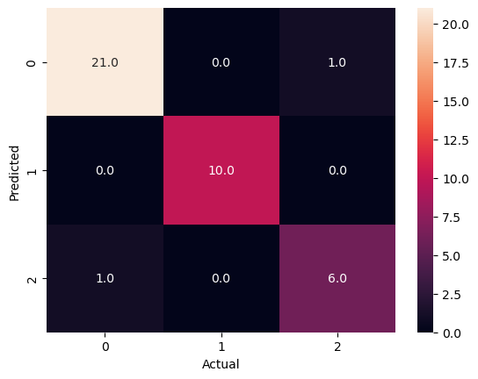

**With PCA**

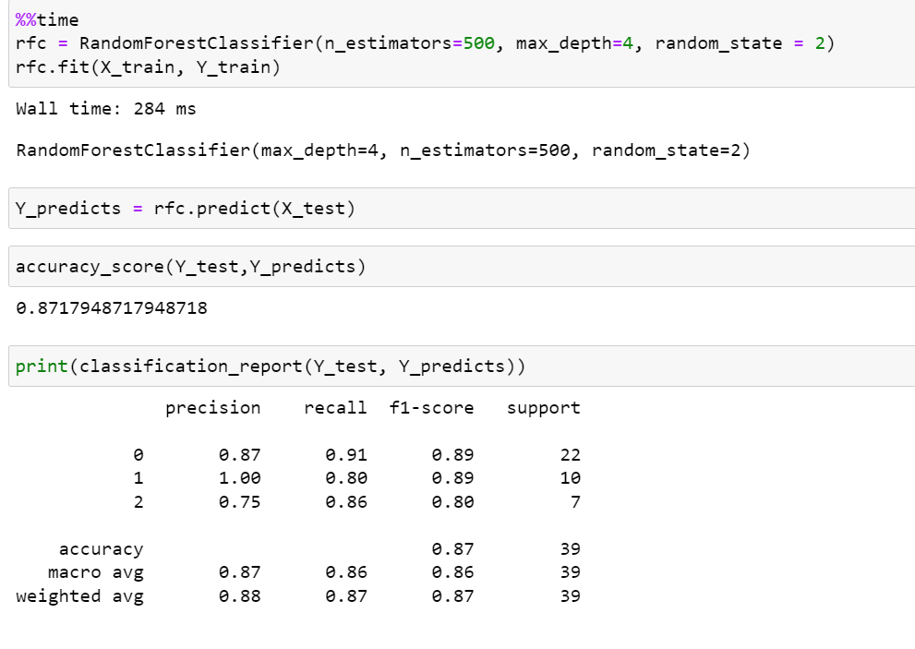

Figure 137: LP4 RF with PCA

1. **ANN**

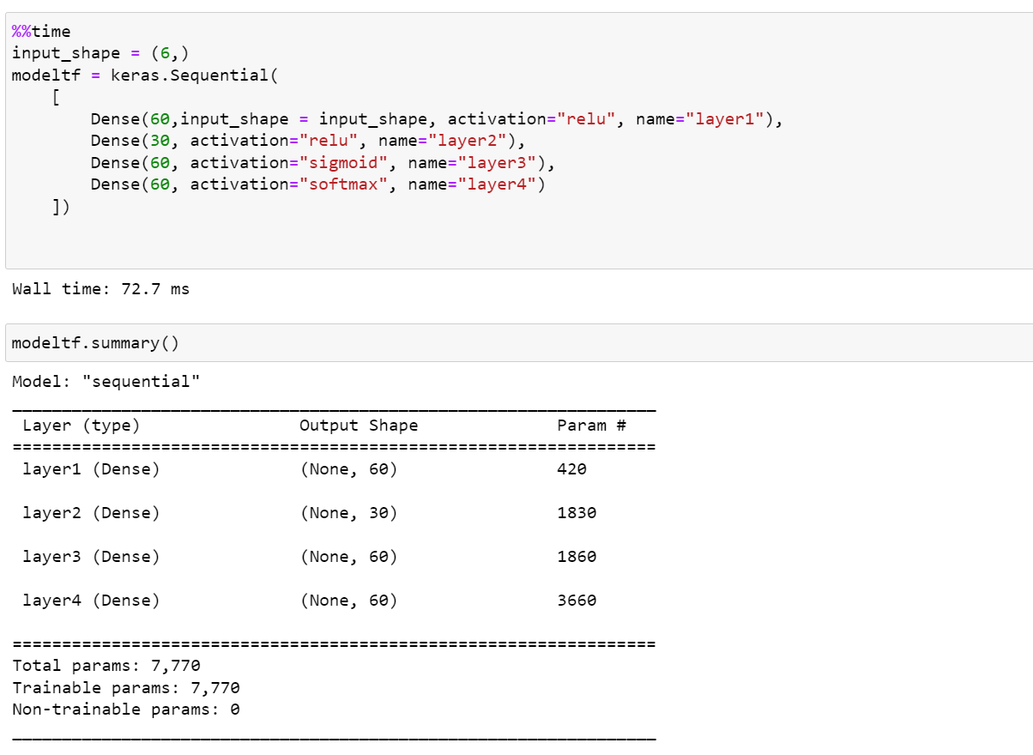

Figure 138: LP4 ANN

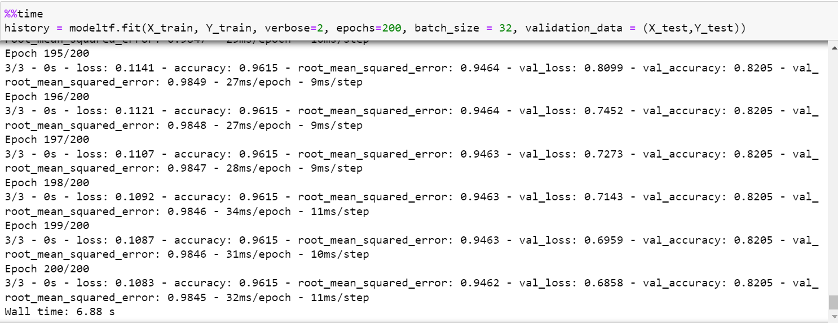

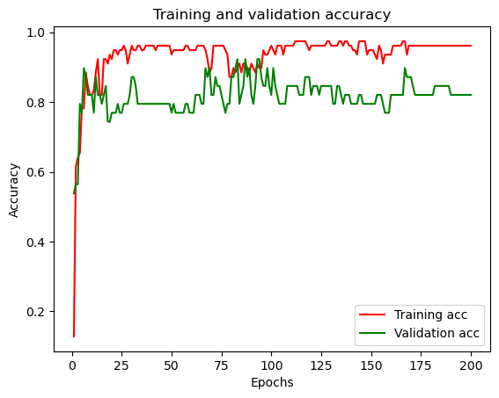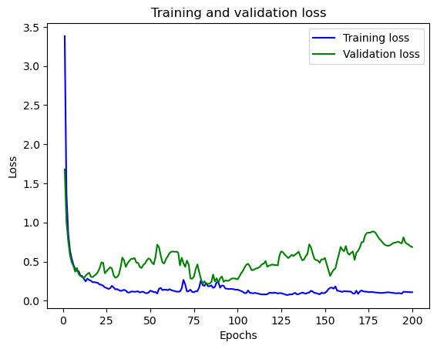

Figure 139: LP4 ANN Train & validation accuracy

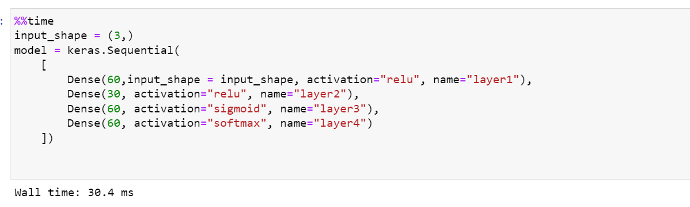**With PCA**

Figure 140: LP4 ANN with PCA

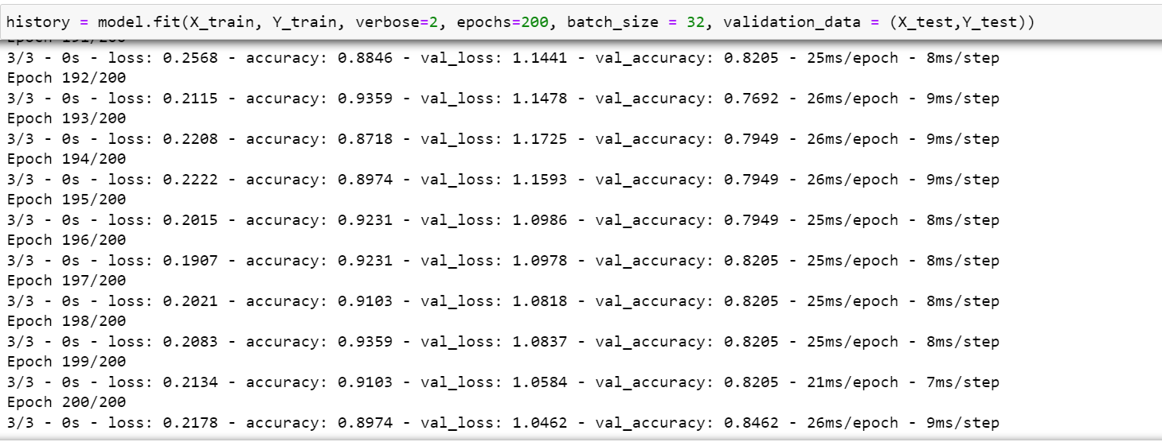

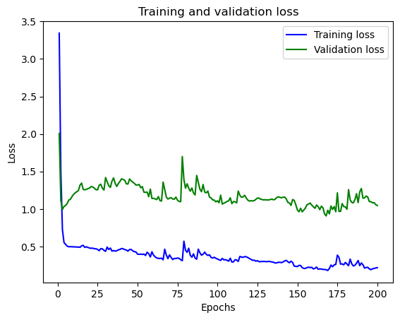

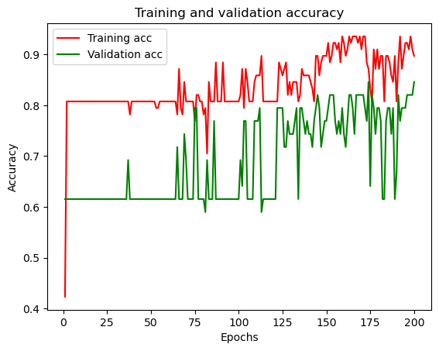

Figure 141: LP4 ANN with PCA train & valid acc

## LP5

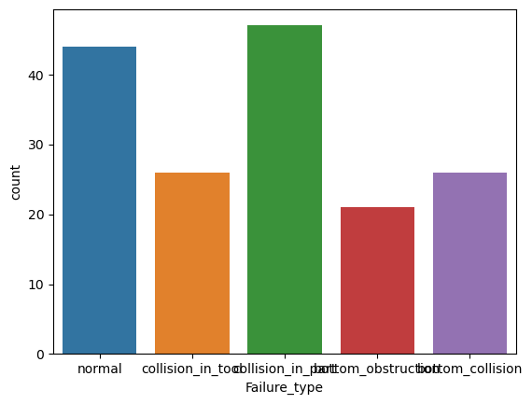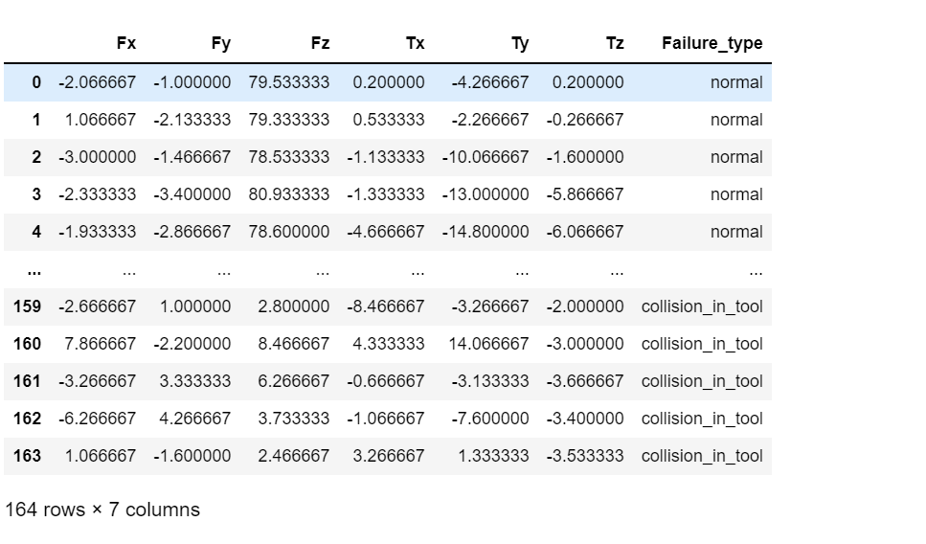

Figure 142: LP5 Class count

LP5 consists of 164 datasets, and they are almost evenly distributed among the classes.

1. **Decision tree**

Decision tree seems to provide acceptable accuracy score for every dataset possibly due to it not requiring scaling of data and less effort needed during data preparation.

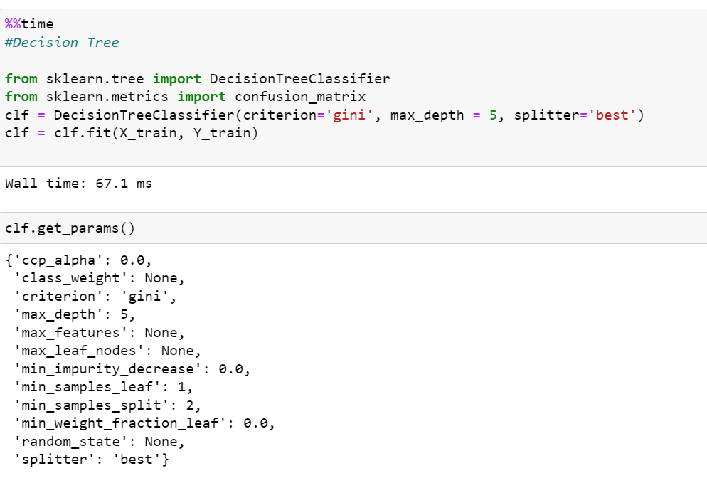

Figure 143: LP5 DT

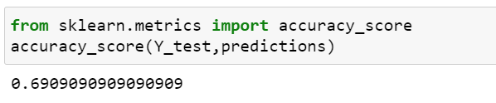

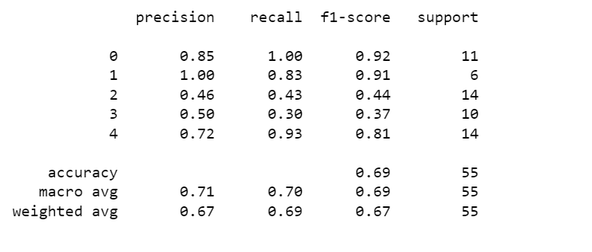

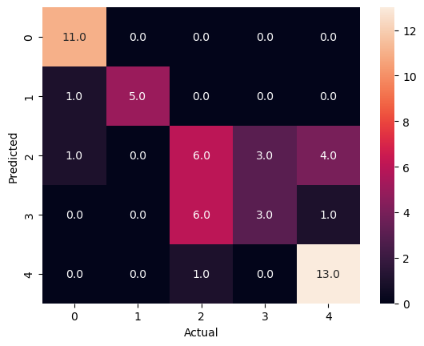

**With PCA**

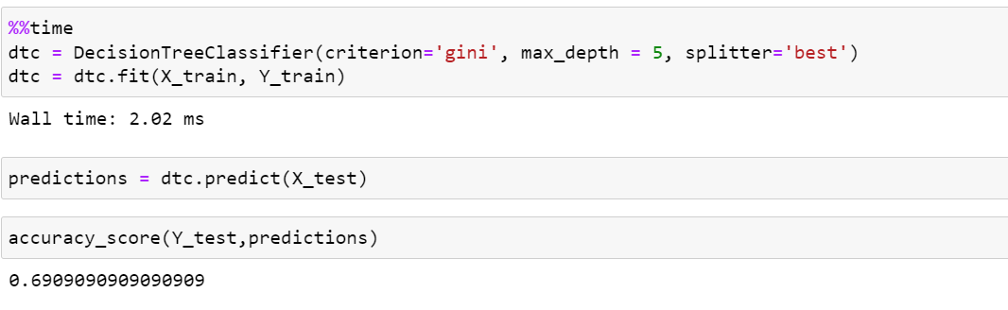

Figure 144: LP5 DT with PCA

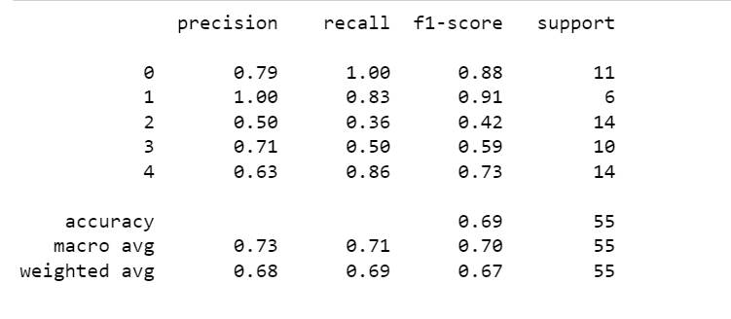

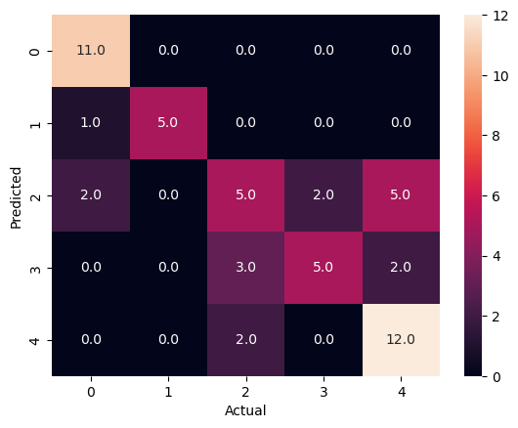

1. **Naïve Bayes**

Naïve bayes tends to give great results due to assuming all features are independent.

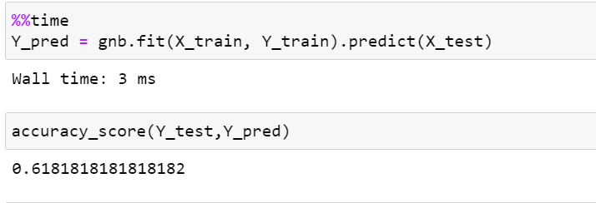

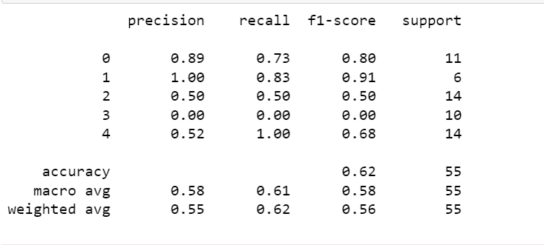

Figure 145: LP5 NB

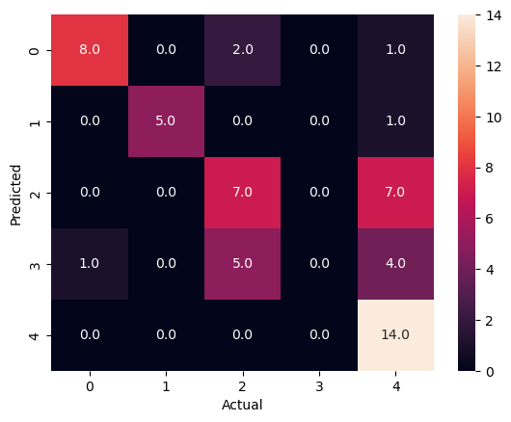

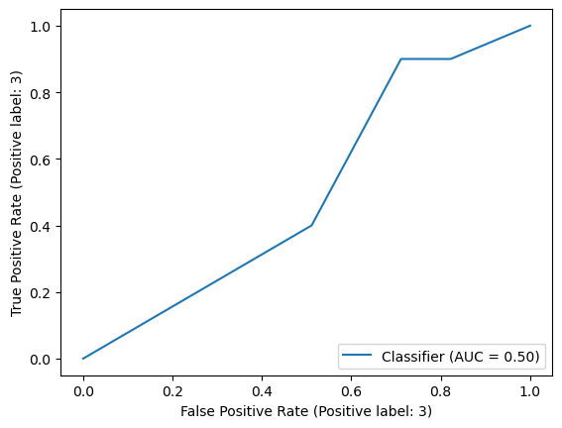

**With PCA**

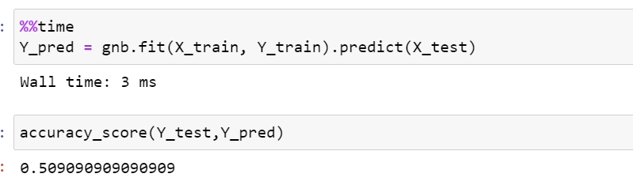

Figure 146: LP5 NB with PCA

1. **KNN**

Since the dataset is small there is overfitting in the data and even though KNN gives high accuracy the quality of the dataset is low.

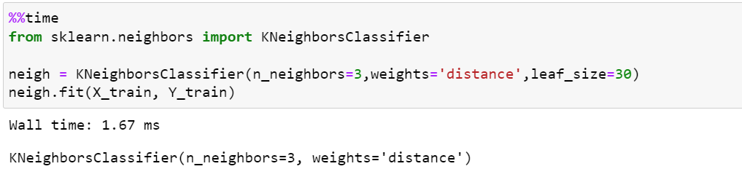

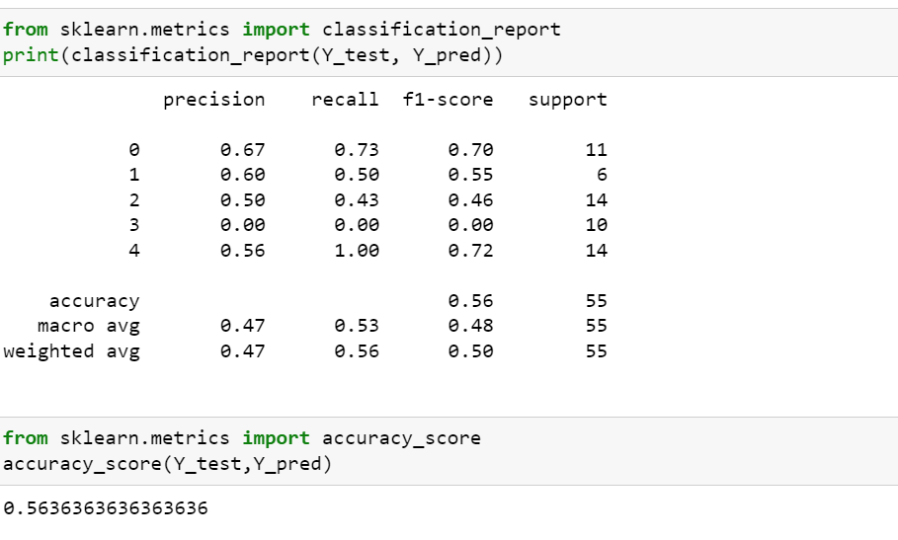

Figure 147: LP5 KNN

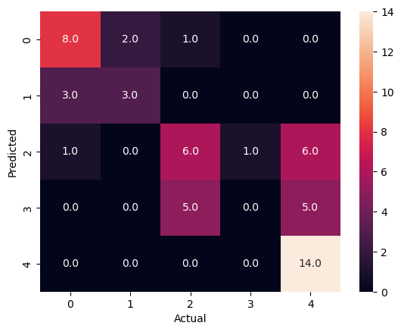

**With PCA**

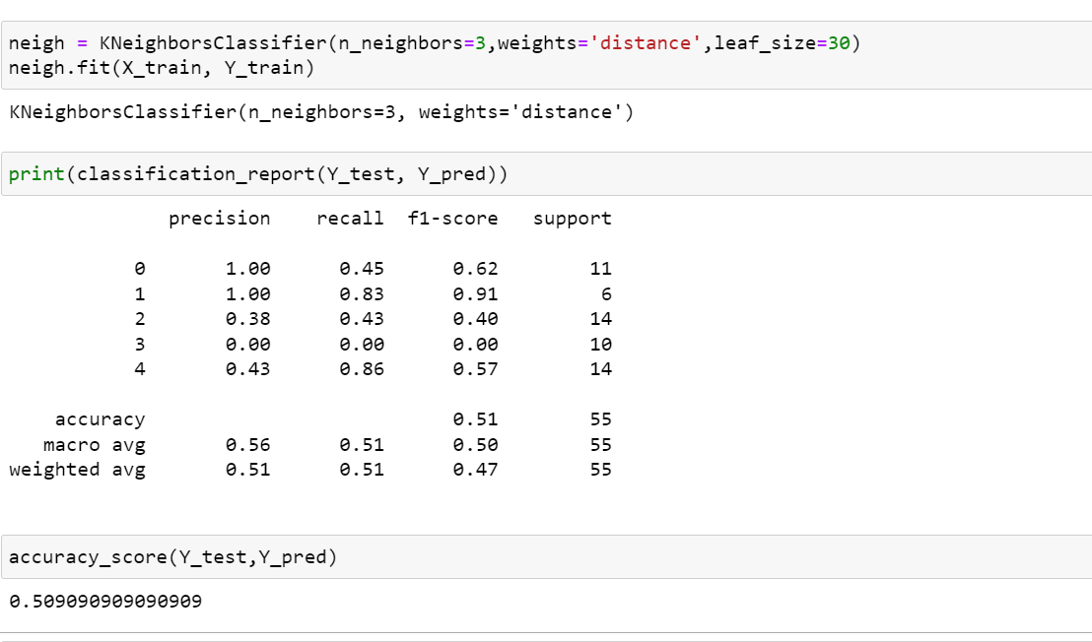

Figure 148: LP5 KNN with PCA

1. **MLP classifier**

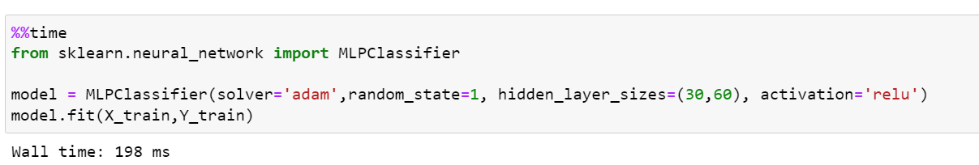

Figure 149: LP5 MLP

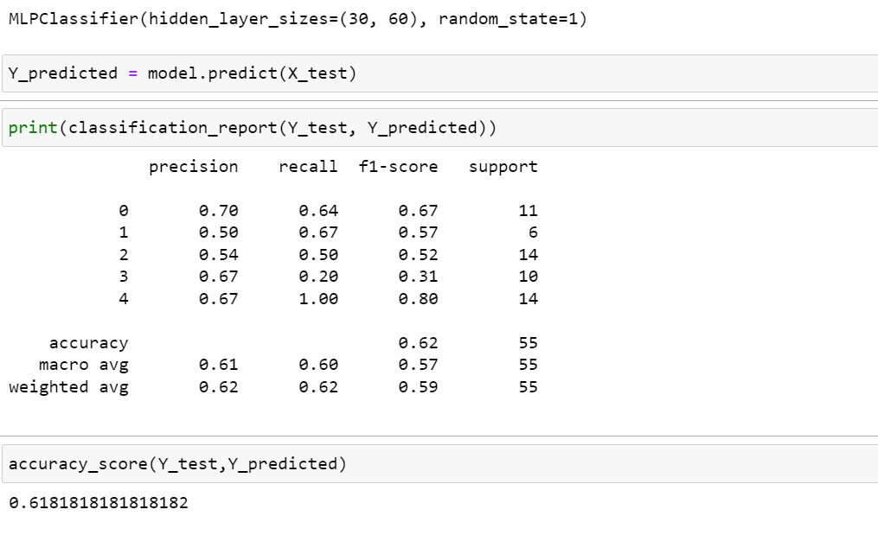

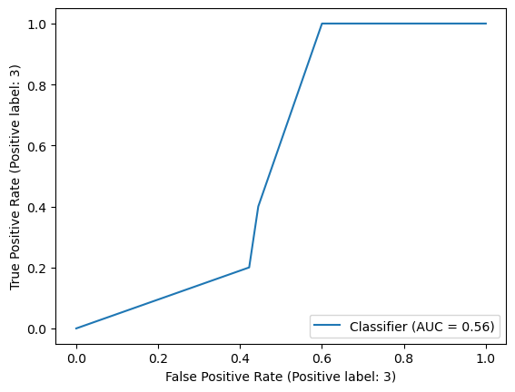

1. **Random Forest**

The computation time was expensive even though the accuracy was high.

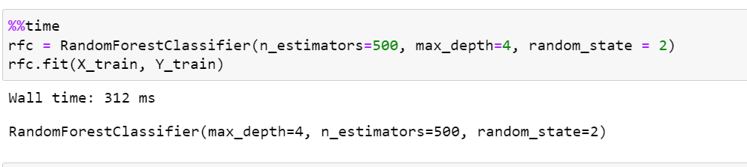

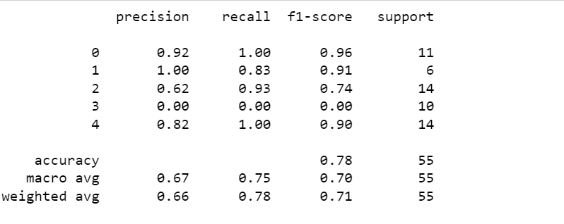

Figure 150: LP5 RF

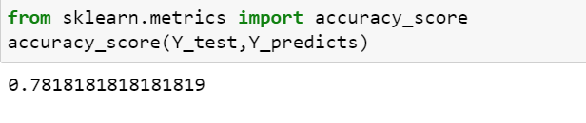

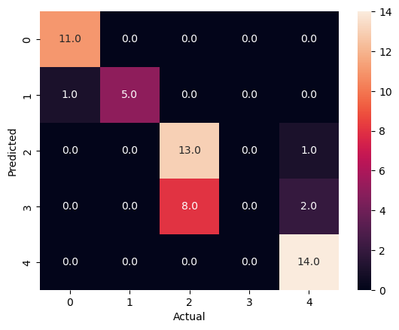

**With PCA**

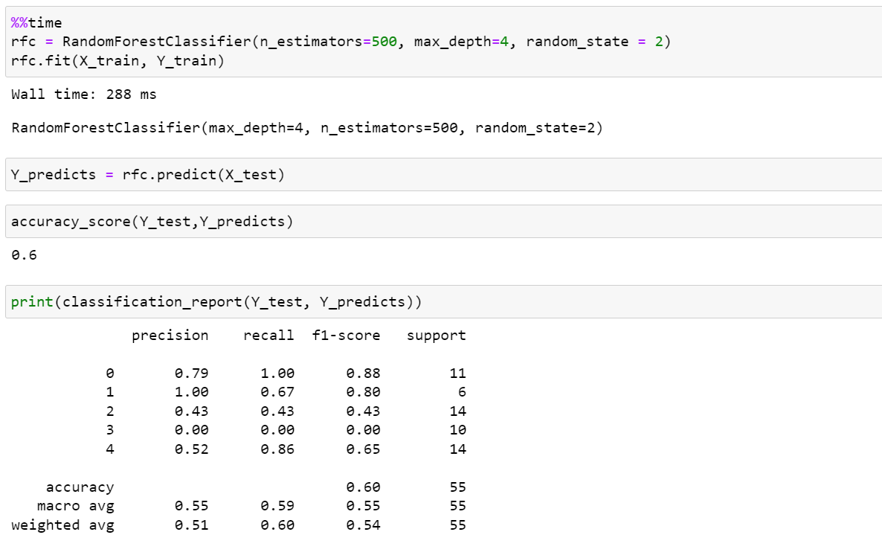

Figure 151: LP5 RF with PCA

1. 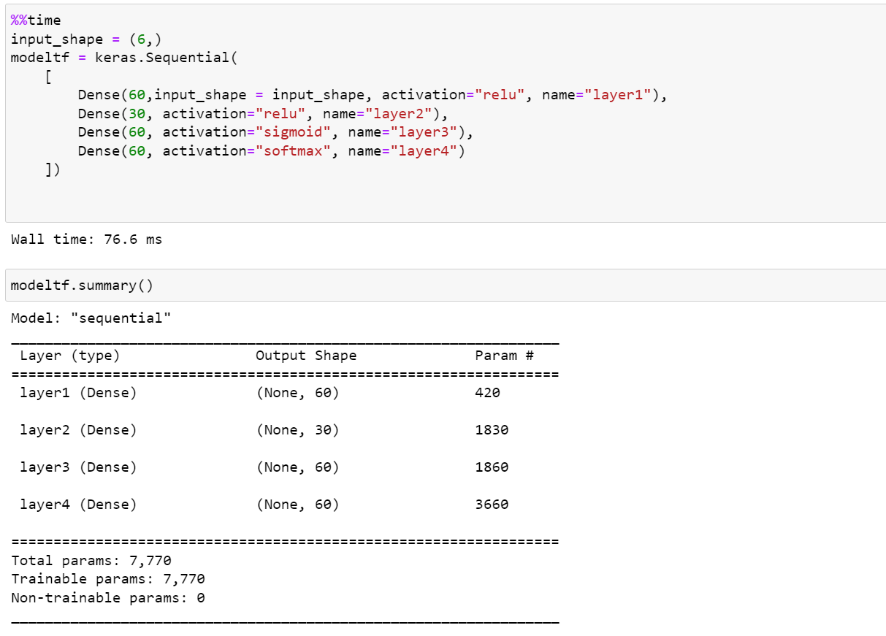**ANN**

The neural network for all datasets has done really well when it comes to accuracy but the validation accuracy is too low, this is because of poor dataset and distribution within the classes cause bias.

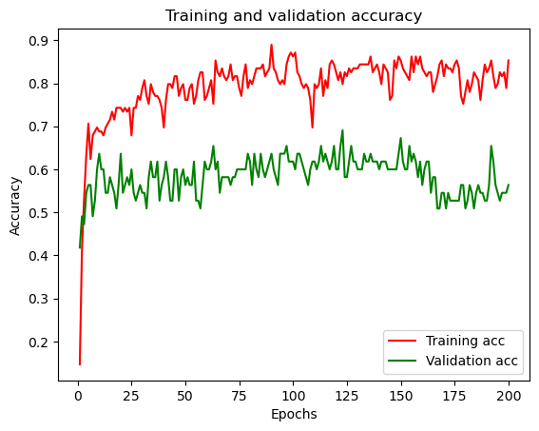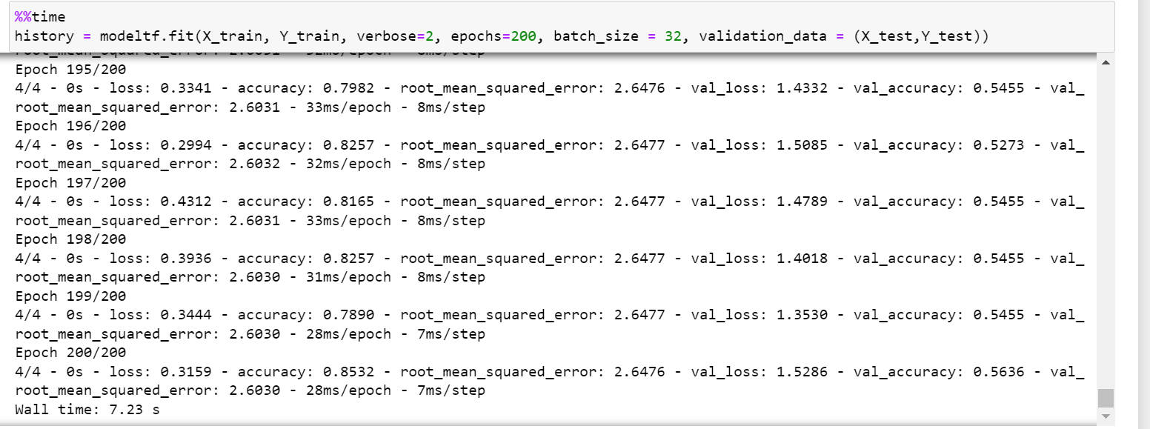

Figure 152: LP5 ANN

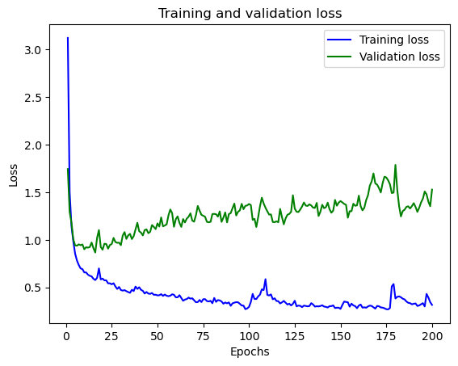

**With PCA**

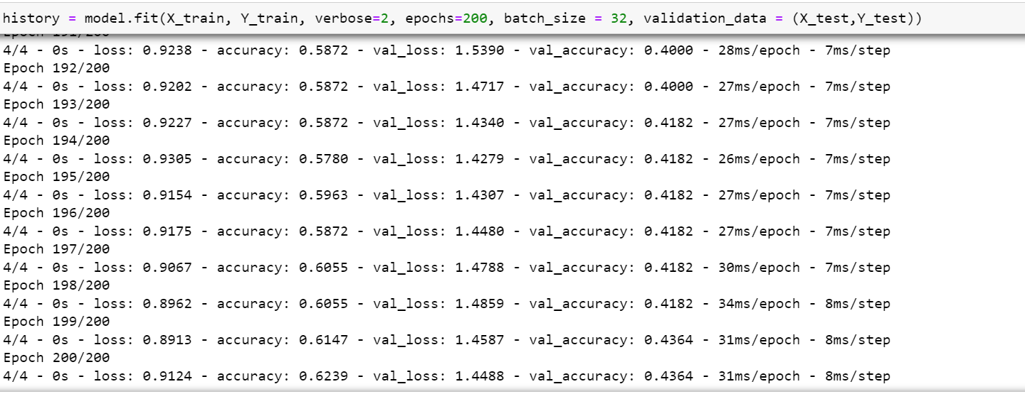

Figure 153: LP5 ANN with PCA

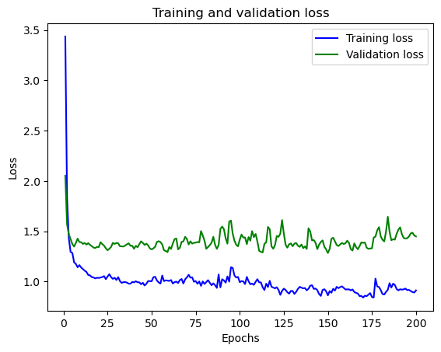

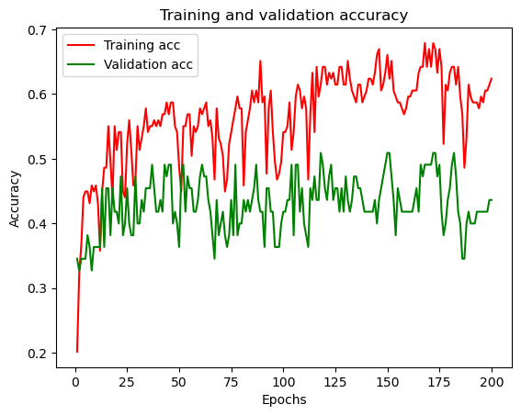

# Conclusion

The datasets used to evaluate each model where too small and this affected the accuracy and other metrics used to evaluate each of the models. The table below shows the best 3 models for each dataset without PCA since it didn’t improve the accuracy significantly:

Table 1: Conclusion

|  |  |
| --- | --- |
| Data set | Methods |
| LP1 | 1. Decision Tree: 90% 2. Random Forest: 90% 3. Neural Network: 98% accuracy and 83.3% validation accuracy |
| LP2 | 1. Decision Tree: 62.5% 2. Neural network: 96.7% accuracy and 43.75% validation accuracy 3. Gaussian naïve bayes: 62.5 % |
| LP3 | 1. Neural network: 93.5% accuracy and 62.5% validation accuracy 2. Gaussian naïve bayes: 81.25% accuracy 3. Decision tree: 81.25% accuracy |
| LP4 | 1. Neural network: 96.15% accuracy and 82.05% validation accuracy 2. Random forest: 94.87% accuracy 3. K-nearest neighbour: 92.3% accuracy |
| LP5 | 1. Neural network: 85.32% accuracy and 56.36% validation accuracy 2. Random forest: 78.18% accuracy 3. Decision tree: 67.27% accuracy |

# 

REFERENCES

Diryag, A., Mitić, M., & Miljković, Z. (2014). Neural networks for prediction of robot failures. *Proceedings of the Institution of Mechanical Engineers, Part C: Journal of Mechanical Engineering Science*, *228*(8), 1444–1458. https://doi.org/10.1177/0954406213507704

Mitchell, T. M. (Tom M. (n.d.). *Machine Learning*.

Ul Hassan, C. A., Khan, M. S., & Shah, M. A. (2018, September 1). Comparison of machine learning algorithms in data classification. *ICAC 2018 - 2018 24th IEEE International Conference on Automation and Computing: Improving Productivity through Automation and Computing*. https://doi.org/10.23919/IConAC.2018.8748995

<https://scikit-learn.org/stable/tutorial/machine_learning_map/index.html>

APPENDICES

Processor 11th Gen Intel(R) Core(TM) i7-11800H @ 2.30GHz 2.30 GHz

Installed RAM 16.0 GB (15.8 GB usable)

Device ID D6AB9347-5E20-4E48-9BE8-B4B392E01CB5

Product ID 00342-20769-70049-AAOEM

System type 64-bit operating system, x64-based processor

Pen and touch No pen or touch input is available for this display